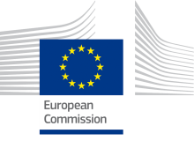

– Guidebook Series —

DRAFT VERSION

**Public Procurement of Innovative solutions (PPI) for the benefit of public services and SMEs/businesses in Europe**

**Financing opportunities under EU programmes 'Horizon 2020', 'Structural and Investment Funds'**

**Foreword**

**Daniel CALLEJA CRESPO, DG Enterprise Director General**

*"Text to be agreed…"*



Table of Contents

Table of boxes 6

Introduction 8

1. Public procurement of innovative solutions: a great opportunity to stimulate growth and jobs 9

1.1 What is Public procurement of innovative solutions - PPI? 9

1.2 What has been done to support public procurement of innovative solutions in Europe? 12

2. How can the 'European legal framework' and 'EU programmes' support Public Procurement of innovative solutions? 15

2.1 The 'legal framework': New EU procurement directives 15

2.2 The potential for public procurement of innovative solutions in the European Structural and Investment Funds 17

2.3 Outlook on PPI support under Horizon 2020 22

3. Supporting public procurement of innovative solutions in practice 25

3.1 How can policy-makers reduce the risks for public procurers of innovation? Some guiding principles for national or regional policy-makers 25

3.2 How does public procurement of innovative solutions work? Some general guiding principles for public procurers launching PPI 26

3.3 Fostering procurers skills and including the main players of the PPI eco-system in the support actions 29

Annex 1: Existing European projects supporting PPI 33

Annex 2: Examples for trans-national and national PPI projects 37

37

# Table of boxes

Box 1 — Public procurement represents almost 19 % of EU gross domestic product (GDP)

Box 2 — Innovation procurement: what are PCP and PPI?

Box 3 — ‘Procurement gap’ between the EU and the USA

Box 4 – What holds back the vast majority of public procurers from purchasing innovative solutions?

Box 5 – 2014 procurement directives

Box 6 — Major Cohesion Policy spending targets (2007-13)

Box 7 – Structural Funds support to public procurement

Box 8 – PPI and PCP central role in ESIF

Box 9 – Number of contracting authorities or entities estimated by the Commission in 2011

Box 10 – Current practices stimulating the most PPI

Box 11 — Current PPI buying groups co-funded by the Commission (2011-15)

Box 12 — Current PCP buying groups co-funded by the Commission

Box 13 — Galicia’s PPI scheme: how did the open call for proposals work?

Box 14 — Number of participants in Galicia’s PPI scheme in 2013

Box 15 — Demand-driven ‘tender map’ of Galicia’s PPI scheme

Box 16 — Communication among stakeholders in the PPI ‘ecosystem’

Disclaimer: The European Commission cannot be held responsible for the correctness of the information provided in this guide or any use which may be made of the information contained therein.

# Introduction

**Public procurement of innovative goods and services can be an important tool for regional authorities to improve the effectiveness and efficiency of public services and address their challenges and needs** (e.g. mobility, heath, aging, construction, environment, security and safety, IT services…), **while helping to create jobs and boost the competitiveness of European industry and SMEs.**

**The** **objective of the Guide is to provide guidance for regional or national policy-makers on how to support specifically public procurement of innovative solutions (PPI). In this guide, PPI is envisaged in the framework of the European Commission support programmes, namely 'Horizon 2020' and 'Structural and Investment Funds'.**

The guide aims at encouraging inter-departmental cooperation and coordination, between the research and innovation department and the departments with important public procurement budgets at national and regional level, such as: construction, transport, health, environment or energy.

The guide outlines the **support that the European Commission and EU programmes can provide to policy-makers**, notably via new funding opportunities under Horizon 2020 and platforms for policy-learning, but also in the context of the new generation of programmes under the European Structural and Investment Funds that will bolster the implementation of smart specialisation strategies, comprehensive transport plans, strategic policy frameworks for digital growth and priorities in the areas of energy, health, environment etc.

The Guide has been developed in the light of experience gained from the previous European Cohesion Funds programme, but also from European Framework Programme 7 (FP7) and the Competitiveness and Innovation Programme (CIP).

This guide further complements the **specific guidance on public procurement of innovative solutions for public procurement officers. This guidance has been published by the Procurement of Innovation Platform with financial support from the European Union: “Public Procurement of Innovation – Guidance for public authorities”** available on: <http://www.innovation-procurement.org/about-ppi/guidance>

# 

# 1. Public procurement of innovative solutions: a great opportunity to stimulate growth and jobs

**Public procurement is** **the process whereby public authorities** — including all levels of government and public agencies — **buy goods and services or commission work.** The resulting contracts make up a **very significant proportion of the European Union market, accounting for about 19 % of its gross domestic product (GDP)** or almost € 2.400 billiona year.

Box 1 — Public procurement represents almost 19 % of EU gross domestic product (GDP)

***Facts & figures***

***With an estimated 18.6 % of the European Union’s GDP in 2010, public procurement has an immense potential to pull EU innovations to the market, support lead customer and catalysing effects, and thus provide innovative firms with a head start in the global markets*** *(source: European Commission, DG Internal Market, 2010)*

[**18.6 %**](http://www.innovation-procurement.org/about-ppi/facts-figures/)

Public contracts above certain value thresholds must be published in national government or European Union Official Journal. This is to ensure greater competition in the context of the European internal market. Public procurement plays a central role in the delivery of public services, such as health and education, and involves all government departments, local authorities, agencies and other public bodies.

In the last decade, more and more considerations have been given to link public procurement and political objectives like innovation and sustainability.

## 1.1 What is Public procurement of innovative solutions - PPI?

Horizon 2020, the new EU Framework Programme for Research and Innovation, includes a useful legal definition of public procurement of innovative solutions (PPI) as a basis for the eligibility of procurement actions for EU co-financing[1]:

**It stipulates that Public Procurement of Innovative solutions (PPI)** is procurement where contracting authorities act as a launch customer for innovative goods or services which are not yet available on a large-scale commercial basis, and may include conformance testing. Public procurement of innovative solutions does not include the procurement of R&D services, which is known as ‘pre-commercial procurement’ (PCP).

**Pre-commercial procurement** **(PCP)** means procurement of research and development services involving risk-benefit sharing under market conditions, and competitive development in phases, where there is a separation of the research and development phase from the deployment of commercial volumes of end-products. PCP is excluded from the procurement directives, and the European Commission developed a specific guidance to Member States in 2007 presenting how to develop PCP procedures[2].

As outlined in the introduction, this guidance is about PPI. PCP is only mentioned in this guide for the sake of putting PPI in its overall policy and economic context. Where reference is made to both instruments, PPI and PCP, the wording "innovation procurement" is used.

Box 2 — Innovation procurement: what are PCP and PPI?

***Facts & figures***

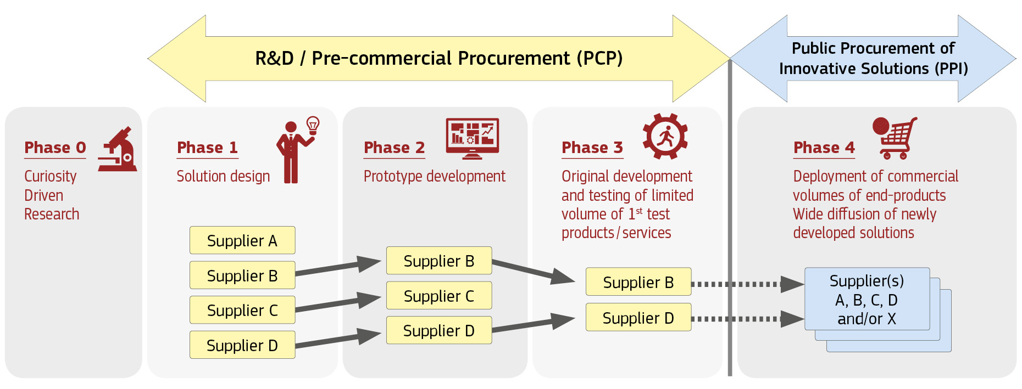

Public procurement of innovative solutions (PPI) plays a key role in improving the efficiency and quality of public services while addressing major societal challenges. It contributes to achieving best value for public money as well as wider economic, environmental and societal benefits in terms of generating new ideas, translating them into innovative products and services and thus promoting sustainable economic growth, to the benefit of European enterprises and SMEs.

Public procurement of innovative solutions (PPI) is particularly useful in **certain areas (e.g. mobility, health, construction, e-government, waste management, recycling), where the public sector accounts for a big part of demand and can use procurement as a means to address key societal challenges such as sustainable transport, resource-efficiency or health and ageing.**

Public procurement of innovative solutions (PPI) provides an early ‘reality check’ of concrete specific public purchasing needs against feasible solutions. **Suppliers can better anticipate demand for new solutions and shorten time-to-market**. Procurers can compare competing solutions and get a better price for an innovative solution that is more fit for purpose. **Public authorities may be able to** **steer the supply of innovative solutions from the demand side** and leverage additional investment in R&D and innovation.

By driving innovation from the demand side and steering the development and first application of innovative solutions corresponding to public-market needs public procurement of innovative solutions (PPI) can enable procurers to **avoid the costs of unnecessary features, prevent supplier ‘lock-ins’** and **take account of longer-term public sector requirements**.

When procurers represent a critical mass, they can **create new lead markets** by acting from the demand side so that entire sectors switch from proprietary to open standardised solutions and provide more flexible solution designs. In certain sectors, the public-sector ‘demand pull’ is the most important factor in developing new markets for innovative solutions.

In spite of the potential benefits of public procurement of innovative solutions (PPI) for both the efficiency of public services and new solutions to societal needs, **public authorities generally tend to adopt a risk-averse approach to purchasing innovation. Public procurers** still write terms of reference and prefer to go for the lowest bids or lowest price as the main criterion when assessing the offers received. Certain barriers need to be overcome for using public procurement more strategically.

Box 3 – What holds back the vast majority of public procurers from purchasing innovative solutions?

***Facts & figures***

**What holds back the vast majority of public procurers from purchasing innovative solutions?**

* **Lack of knowledge and expertise** on: the use of practices that favour innovation, risk management in procurement and market and technological developments;
* **Wrong priorities**, which focus on short-term costs and provide no incentives for taking the additional risks (and initial costs) of purchasing innovative solutions, even if they offer cost savings and efficiency gains in the long and medium term;
* **Mismatch with public policies and strategies** whereby procurement is treated as a purely administrative, legal or financial task without reference to public policy objectives such as health, environment, energy, etc.;
* **Lack of capability in public organisations to identify innovative solutions**, with few or no resources dedicated to identifying, or evaluating innovations, or even to establishing whether problems could be addressed more effectively through innovative solutions; and
* **Fragmentation of demand/lack of critical mass** due to the dispersed nature of procurement action across borders and administrative boundaries, which leads to individual procurements being too small for companies to make the effort of coming forward with innovative solutions.

**From the business point of view**, as regularly confirmed by Innobarometer surveys since 2009,[3] very few European companies (7 % of the respondents) have had the opportunity to sell innovative solutions to public procurers.

The Innobarometer surveys conclusions on opportunities for companies to sell innovative solutions to public purchasers are supported by other studies that show the **difficulties for innovative SMEs to get access to public procurement contracts**.[4]

Overall, this hampers public authorities’ access to the innovative potential of SMEs.

## 1.2 What has been done to support public procurement of innovative solutions in Europe?

Considering the potential of innovation procurement – including both PPI and PCP - to stimulate growth and job creations, some **Member States** (e.g. the United Kingdom,[5] the Netherlands,[6] Sweden,[7] Italy,[8] Spain,[9] Austria,[10] Germany,[11] France[12] and Finland[13]) have been supporting and carrying out PPI — and PCP — for ten to fifteen years, with specific policy actions often developed via national, and in some cases regional, innovation agencies (e.g. BIS (UK), the Agency (NL), VINNOVA (SE), TEKES (FI) and IWT (Flanders region, BE)).

Often driven by quantitative objectives for the share of public procurement of innovative solutions in the procurement volume (e.g. Netherlands 2.5 %, France 2 %, Spain 3 %), these programmes have encouraged procurers to feed ‘innovation’ considerations and approaches into their regular procurement activity. In the past few years, almost all Member States have developed PPI-related policy actions.

More recently, **European regions** have taken targeted measures to support their public procurers in contracting innovative solutions and services. Flanders[14] (BE) and Lombardy[15] (IT) have been pioneers in this respect.

On the EU level, the European Commission has provided significant and increasing support for PPI since 2009[16]. The support from the European Commission can be differentiated in three categories (see Annex 1):

* First, **direct support measures** **to** **reduce the financial risks** of public procurement of innovative solutions (PPI). This includes both financial support to the establishment of cross-border procurer networks and a financial contribution to the purchase of innovative solutions, a so-called ‘topping-up’.
* Second**, indirect support measures to improve the skills of procurement officers**, such as a web platform to exchange best practices and experiences with regard to public procurement of innovative solutions (PPI); guidance for the public procurement of innovative solutions in specific areas (e.g. sustainable construction, healthcare).
* Third, **accompanying measures to improve the evidence base**, such as measuring public procurement of innovative solutions (PPI) and pre-commercial procurement (PCP) and benchmark Member States’ actions to support public procurement of innovative solutions (PPI).

In 2013, € 94.5 million was allocated in the Competitiveness and Innovation Framework Programme and the 7th Framework Programme for Research and Development to innovation procurement – including both PPI and PCP -.

In the light of the European R&D&I programme Horizon 2020, the European Commission intends to develop new opportunities for funding and promote innovation procurement – including both PPI and PCP - in the coming years – see Part 2.3 of this guide -.

Also, the **Procurement of Innovation Platform** is a new system that aims to make public procurement – of innovative solutions a widespread reality in Europe. It has been developed to help public authorities, procurers, policy-makers, researchers and other stakeholders harness the power of PPI. Custom-made to meet the needs of these users, the PPI Platform comprises the following elements:

* **The PPI Platform website** 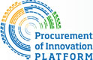 [www.innovation-procurement.org](http://www.innovation-procurement.org) is the first port of call for all things PPI. It contains the latest news and events, the European legal framework, policy support and updates on PPI- related projects;
* **The Procurement Forum** [www.procurement-forum.eu](http://www.procurement-forum.eu) is a space for procurers and other stakeholders to discuss, share and connect, allowing them to post comments and upload documents, images or videos. Users can create groups, which are ideal for developing and coordinating projects;
* **The Resource Centre** [www.innovation-procurement.org/resources](http://www.innovation-procurement.org/resources) provides a central database for PPI knowledge, gathering useful documents and examples in one place. Resources include national and European policy and strategy documents, tools, case studies, details of projects and initiatives, and reports;
* **The Public Procurement of Innovation Award** <http://www.innovation-procurement.org/award> aims to recognise successful public procurement practices that have been used to purchase innovative, more effective and efficient products or services.

Feedback on the Platform is welcome and can be sent to [info@innovation-procurement.org](mailto:info@innovation-procurement.org) Platform activities, including awards and events, can be followed on:

*  @ProcureInno; and
* Supporting Public Procurement of Innovative solutions.

**2. How can the European legal framework and EU programmes support Public Procurement of Innovative solutions?**

There are two main ways to support European public procurers to purchase more innovative solutions: first, in having **a more innovation friendly legal framework** and second, in **developing policy support actions** to the benefit of public procurers and supporting organisations. These two potential routes for action are set out in the following pages.

## 2.1 The legal framework: New EU procurement directives

Public procurement is currently subject to the Public Procurement Directives - 2004/17/EC (procurement in the water, energy, transport and postal services sectors), 2004/18/EC (public works, supply and service contracts) and [2009/81/EC (defence and sensitive security procurement](http://eur-lex.europa.eu/legal-content/EN/TXT/?uri=CELEX:32009L0081)).

The new Public Procurement Directives 2014/24/EU and 2014/25/EU replacing Directives 2004/17/EC and 2004/18/EC[17] came into force on 17 April 2014. **The new directives will encourage companies to develop their capacity for innovation, while maintaining the basic requirements of competition, transparency and equal treatment. The Member States have now to transpose them into national law, at the latest by April 2016.**

The **new competitive procedure with negotiation** replaces the current negotiated procedure with prior publication of a contract notice. To ensure fairness, transparency and efficiency, this new procedure is clearly structured and ensures equal exchange of information between the contracting authority and tenderers. It focusses on the improvement and adaptation of the tenders and provides contracting authorities with effective instruments to obtain the best possible procurement outcome in the negotiations.

Secondly, the **competitive dialogue** has been simplified for particularly technically and financially complex projects.

These procedures give contracting authorities more flexibility, greater options and new routes to procurement. They have much greater freedom to choose the type and design of procedure best suited to their needs. Contracting authorities can effectively use such procedures in all situations where negotiations are required (e.g. for contracts which include an element of design or innovation, or if technical specifications cannot be sufficiently defined). Procurers will thus have greater flexibility in the choice of procedure to meet their needs and to evaluate a range of solutions.

The new rules also introduce a new procedure called innovation partnership*[18]* to enable public procurers to have an innovative solution developed tailored to their requirements. The innovation partnership foresees the funding of R&D for an innovative solution in the same procedure as the procurement of the solution. It is therefore not relevant for PPI financed under Horizon 2020.

Beyond the above new and revised procedures available to contracting authorities, the 2014 Public Procurement Directives further facilitate procurement approaches which have been found to be ‘innovation friendly.’ The possibility to conduct preliminary market consultations is underlined. The ability to take environmental and social considerations into account at various stages of the procurement process, and the use of life-cycle costing at award stage, are given a stronger legal basis. By allowing buyers to focus on criteria beyond the initial purchase costs, environmental and social criteria and life-cycle costing can promote innovative solutions which may be awarded more points in the light of their long-term financial benefits. Similarly the use of functional or performance-based specifications can allow more scope for innovative proposals.

Box 4 – 2014 procurement directives

***Facts & figures***

**2014 procurement directives**

*Summary of provisions relevant to PPI*

1. **Streamlining of documentation requirements at selection stage:** to encourage participation of SMEs in public tenders
2. **Clarifying the exemption for R&D services or what is called Pre-Commercial Procurement (already existing in the 2004 legal framework) :** to encourage public procurers to stimulate the development of new/innovative solutions
3. **Clarifying rules on preliminary market consultations:** to allow a better market consultation and stimulation of the market
4. **Encouraging functional and performance-based specifications:** to better stimulate the development of innovation in avoiding technical specifications
5. **Encouraging competitive procedure with negotiation:** to allow a better market consultation and stimulation
6. **Greater availability of competitive dialogue:** to better stimulate the development of innovative solutions
7. **Ability to apply environmental and social criteria and take life-cycle costs into account:** to better stimulate the development of innovative solutions
8. Possibility to introduce award criteria referring to innovative characteristics (article 67 of the revised directive)

1. **Clarifying rules on joint (cross-border) procurement:** to enable larger market pull and spread the individual procurement risk for early innovative projects implying uncertain outcomes
2. **Organising the annual reporting by Member States on public procurement of innovative solutions and SME involvement:** to have a better qualitative and quantitative idea on the nature of procurement.

Finally, a number of changes to selection procedures and documentation requirements are also aimed at ensuring SMEs — many of which are highly innovative — have better access to public procurement procedures. New rules on cross-border joint procurement will enable buyers from various Member States to make joint purchases. Aggregating demand from various Member States can encourage risk and benefit-sharing for innovative projects and the pooling of demand.

Last but not least, and perhaps most importantly, the implementation of the new directives by Member States offers them an opportunity to assess public procurement from a strategic perspective as well as to identify how innovation and other objectives can best be delivered. The forthcoming years will see many organisations adopting new approaches to achieve better procurement outcomes.

Meanwhile, this process should be assisted by greater reliance on electronic systems with the current mainstreaming of e-procurement, following the European Commission strategy to make the use of e-procurement the rule in the European Union by mid-2016[19]. This development of e-administration has to be seen also as a unique opportunity to encourage innovation in public procurement.

## 2.2 The potential for public procurement of innovative solutions in the European Structural and Investment Funds

**European Structural and Investment** **Funds (ESIF) support massive investments, mostly via public procurement** – see precise data below -, **in infrastructure providing basic services to citizens in the areas of energy, environment, transport and ICT, and social, health, research, innovation, business and educational infrastructure.**

**They also direct these investments in the development of endogenous potential of EU industries, including increasingly research and innovation, support services, clusters and networks**. The percentage dedicated to innovation increased from 6% in the pre-2000 operational programmes to around 25% in the 2007-2013 programmes, including under the “European Territorial Cooperation objective” of the European Regional Development Fund (commonly known as “INTERREG”).

This is further enhanced through the thematic concentration of the post 2013 European Regional Development Fund (ERDF) on research, innovation, ICT, SME competitiveness and low-carbon economy investments that is expected to earmark around € 110 billion for these themes. Alongside this, also the European Social Fund (ESF)[20], the European Agricultural Fund for Rural Development (EAFRD)[21] and the European Maritime and Fisheries Fund (EMFF)[22] actively support innovation and the Cohesion Fund holds potential for the purchase of innovative solutions in the fields of transport and energy. These five funds are the so-called “European Structural and Investment Funds” (ESIF) and are governed by separate regulations, but held together via a Common Provisions Regulation.[23]

**Regarding the last cohesion policy funding period (2007-2013), the 2012 European Parliament study *Public procurement and cohesion policy*[24] draws interesting conclusions on the use of these funds and their relationship with public procurement.**

**Firstly, it showed that many European projects receiving regional policy support involved large-scale public procurement procedures. Major construction works relating to infrastructure investment account for the biggest proportion of these.**

**Overall, such procurement accounted for 46 % of the total Cohesion Policy budget — some € 159 billion — at European level in 2007-13 (this includes only procurement exercises over the EU publication threshold). Therefore, using public procurement to stimulate innovative solutions could exert significant leverage.**

The EP report indicates that **large-scale public procurement** as part of infrastructure investment (46 % of the total Cohesion Policy budget) concerns the following sectors:

* Transport (24 %);
* Environment (direct investments, 15 %); and
* Energy, ICT infrastructure, urban development (rehabilitation, regeneration, housing), health, research and education infrastructure:

Large-scale public procurement accounts for

* 1. € 144 billion in less developed regions (‘convergence’ objective) or 80 % of the total Cohesion Policy budget; 52 % of the budget for these regions goes into large infrastructure; and
  2. € 14.5 billion in more developed regions (‘competitiveness’ objective) or 21 % of their overall budget.

Box 5 — Major Cohesion Policy spending targets (2007-13)

***Facts & figures***

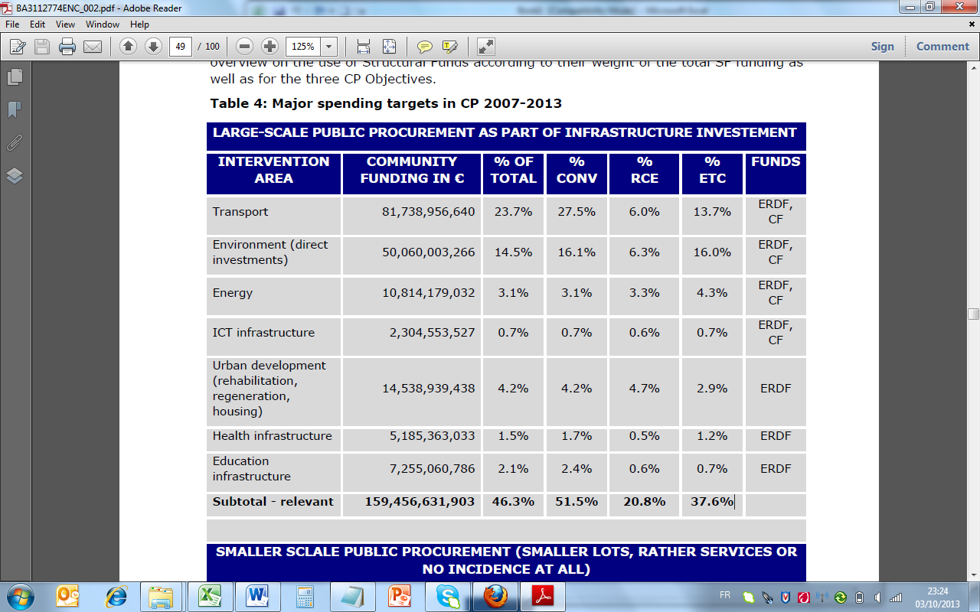_

***Source:*** *Public procurement and cohesion policy, EP, 2012:* [*http://bookshop.europa.eu/en/public-procurement-and-cohesion-policy-pbBA3112774/?CatalogCategoryID=f.cKABstF7wAAAEjwYYY4e5K*](http://bookshop.europa.eu/en/public-procurement-and-cohesion-policy-pbBA3112774/?CatalogCategoryID=f.cKABstF7wAAAEjwYYY4e5K)

**Secondly, the report also shows the use of cohesion funds funding in the light of smaller scale procurements,** smaller contracts and purchases of goods and services, in particular with regards to the acquisition of:

* Private and public purchase of ICT products and services;
* Machines, equipment and small infrastructure;
* SME support services;
* Education and training services for RTDI human capital, employment and social inclusion.

These data show the enormous potential in terms of the budgets and economic sectors concerned. The sectors are employment-intensive, have a great need for innovation and are areas in which European industries are world leaders.

**As from 2014 onwards, the new ESIF investment rules show a strengthened emphasis on the need to address new areas, new types of actions and new priorities. It is worth noting in particular the following:**

* **The emphasis for regions to develop 'cooperative partnerships'** between: research, education and innovation actors;
* **The opportunity to 'invest'** in areas such as eco-innovation, social innovation, public service applications;
* **The possibility to use the 'demand stimulation' for**: innovations, networking, clusters, early product validation, advanced manufacturing capabilities and first production, in particular in key enabling technologies and diffusion of general purpose technologies.
* **The development and take-up of** e-government, e- learning, e-inclusion, e-culture and e-health solutions, enhancing institutional capacity and efficiency of public administration, supporting the shift towards a low-carbon economy, climate change adaptation, risk prevention and management, preserving and protecting the environment and promoting resource efficiency, promoting sustainable transport and removing bottlenecks in key network infrastructures, promoting sustainable and quality employment and supporting labour mobility count among the investment priorities. This holds a substantial potential for **creating more demand for innovative products and services through public procurement of innovative solutions (PPI)**.[25]

Whether this potential of the European Structural and Investment Funds will be a reality depends largely on the Managing Authorities, i.e. national and regional authorities, and the priorities and implementation modalities they choose for the forthcoming ESIF programmes. It is not necessary to expressly mention PPI in the ESIF programmes in order to be allowed to use it, however, it would be welcomed to mention PPI as a type or example of actions to be supported or as guiding principle for the selection of operations under the relevant priority axis (see Art 96(2)b).

Box 6 – PPI can play a central role in ESIF

***Facts & figures***

**PPI can play a central role in ESIF programmes from three different angles, by**:

1. **Helping to improve innovative public procurement procedures and skills of procurement officers**: the European Social Fund programmes can enhance the administrative capacities of national and regional authorities in terms of procurement related skills (under “investment priority” 11 for enhancing institutional capacity of public authorities) or the ERDF could support the introduction of e-procurement tools and procedures (under “investment priority” 2c for strengthening ICT applications for e-government). Mutual learning among public authorities on PPI could also be supported under the MED programme under the ERDF (see examples in Annex 2). Which investment priority is used depends on the specific objective. If e-government improvement is the main objective, the limit is that the investments have to be governed by a single strategy and not split for instance between a strategy for the modernisation of public sector and a separate one for e-government.
2. **Fostering innovation through public procurement**, via the development of innovative solutions for public sector needs (under ERDF “investment priority” 1b, or also under 4f for research and innovation in low-carbon technologies), i.e. the main purpose and major share of the budget should target strengthening innovation (including the improvement of public sector innovation) and not for instance mainly transport or environment or health objectives. They depend on the **Smart Specialisation Strategies (RIS3)**, i.e. a new generation of innovation strategies that have to be developed by regions and national governments through an entrepreneurial discovery process, to identify priorities based on competitive advantage and emerging opportunities and market developments
3. **And fostering wider public benefits by buying innovative solutions** (under “investment priorities”1a, 2, 4-10, i.e. the take-up of innovative solutions for problems related to energy, environment, climate change, resource efficiency, sustainable transport, ICT, health, educational, social and research infrastructures, etc. mainly from the ERDF and Cohesion Fund, but also from the EAFRD and EMFF and ESF).

As the identification of **'investment priorities'** is a key element of the ESIF Programmes, it should be noted that practically all of the **11 investment priorities[26] of ESIF** allow for PPI use.

However, in order to avoid an incorrect classification of actions - for instance to comply with "thematic concentration obligations" –, a direct link between the use of PPI under the investment priority needs to be insured.

It has to be noticed that since direct beneficiaries of PPI actions are always public bodies (bodies subject to the procurement Directives), therefore it cannot be used under investment priorities 3 a-d (enhancing the competitiveness of SMEs) to directly support SMEs, unless public infrastructure or services are procured specifically for SMEs. Nonetheless, **PPI actions can indirectly help innovative SMEs by giving them an opportunity to find a lead customer and thus bring their innovations faster to the market and obtain faster return on investments**.

Box 7 – Structural Funds support to public procurement[27]

***Facts & figures***

**Structural Funds support to public procurement**

**Structural Funds support to public procurement is not subject to any special rules**. As regards the procedures, the EU Procurement Directives have to be respected. As regards the type and volume of the procured goods and services, the only requirement is that they are in line with the priorities and budget allocations laid down in the relevant ESIF programme. Respecting public procurement rules seems however to pose significant problems to many Managing Authorities, as a large number of the errors identified in Structural Funds audits relate to the need of compliance with procurement procedures.

## 2.3 Outlook on PPI support under Horizon 2020

Horizon 2020[28] is the financial instrument implementing the Innovation Union[29] – a [Europe 2020](http://ec.europa.eu/europe2020/index_en.htm) flagship initiative aimed at securing Europe's global competitiveness. It aims at:

* Boosting excellence in science;
* Strengthening industrial leadership;
* And addressing societal challenges.

Under Horizon2020, public procurement of innovative solutions (PPI)[30] has been recognised as new innovation support form,.

**Horizon 2020 foresees three types of support to public procurement of innovative solutions** carried out by procurers from Member States and Associated Countries by awarding a grant:

* **For networking public procurers** in a specific area of public interest (**Coordination and Support Action - CSA**); For these type of actions the Horizon 2020 **co-financing rate is 100% ;** These actions typically also include activities for preparation of a joint or coordinated PPI, management and follow-up, such as activities for awareness raising, networking, training, evaluation, validation and dissemination of results);
* For co-financing the price of a joint or coordinated procurement of innovative solutions (**Co-fund Action - CA**). For this type of actions the Horizon 2020 co-financing rate **is 20%.** The eligible costs include the price of the purchase as well as related coordination and networking costs to prepare, manage and follow-up the call for tender;
* For a third channel is foreseen with Horizon 2020 for supporting PPI carried out by the EU (or relevant funding body) on its own behalf or jointly with contracting authorities from Member States and Associated Countries (Procurement Action).

**Inviting public procurers and support organisation to**

**Team up with other procurers in the framework of a Horizon 2020 project** can help not only with the **identification of the state-of-the-art technology and performance levels**, but also with the **correct handling of procurement procedures** in line with the Directives and the risk management of PPI projects.

**Teaming up can also bring down the cost for the innovative solution**, thanks to economies of scale due to the greater procurement volume. Such Horizon 2020 projects can also facilitate the procurement of additional quantities of the innovative solutions through ESIF.

To obtain support under Horizon 2020**, these groups of public procurers have to respect certain administrative rules, in-line with the Horizon 2020 rules for participation. For example** a consortium has to include participants from at least 3 different countries, of which minimum 2 public procurers from 2 different countries with common procurement needs. In addition, other procurers – e.g. private, NGO procurers - that are providing services of public interest and other entities that are assisting the procurers can participate in a consortium.

PPI actions are likely to be mainly used under the three Horizon 2020 priorities: "Excellent Science”, “Industrial Leadership” and “Societal Challenges" (health, demographic change and wellbeing, food security, sustainable agriculture and forestry, marine and maritime, inland water research, security, clean and efficient energy, smart, green and integrated transport, climate action, environment, resource efficiency and raw materials).[31]

If you are looking for more information, do not hesitate to get in touch with your Horizon2020 National Contact Points. They can help public procurers in the identification of potential cooperation partners. Also the “Horizon 2020 Helpdesk” stands ready for further enquiries.[32]

**For more information, two websites are informing about on-going activities on on public procurement of innovative solutions (PPI)**: <http://ec.europa.eu/digital-agenda/en/innovation-procurement> **and:** <http://ec.europa.eu/research/participants/portal/desktop/en/home.html>.

Finally, be aware that it is also possible to combine EU funding, namely Horizon 2020 and ESIF. A specific guidance will be developed on synergies between ESIF and Horizon 2020 on the implementation of PPI, and will be available here: <http://s3platform.jrc.ec.europa.eu/home>

# 3. Supporting public procurement of innovative solutions in practice

How should the support to public procurement of innovative solutions work in practice?

**Policy-makers can apply the same instruments to support public procurement of innovative solutions as the European Commission does** at EU level with three main approaches:

1. **Sharing the risk of innovation procurement: financial support to public procurers**
2. **Guidance** to procurement bodies on how to procure innovative solutions
3. **Indirect support for the administrative capacities** of procurement officers: skills and the PPI eco-system

These three approaches are detailed below.

## 3.1 How can policy-makers reduce the risks for public procurers of innovation? Some guiding principles for national or regional policy-makers

Procuring innovative solutions that are not yet commercially available on a large scale involves higher risks than the procurement of products or services that have a proven track record. Policy-makers can give financial support to procurement bodies to reduce these risks. In order to reach the political objectives, calls for proposals for co-financing the public procurement of innovative solutions need to be well designed.

**The design phase is crucial if a call for proposals is to achieve the managing authorities’/RIS objectives**. In the Commission’s experience of supporting innovation procurement by public procurers operating alone or together, the following activities should be included in the terms of reference and addressed in the project proposals (this is a non‑exhaustive list):

**Proposals for PPI** **support** should describe the challenge being addressed — following a serious ‘needs assessment’ - and the solution sought. Activities covered could include:

* **Activities in the preparation phase (particularly for a group of procurers)**:
  + Identifying procurement needs that are common to the public procurement bodies involved;
  + Determining potentially available state-of-the-art solutions through market consultation along the supply chain, accompanied by an early announcement;
  + Developing common functional/performance-based specifications;
  + Organising ‘meet-the-market’ events where procurement of innovative solutions will be signalled at an early stage and promoted across the EU;
  + Carrying out legal work to ensure that procurement complies with European and national law;
  + Improving procurement capabilities by joint training, workshops and other networking activities; and
  + Reducing procurement risks further by developing standards, certificates and/or insurance schemes.
* **Activities in the procurement phase**:
  + Calls for tender for innovative solutions published in the EU Official Journal;
  + Evaluating competing offers and completing the award procedure;
  + Purchasing, as launch customers, the innovative solution on offer;
  + Ensuring that the procurement process complies with European/national law and is truly fair to all stakeholders; and
  + Evaluating the benefits of the procurement.

While designing and preparing the call for tenders in trying to encourage innovative solutions, it is also very important to get support from various organisations or players evolved in the PPI eco-system: see part 3.4 below.

## 3.2 How does public procurement of innovative solutions work? Some general guiding principles for public procurers[33]

There is no ‘one size fits all’ approach to PPI. Different steps and procedures will be involved depending on the need, the contracting authority and market sector. However there are some common lessons which can be drawn from the experience of authorities who have procured innovation:

* **Start early and understand your unmet future needs —** all procurers are aware of how timescales can influence procurement outcomes. Too often documents are rushed out or suppliers are given inadequate time to respond to complex requirements. In other cases procedures may drag on for years, eating up resources and causing the parties to miss out on other opportunities. For PPI, a bit of forward-planning can go a long way to ensuring the procurement itself is done in a timely manner. Once a need has become clear (e.g. through a needs assessment), even if all the details and budget have not yet been decided, there is scope to start analysing the market and identifying suitable procedures. Consulting other public or private organisations who have procured similar needs can also be a valuable use of time in the run up to a formal procedure being launched. Forward commitment procurement is one way of providing the market with early notice of upcoming contracts and an incentive to participate in the process.

***How the Commission can help***: under Horizon 2020 and under INTERREG, trans-national platforms bringing together procurers to identify shared needs, can be supported.

* **Know the market —** perhaps the single most important lesson from successful PPI examples. A thorough understanding of the potential supply chain for an innovative product or service is indispensable, and this may go beyond the existing knowledge of category managers. This is because PPI will often involve new market players or groupings, require specialist materials or services to be sourced, and structure contracts or payment in new ways. To understand the scope and willingness for this on the supply side, detailed research and pre-procurement market engagement may be needed. Advice from professionals or others with up-to-date knowledge of the market can be valuable, and a wide range of sources should be consulted if possible to ensure a full picture (Preliminary market consultation). Support for early market engagement may be available from other departments within your own organisation as well as innovation agencies and EU schemes.

***How the Commission can help***: the Procurement of Innovation Platform can provide opportunities for mutual learning among procurement officers. See below.

* **Assess and actively manage risks — be an ambitious customer —** many different risk assessment techniques are used as part of project management in the public sector. The best ones tend to emphasise that risk should be managed by the party best able to do this, rather than a default position such as ‘the supplier takes all risks.’ Honest, accurate and regularly updated appraisals of risk make it less likely that an innovative procurement will fail — but only if they are communicated and acted upon. One way to do this is by having a project steering group which is able to handle both informal and formal communication, so that risks can be dealt with as they arise as well as through an initial strategy. Many (but not all) risks can be managed by choice of procurement procedure, intellectual property strategy and contract terms, all of which are discussed below.

***How the Commission can help***: the ESF may support the training of procurement officers. Check with the relevant Managing Authority.[34]

* **Competition is not just a formality** — it is a tool for obtaining the best the market has to offer. Sometimes with innovative requirements it can be tempting to think that only one supplier can deliver what is needed. In certain cases this may be true, and the procurement directives do allow for derogation in exceptional circumstances from the general rule that a competition must be held.[35] However before seeking to use this derogation, you should ask whether it is really clear that only one operator is in a position to deliver, and whether you can be confident of obtaining optimum value from that operator without a competition. Is it possible that two or more suppliers could deliver the requirements if they formed a group? Are you familiar enough with the market in other countries or regions and have you published a PIN and advertisements in trade journals/websites to identify potential suppliers? Relatively small investments in publicity and attracting competition can deliver savings and better results.
* **Do not over-specify and use outcome-based specifications** — as this can kill innovation. Performance-based or functional specifications are one way of allowing for flexibility for suppliers to propose solutions. Allowing variants is another. There is a fine balance between making sure the market knows exactly what your requirements are and leaving the door open to different and new ways of meeting those requirements. For example, it is essential for suppliers to know about any environmental standards to which a product or service must conform — but it may be possible to specify a performance requirement or to use outcome-based specifications (e.g. maximum CO2, energy or water consumption) rather than a detailed list of inputs. In other cases such matters can be better addressed in award criteria, to allow for comparison of suppliers and weighing against cost and other factors. It is good practice to challenge every procurement specification, to ensure it covers all requirements without being overly prescriptive.
* **Make information freely available** — whenever possible. Many public sector organisations are moving towards more open sharing of their data online. In addition to improving overall transparency, this can encourage researchers and enterprises to think about public sector challenges and develop potential solutions, even before procurement has been launched. In the context of PPI, the level of detail and accuracy of information shared with the market, and the timing of this, can be vital in securing the best outcome. Note that there may be a trade-off between quantity, quality and timing of information shared — in some cases a short prospectus published well in advance of a procedure being launched will be more valuable than pages of data included in tender documents, and in some cases it will be the other way around. Try to think about the information from the perspective of a supplier who is not overly familiar with the organisation, so that it can be understood by all those who may be able to respond.

**Agree an intellectual property strategy** — PPI involves an investment in making new ideas a reality, both by the contracting authority and the supplier(s) or service provider(s) involved. Each will want to recoup its investment, and this often takes the form of asserting intellectual property rights (IPR). In order to capture the benefits of innovation which are most important to it, without paying unnecessarily for rights and options which won’t be used, the contracting authority should develop a strategy on IPR which takes into account the likely future applications of the product or service it is purchasing. For example, if a new design for recycling bins is developed as part of a waste management contract, does it make sense for the authority to purchase or licence this, and what about rights to the design of vehicles which empty the bins? Issues to consider in answering such questions include the future ability of the authority to change service providers, and whether the design could also be licensed to other users of the service. In some cases sharing of information without the actual transfer of intellectual property rights will be sufficient to realise these objectives.

* **The contract is the thing — involve users in the procurement process** that ultimately determines the value of the procurement, along with the way in which that contract is managed. The terms of a contract should never be an afterthought, and for most PPI it is unlikely that standard terms and conditions will suffice. If a framework agreement or phased contract is being used, the conditions for award of further contracts or phases should be clear. Key performance indicators, incentives and penalties, licensing rights, termination and renewal clauses are all likely to be particularly important for PPI, and insurance and indemnities may also have a role to play. Discussion of these topics in the course of a competitive dialogue or negotiations should be structured around the main purpose of the contract, so that every term in the contract contributes to its overall objectives. For example, if users of a new IT system will be the main source of information on how well it works; there should be a mechanism for ensuring this reaches the supplier and is acted upon, rather than just a standard clause which requires the supplier to remedy defects.

**Choose the procedure best suited to your needs; procedures** *such as the* competitive dialogue orcompetitive procedure with negotiation allow greater interaction with the market in order to refine requirements and award a contract, compared to the open or restricted procedures. The disadvantage is that they normally take longer to conduct, especially if the authority is using them for the first time or does not have adequate capacity. It is important then to consider how the procedure chosen will be managed and what the resource implications are — for both sides.

Keep in mind that preliminary market consultation may be combined with any procedure in order to obtain the best results.

***How the Commission can help***: PPI Platform Consortium’s “Public Procurement of Innovation — Guidance for public authorities”

## 3.3 Fostering procurers skills and including the main players of the PPI eco-system in the support actions

In reality, European public procurers have always procured innovation but, for the reasons set out in Part 1.1 above, this has been on a limited scale. Also, the procurement community has sometimes purchased novel solutions without consciously engaging in ‘Public Procurement of Innovative solutions. In order to foster the public procurement of innovative solutions, it is essential that procurement officers have the necessary know-how and innovation procurement skills. Certain procurement practices can have an important impact on innovation.

Box 8 – Number of contracting authorities or entities estimated by the Commission in 2011

***Facts & figures***

**250 000**

***… is the number of contracting authorities or entities estimated by the Commission in 2011*** *(source:* Evaluation Report on *Impact and Effectiveness of EU Public Procurement Legislation,* Staff Working Document, DG Internal Market, SEC(2011) 853 final)

Indeed in preparing the 2014 reform of the 2004 public procurement directives, the European Commission has carried out several studies on public procurement in Europe. **One of these, on the *Strategic Use of Public Procurement in Europe*, lists current practices stimulating the most PPI.**

Box 9 – Current practices stimulating the most PPI

***Facts & figures***

**Current practices stimulating the most PPI**

* Awarding based on the EMAT - Economically Most Advantageous Tender;
* Functional requirements in procurement;
* Acceptance of alternatives;
* Use of standards;
* Use of life-cycle costing;
* ‘Best available technology’ clause; and
* Forward commitment procurement.

That study also says that in average, EMAT (42 %), functional requirements (38 %) and the acceptance of alternatives (35 %) are used by the most contracting authorities to promote innovation in tender documents. Forward commitment procurement is used by only 6 %.

The PPI front-runners among the Member States more often use EMAT (63 % as compared with 36 % in the other Member States), functional requirements (54 % as compared with 41 %), acceptance of alternatives (44 % as compared with 28 %) and life-cycle costing (33 % as compared with 16 %) to promote innovation.

As regards award criteria, contracting authorities mostly look for functionality above the minimum required functions (33 %). Other criteria used are life-cycle costing (19 %) and additional standards (18 %).

**This shows the need for procurers to upgrade their knowledge about procurement practices that are not largely used in the European procurers' community.**

**Trainings, sector oriented guidance or legal support of procuring departments are therefore crucial needs in order to support the development of PPI in Europe.**

**Also, once procurers gain skills and knowledge on PPI, they still could benefit from support by other players in the ecosystem.** Indeed,innovation in organisations is primarily a question of *acceptance of change* and *cooperation among actors* to develop a favourable ‘ecosystem’, and the same applies to public procurement of innovative solutions (PPI). Public procurers willing to purchase innovations need support, advice, expertise and reassurance.

National, regional and local governments can support purchasing authorities (e.g. city, municipal, facility-managing) or their own procurement services/agencies politically, institutionally and financially.

The project experience gained by the Commission since 2009, in the support to public procurement of innovative solutions (PPI), has demonstrated that third parties such as innovation agencies, chambers of commerce, research centres, legal advisory bodies, public authority platforms and European groupings of territorial cooperation (EGTCs) act as enablers of public procurement of innovative solutions (PPI). They are also catalysts of the *behaviour change* that is needed in public procurement departments. They are indispensable partners if innovation procurements are to be prepared and run in the best possible conditions.

As shown by a recent OECD study,[36] the externalisation of public administration has meant that more and more agencies exercise public procurement responsibilities separately from the parts of government tasked with fostering innovation. While such specialised agencies can and do focus on efficiency, they may lack expertise in the fields of innovation concerned. On the other hand, some procurement agencies (e.g. PIANOo[37] in the Netherlands) have been involved for years in support for PPI and are very active in supporting European groups of innovation purchasers.

**To sum-up, it has to be recalled that policy makers can support public procurers of innovation and PPI notably via:**

* The **financial support** to individual public procurers or group of public procurers of innovation ;
* The **development** **of** **specific guidance** with sector specific approaches (e.g. construction, energy, mobility…) or related to the type of public procurers (e.g. local authorities, hospitals..) s;
* The **development of** **dedicated trainings** on legal or managerial aspects of PPI;
* The **involvement of various players such as innovation agencies, chambers of commerce, advisory bodies** – "public procurers cannot do everything on their own";
* The **support to the PPI eco-system** to get access to European funding programmes;
* The **public awareness**, **community building** to PPI potentials and challenges.

**Perspectives & get enrolled!**

The Procurement of Innovation Platform was launched in October 2013 by the Vice-President of the European Commission Antonio Tajani, in charge of industry and entrepreneurship.

Since then, the community of European public procurers and support organisations is regularly increasing on the platform that counts more than 2.500 members in May 2014.

The overall objective of the Platform is to structure and coordinate networking, capacity building, launching of the PPI Award, dissemination and use of public procurement as a mechanism for procurement of innovation, aiming in particular at making widely available know-how on public procurement procedures for innovation procurement (e.g. PPI & PCP), and state-of-the-art solutions accessible to other procurers.

**Join the community and get enrolled @** [**https://www.innovation-procurement.org**](https://www.innovation-procurement.org)

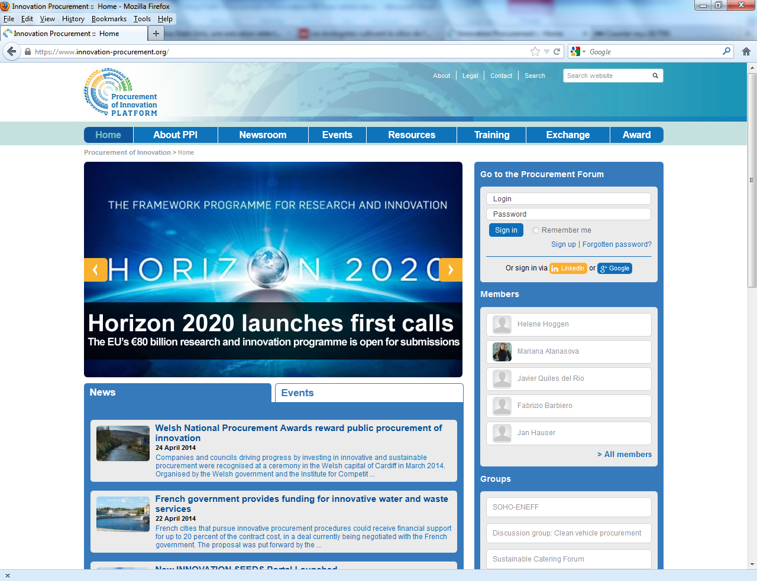

**Annexes**

# Annex 1: Existing European projects supporting PPI

The Commission has provided significant and increasing funding for innovation procurement[38] since 2009, with **direct support** via ‘top-up’ payments to purchaser groups and **indirect support** via accompanying measures including:

* web platform and forum;
* a European Award;
* guidance;
* measuring PPI and PCP; and
* benchmark studies on Member States’ action to support PPI.

In 2009-10, the Commission allocated € 4.5 million to efforts to establish procurer networks. In 2011-12, support for innovation procurement via the creation of ‘innovation purchaser group’ reached € 43 million. In 2013, € 94.5 million was allocated to innovation procurement. The Commission intends to make extensive use of Horizon 2020 funds to further promote innovation procurement in the coming years.

## 

Funded projects and "buyers' groups" of innovations

In 2009, under its policy to support PPI, the Commission launched a first wave of innovation procurer networks in the framework of the Lead Market Initiative. While actual procurements were not expected in their lifetime, the SCI-NETWORK,[39] LCB-HEALTHCARE[40] and ENPROTEX[41] projects did produce significant outcomes.

Following these first pilots, 2011 saw the launch of various calls for proposals for support for public PPI or PCP procurer groups. These led to the formation of a number of ‘innovation purchaser groups’, i.e. consortia of public procurers seeking to procure innovative solutions jointly or simultaneously.

These projects served as references for various guidance documents.

Box 10 — Current PPI co-funded projects by the Commission (2011-15)

|  |  |  |
| --- | --- | --- |
| **Name** | **Coordinator** | **Sector/Solutions Targeted** |
| [HAPPI](http://www.happi-project.eu)  <http://www.happi-project.eu> | Resah Ile-de-France | Healthy ageing (communication, care, mobility, eating, sleeping and personal hygiene) |
| [FIRED-uP](http://www.fired-up.eu)  <http://www.fired-up.eu> | London Fire Brigade | Environmental impact of fire service vehicles |
| [EcoQuip](http://www.ecoquip.eu)  [http://www.ecoquip.eu](http://www.ecoquip.eu/) | UK Dept. for Business, Innovation and Skills | Hospital equipment, consumables and services |
| [SYNCRO](http://www.syncromobility.eu/)  [http://www.syncromobility.eu](http://www.syncromobility.eu/) | Conseil Général de l’Isère | Information systems for road users |
| [SPEA](http://www.speaproject.eu)  [http://www.speaproject.eu](http://www.speaproject.eu/) | Barcelona City Council | Energy efficiency for municipal buildings |
| [Innobooster](http://www.bbg.gv.at/english-information/projects/innobooster-inlife/) http://www.bbg.gv.at/english-information/projects/innobooster-inlife | Austrian Federal Procurement Agency | Office furniture and lighting |
| [Innobuild](http://www.innobuild.eu)  [http://www.innobuild.eu](http://www.innobuild.eu/) | Municipality of Lyngdal | Sustainable building systems |
| [Pro-LITE](http://www.pro-litepartnership.eu/)  <http://www.pro-litepartnership.eu> | Transport for London | Lighting for underground networks, surface transport and buildings |
| [PAPIRUS](http://www.sustainable-catering.eu) | Parque Tecnologico De Bizkaia | Sustainable Construction |
| PROBIS | Parco Scientifico E Tecnologico Per L'ambiente - Environment Park | Sustainable Construction |
| [INNOCAT](http://www.sustainable-catering.eu)  <http://www.sustainable-catering.eu/home> | ICLEI – Local Governments for Sustainability | Eco-innovative catering for schools, health and welfare services and workplace canteens |
| STOP AND GO  http://stopandgoproject.eu | Smart Homes | ICT based telecare services |

Each project involves a number of partners in other Member States and is pursuing its own approach to market engagement and procurement. The lessons learned to date from these projects and case studies are set out in the next section. Readers are invited to follow the progress of the eight projects via the above websites and on the Procurement of Innovation Platform (see below).

Further calls for proposals have resulted in a range of projects across Europe targeting PPI and PCP. The following projects involve joint cross-border PCP with co-financing from the Commission:

Box 11 — Current PCP projects co-funded by the Commission[42]

|  |  |  |
| --- | --- | --- |
| **Name** | **Coordinator** | **Sector/Solutions Targeted** |
| [CHARM](http://www.rws.nl/en/about_us/business_opportunities/charm_pcp/index.aspx)  <http://www.rws.nl/en/about_us/business_opportunities/charm_pcp/index.aspx> | Highways Agency (UK) | Traffic management systems |
| [Smart@Fire](http://www.smartatfire.eu)  <http://www.smartatfire.eu/Home> | Flemish Innovation Agency (BE) | Smart personal protective equipment |
| [V-CON](http://www.rws.nl/v-con)  [http://www.rws.nl/en/highways/v_con](http://www.rws.nl/en/highways/v_con/) | Ministry of Infrastructure and the Environment (NL) | Building information modelling |
| C4BI (networking project)  http://89.152.245.33/dotnetnuke/procurers/en-us/home.aspx | Câmara Municipal de Espinho - Portugal | Integrated answer to the challenge of urban innovation in relation to active aging |
| [TRANFORM](http://www.silverpcp.eu/)  <http://www.transformproject.eu/> | Technology Strategy Board (UK) | To develop the technology that facilitates a learning healthcare system |
| [SILVER](http://www.silverpcp.eu/)  [http://www.silverpcp.eu](http://www.silverpcp.eu/) | Technology Strategy Board (UK) | Robotics to support independent living for the elderly |
| [DECIPHER](http://www.decipherpcp.eu/)  <http://www.decipherpcp.eu> | Catalan Agency for Health Quality and Assessment (ES) | Electronic patient records |
| [PRACE-3IP](http://www.prace-ri.eu/PRACE-3IP)  <http://www.prace-ri.eu/PRACE-3IP> | Jülich Research Centre (DE) | Energy-efficient high performance computing |
| [C4E](http://www.cloudforeurope.eu/)  <http://www.cloudforeurope.eu> | Fraunhofer Institute for Open Communications Systems (DE) | Cloud computing services |
| [IMAILE](http://www.halmstad.se/forskolaskola/kvalitetochutveckling/internationelltarbete/fp7imaileproject.10315.html) <http://www.halmstad.se/forskolaskola/kvalitetochutveckling/internationelltarbete/fp7imaileproject.10315.html> | Halmstads Kommune (SE) | e- learning in the European classroom |
| THALEA  http://www.thalea-pcp.eu/ | University Clinic Aachen (DE) | Intensive Care Units to improve the care for live-threatened patients by telemedicine & telemonitoring |
| ENIGMA  http://www.enigma-project.eu/en/About/Overview/ | Eindhoven (NL) | Public lighting |
| [NYMPHA-MD](https://www.create-net.org/presscoverage/project-nympha-md-was-officially-launched)  https://www.create-net.org/presscoverage/project-nympha-md-was-officially-launched | CREATE-NET (IT) | New models of care for patients with mood disorders |
| [UNWIRED-HEALTH](http://www.ticsalut.cat/innovacio/internacional/en_projectes/15/unwired-health) http://www.ticsalut.cat/innovacio/internacional/en_projectes/15/unwired-health | Fundació TicSalut (ES) | Redesign health care delivery, introducing a mobile care path for consumers |
| [PREFORMA](http://www.preforma-project.eu)  <http://www.preforma-project.eu> | Riksarkivet - National Archives (SE) | Redesign health care delivery, introducing a mobile care path for consumers |
| P4ITS (networking project)  <http://p4its.eu/> | ERTICO - ITS Europe (BE) | Mutual learning between network members; Develop a common approach for PPI amongst ITS purchasers; A better knowledge of PPI amongst the ITS community; Creation of PPI partnerships for C-ITS; More successful PPIs |
| Inspire (networking project)  http://inspirecampus.eu/ | NHG CONSULTING OY (FI) | Create practical impact on the use of the PCP instrument and to strengthen forward looking procurement strategies in the domains of eHealth Active Ageing and Independent Living |

Funding has been granted to many other PPI and PCP projects. For an overview and details of upcoming funding calls, see the [Directorate-General Enterprise & Industry](http://ec.europa.eu/enterprise/policies/innovation/policy/lead-market-initiative/public-proc_en.htm)[43], [Cordis](http://cordis.europa.eu/)[44] and Horizon 2020[45] portals.

## 

# Annex 2: Examples for trans-national and national PPI projects

## [we are clarifying in the light of comments from CNECT]

Example: a call for proposals launched by an MED managing authority

In 2012, a targeted call on *Innovation for renewable energy and energy efficiency solutions in Mediterranean regions and cities*[46] under the MED Programme (for transnational European territorial cooperation) invited applicants to include in their proposals specific action to support innovation procurement.

The call touched on the need to stimulate the demand side, explaining that much had to be done to improve the implementation of existing solutions, either through more targeted and professional public procurement or involving final users more in decision-making, awareness-raising and training. As technologies still needed to be improved, there was major concern about the wider and more efficient use of available solutions.

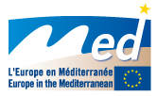

The call stressed that public procurement rules could promote efficiency so as to increase energy savings in the sector in question, spread innovative solutions and boost the transition to ‘smart cities’.

The call invited potential bidders to overcome market failure and increase SME potential by:

* identifying market failures hampering innovation activity in the areas of renewable energy and energy efficiency (misplaced incentives, lack of access to financing, mispricing, lack of information, misinformation or insufficient culture of energy efficiency, etc.);
* proposing operational solutions to unlock markets and harvest the full potential of methods and technologies (awareness-raising and competences, involvement of final users, **smart public procurement**, integrated supply chains, etc.);
* improving SME access to public procurement; and
* promoting innovative contracting procedures (smart public procurement, green public procurement).

It also invited stakeholders to promote the smart management of supply and demand, in order to:

* **enhance the skills and competences of public procurement services** in the areas of renewable energy and energy efficiency;
* **establish networks of public procurers** (to identify needs, analyse markets and demand, draw up standards, make joint investments, etc.);
* **ensure that public demand includes all ‘cost-optimal’ energy efficiency measures and promote them in contacts with business** (better knowledge of solutions available, quality requirements, search for innovative solutions or services, life-cycle analysis, innovative procurement methods, etc.);
* **mobilise, consult and inform final users to better identify needs** and ensure appropriate and efficient use of available technologies; and
* **mobilise intermediary bodies** (chambers of commerce, business centres, innovation agencies, etc.) to contact public institutions so as to improve the quality of public demand.

Fewer proposals and contracts were awarded in relation to PPI than the initial programme managers expected, mainly due to potential applicants’ lack of awareness of this new instrument and its full potential. However, this initiative is the first example of an attempt to include PPI in an INTERREG call for proposals.

Member States supporting PPI and PCP in using the Structural Fund

[DG CNECT will provide another example]

Spain

In June 2011, the Spanish government adopted Law 14/2011 on science, technology and innovation to support PPI and PCP.

The Ministry of Economy and Competitiveness drew up two parallel programmes using internal resources and Structural Funds: INNOCompra[47] (support for procurers) and INNODemanda[48] (support for suppliers). The Ministry also took supporting measures, setting up a PPI/PCP help-desk (September) and producing a guide for PPI/PCP (November 2011).[49]

These moves were in line with the subsequent (February 2013) inclusion of PPI, with earmarked funds of 3 % of the government’s investment budget, in the National Science and Innovation Strategy.



**An example of the INNOCompra programme: PPI in Galicia**

*Context*

The public healthcare sector in Galicia covers 95 % of the 2.8 million population. It has a budget of € 3 400 million a year, which makes up 40.5 % of the region’s total budget.

The healthcare sector owns 14 secondary care trusts and hospitals, 493 primary care centres, 90 emergency centres and over 165 homes for the elderly, and has more than 36 000 employees.

The importance of the sector, coupled with new challenges in the form of a higher percentage of people over 65, increasing rates of chronic disease and the economic crisis, prompted the regional authorities to launch a specific programme, using ERDF funding, to support demand for innovative solutions in healthcare.

*Objective*

The general objective of the programme is to turn the challenges faced by trusts and hospitals in Galicia into opportunities, by:

* switching from a reactive to a proactive model (health promotion, disease prevention, chronicity management, patient empowerment, etc.);
* ensuring continuity between the various levels of care;
* adopting sound methodologies for the evaluation of health impact and cost;
* empowering patients; and
* using ICTs to bring services to patients in their homes.

*Implementation*

The H2050 and *Innova Saúde* project[50] involves spending € 90 million[51] between 2012 and 2015 to provide the Galician public health system with innovative products and services through PPI. € 45 million will be dedicated to the development of innovative solutions, and € 18 million to supporting their procurement.

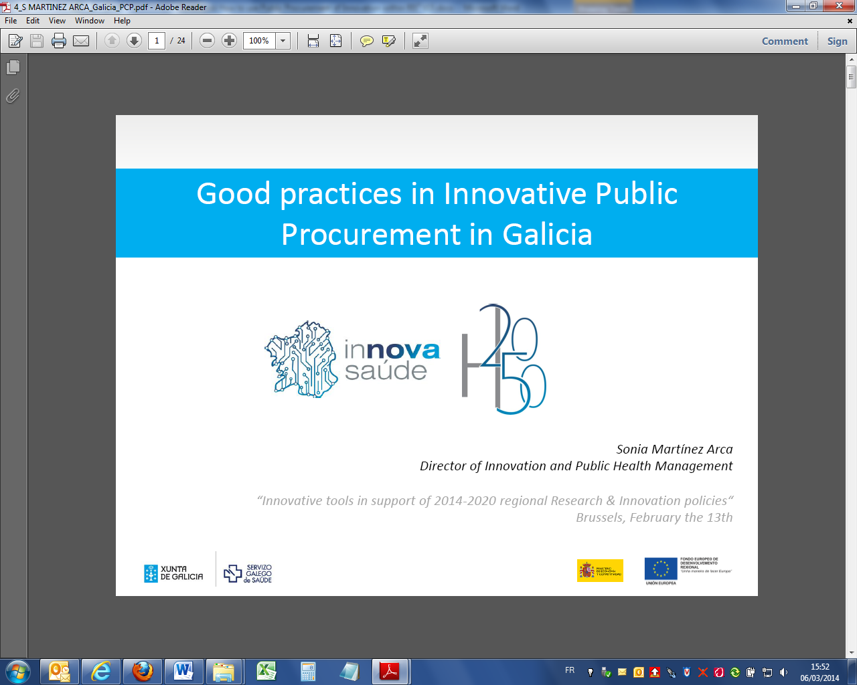

The main actors are the practitioners and patients involved in drawing up, developing and evaluating the plans.

In order to facilitate the use of PPI, the authorities launched an open call for proposals for managing the process, as a result of which the SERGAS online system was adopted; this guarantees confidentiality, transparency and equal opportunities – see:   
<http://www.sergas.es/MostrarContidos_N2_T01.aspx?IdPaxina=60796>

Box 12 — Galicia’s PPI scheme: how did the open call for proposals work?

**

With the SERGAS system, it was possible to set out functional specifications for each sub‑project and prepare technical requirements to be used in the documents for the PPI open tender procedure.

**Technical dialogue: proposals for innovative solutions from the supply side**

Since the launch of the project in April 2012, 296 proposals have been received (228 from private companies and 68 from research entities), involving a total of 107 (public and private) participants.

Box 13 — Number of participants in Galicia’s PPI scheme in 2013

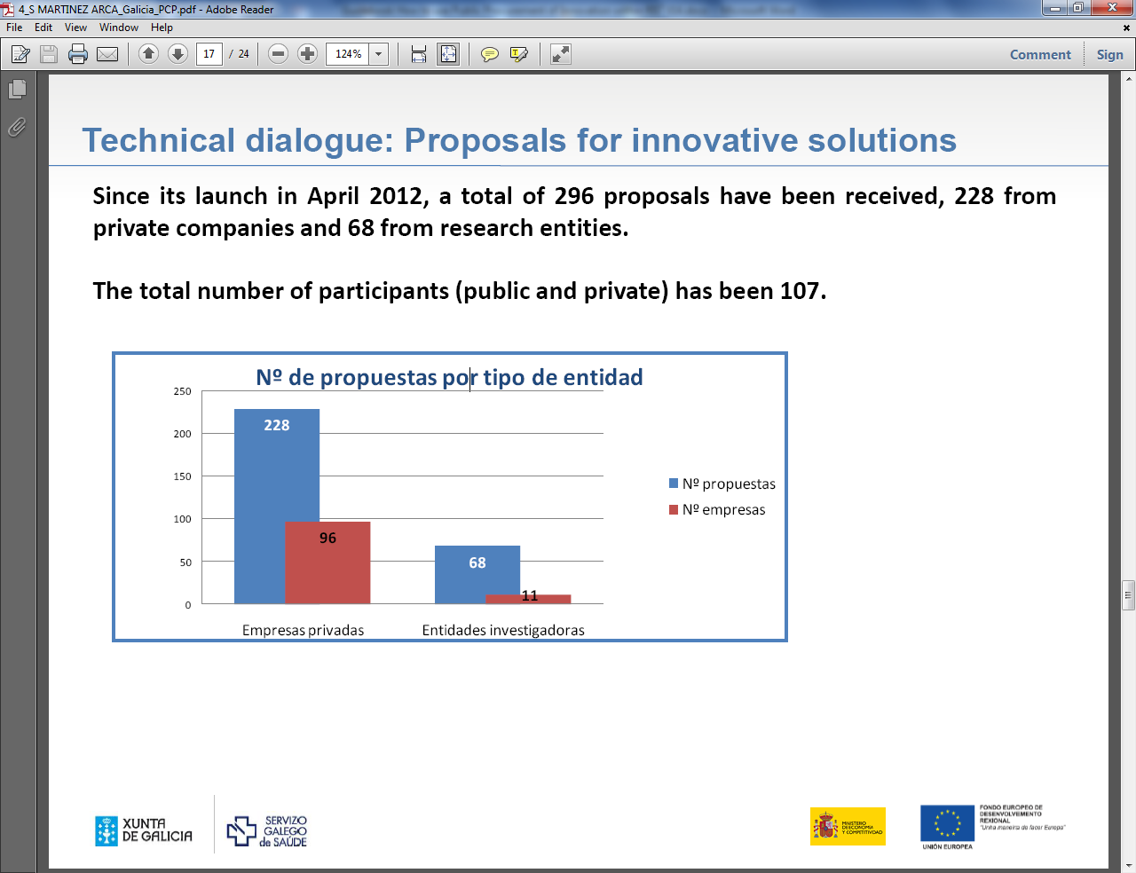

Following evaluation of the proposals received, over 50 % were taken into account in the detailed drawing-up of the various H2050-IS projects.

**Demand-driven ‘tender map’ for H2050 and *Innova Saúde***

The demand-driven ‘tender map’ is an innovative procedure whereby the desired outcomes of each sub-project are outlined, thus helping market suppliers anticipate the needs of procurers and allowing companies to gear their R&D&I efforts to future tenders. Potential suppliers can consult it online:   
<http://www.sergas.es/Docs/H2050_IS/Early%20Demand%20Map%20H2050-IS.pdf>

Box 14 — Demand-driven ‘tender map’ of Galicia’s PPI scheme

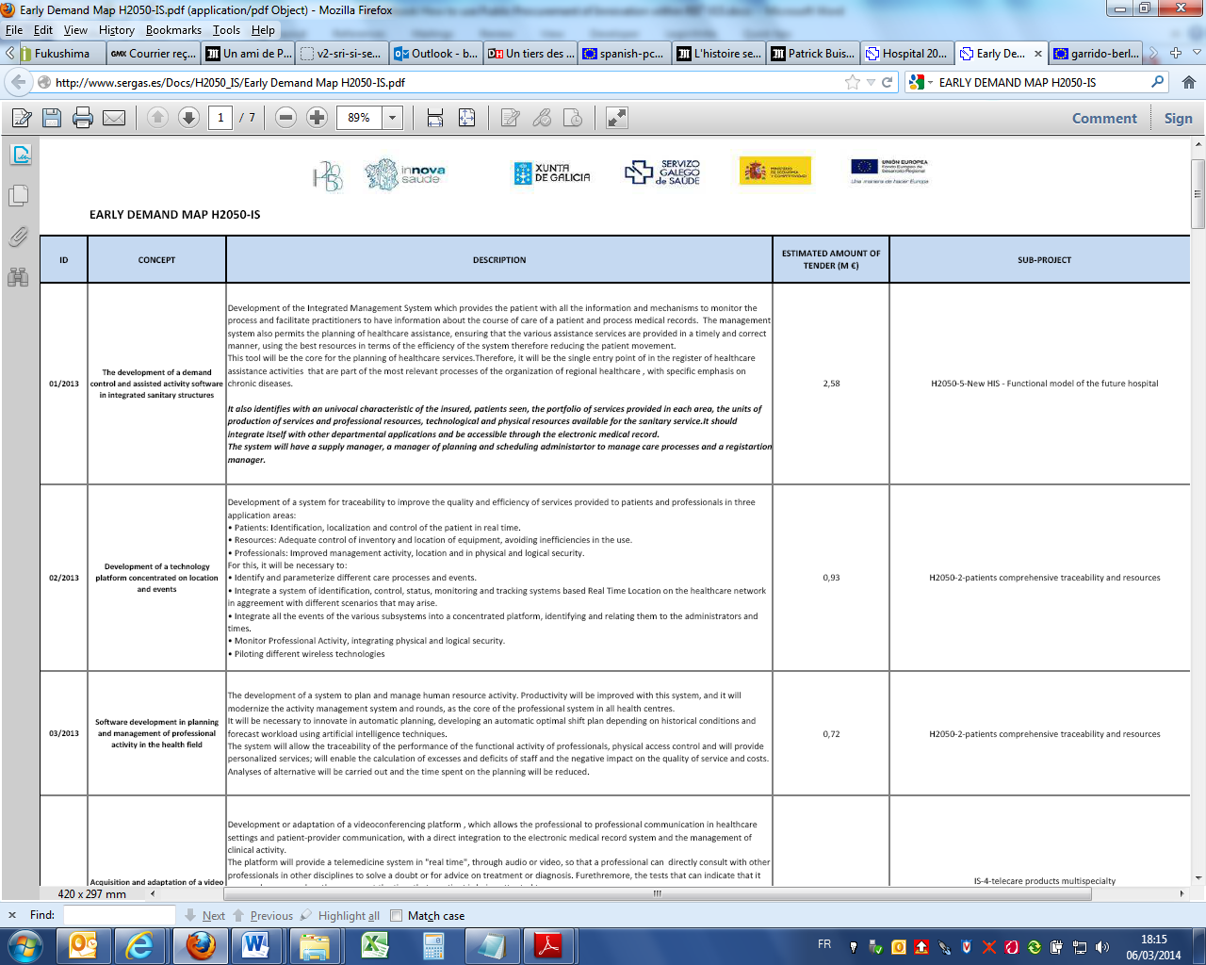

**Information on progress and participation**

Fact-sheets are published on the progress of each project prior to publication of the PPI tender documents. A list of all entities that have submitted proposals for each project is also published.

**In summary**

* In the framework of the Innovation Strategy of the Galician Health Ministry, funding opportunities for incorporating innovative products and services to the health system have been identified: in running this scheme, Galicia is a pioneer in the Spanish healthcare sector;
* Through the use of PPI instruments, Galicia is fostering innovation in companies and helping to strengthen innovative companies at international level;
* The process has been developed via a **technical dialogue** with companies, with a very good response from technology providers;
* Communication among stakeholders and in the PPI ‘ecosystem’ is key.

Box 15 — Communication among stakeholders in the PPI ‘ecosystem’

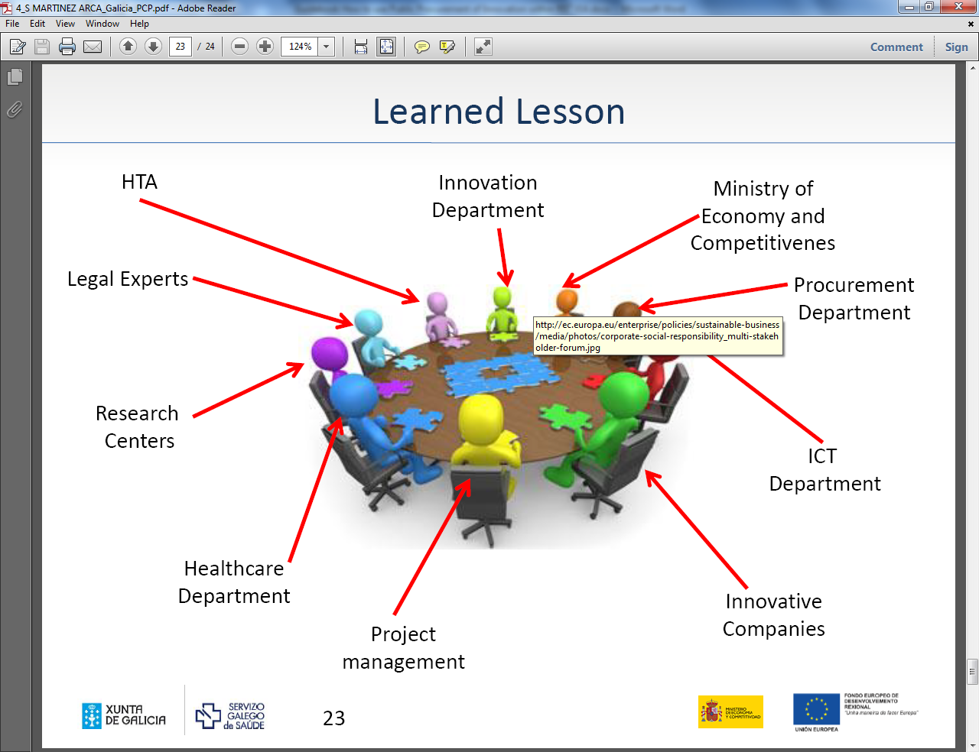

Italy

In 2012, the Italian Ministries of Research (MIUR) and Economy (MISE) issued Italy’s first national call for PCP proposals using the Structural Funds,[52] inviting public authorities from four regions to submit (by June 2013) proposals on topics of public interest requiring new solutions to be developed via PCP.

The call has a maximum budget of € 150 million and focuses mainly on the four ‘convergence regions’ (Calabria, Campania, Puglia and Sicily), which can submit proposals for PCP projects, possibly in cooperation with public authorities from other regions.

The resulting PCP procurements will be coordinated by the Italian Digital Agenda Agency, with financing from the ministries and from the Structural Funds. Up to 20 % of the budget can be allocated to PPI projects.

These four main regions concerned, and others (e.g. Lombardy, Piedmont, Trento) have subsequently developed specific innovation procurement schemes.

Example of regional innovation strategies using PPI as policy tool

Several European regions have adopted RISs showing that a **demand-driven** approach to supporting innovation is central to their policy intervention and that they see PPI as an essential tool in this respect.

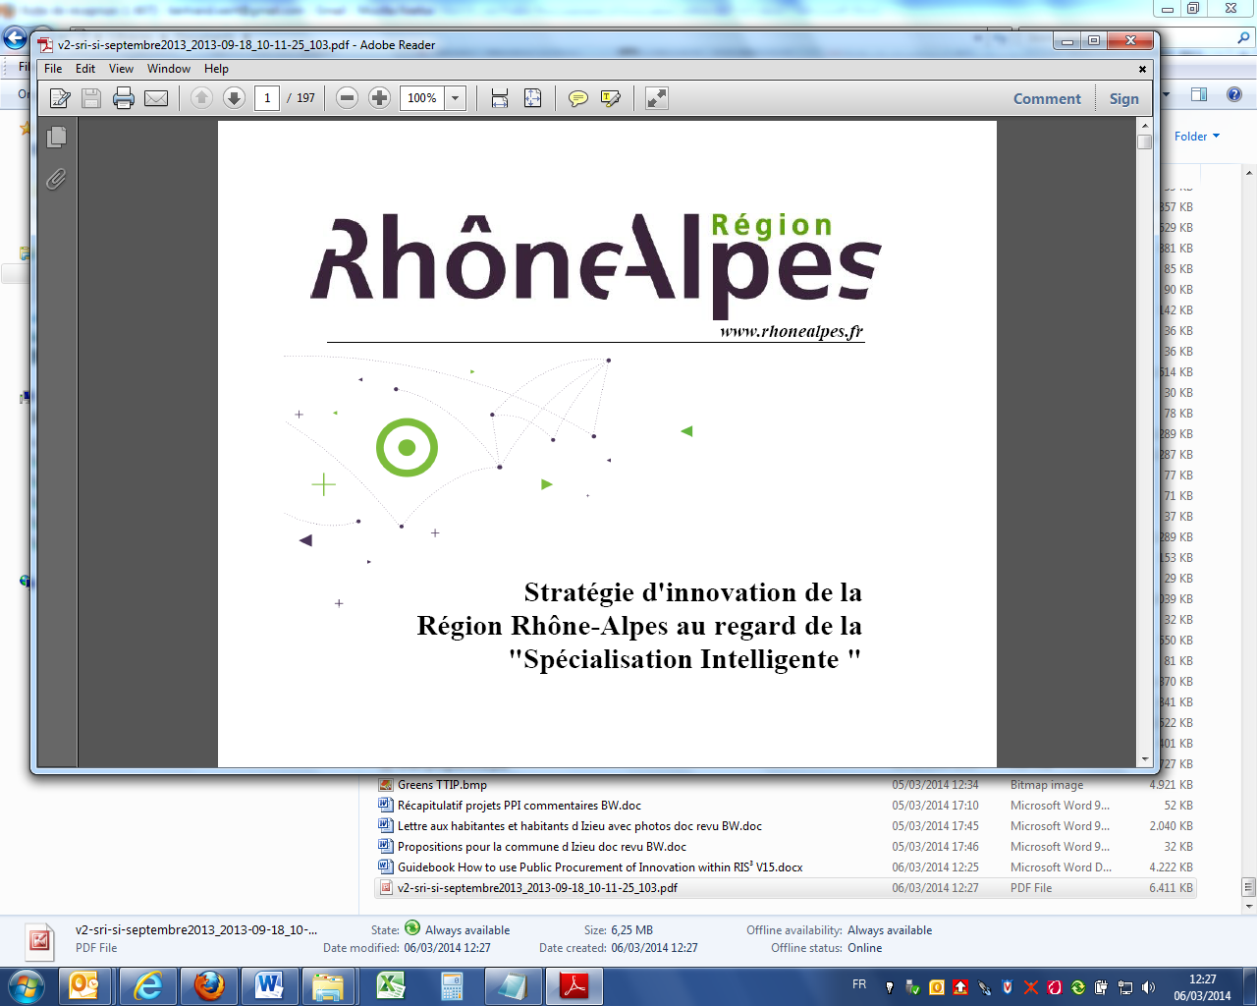

## 

Rhône-Alpes Region (France — 6.2 million inhabitants)

**Innovation procurement** (extract from the RIS)[53]

**CHALLENGES FOR PUBLIC AUTHORITIES AND BUSINESSES**

The purpose of this tool is to boost the *Rhône-Alpes* industrial ecosystem, especially in the smart specialisation sectors. **Many challenges remain for the region and for the local authorities**, including:

* replacing subsidies to businesses by direct funding for R&D, prototypes and/or innovative services to meet the needs identified by public bodies;
* strengthening partnership between the region and local authorities in identifying needs prior to the launch of calls for proposals;
* involving citizens in a ‘living lab’ approach in the testing phase for public‑sector measures; establishing links with the ‘user‑driven approach’ of the RIS;
* making *Rhône-Alpes* a technological showcase and promoting the image of the public services;
* accessing EU funding in the new (2014-20) programming period.

Innovation procurement also presents **numerous challenges for innovative companies** in the region, including:

* financing the prototyping and experimentation phases;
* increasing business opportunities for products and services;
* reducing time-to-market for products and services;
* obtaining labels and certificates from the public purchaser;
* sharing the risks and benefits of design and development between suppliers and procurers.

To meet these challenges, regional public procurers must anticipate constraints, such as the need to involve more actors (e.g. businesses, consumers, other public bodies, research centres) in the consultation phase before launching procurement procedures. They should also ensure that intellectual property rights are managed as effectively as possible (e.g. let IPR rights to suppliers in exchange for royalties, reducing the commercial value of the offer, or allowing free use of prototypes or software).

_

**FUTURE ACTION**

The main purpose of the ‘innovation procurement’ tool is to facilitate the emergence of innovative solutions and enhance the competitiveness of *Rhône-Alpes* enterprises by sharing risks between innovators and public purchasers. To do this, it seems appropriate to interact with innovation partners and regional public purchasers on three levels:

**Level 1: Informing and training regional stakeholders (public purchasers and companies)**

* Planning a regional PPI conference to inform all stakeholders of the innovation ‘ecosystem’ and launch a regional action plan targeting:
  + regional innovation bodies (e.g. chambers of commerce, clusters, innovation agencies); and
  + regional public purchasers (e.g. *Rhône-Alpes* services, urban communities, group of cities, cities, transportation services, airports, hospitals, water and energy management/production services, national (e.g. defence) services in the region, public research institutes);
* Awareness-raising and information activities in the field among:
  + high-schools, transport systems, ICT departments;
  + public purchasers, to change working methods and promote the inclusion of ‘innovation’ criteria and methodologies in procurement procedures;
  + innovative companies, to facilitate their access to public procurement, by developing targeted information systems on the basis of existing technology development networks, clusters and chambers of commerce.

**Level 2: Identifying buyers’ needs and encouraging contact with innovative companies**

* Supporting assessments of regional public procurers’ needs and functional requirements of procurement requiring R&D; and
* Bringing innovative companies and public buyers together to develop awareness of their respective needs; public buyers will be able to influence public support for market stakeholders in the region (e.g. through the SME plan).

**Level 3: Incentive measures for PPI**

* Helping territories and public purchasers assess their needs so that functional requirements can be taken on board ahead of innovation procurement (see Axis 1 of the *Rhône-Alpes* Region RIS: ‘Innovation by usage’);
* Issuing European calls for proposals in relation to PPI;
* And increasing stakeholders’ capacity to participate in European projects.

**Glossary**

Buyers' group of innovation — groups of buyers of innovative products or services can foster innovation by specifying their needs at the appropriate levels on the market. The larger the group, the greater the potential market and therefore the greater the interest for suppliers in meeting ambitious product specifications and delivering more innovative products.

Demand-driven/side innovation — supports the placing of new innovative goods and services on the market, adding an innovation ‘pull factor’ to ‘innovation‑push’ policy measures such as R&D funding.

Escrow agreement— an agreement whereby intellectual property rights or other property is held by a third party (agent), to be released only if certain conditions are fulfilled or events take place. For example, if an innovative design or software code is developed, it may be held in escrow so that a contracting authority can access it if the developer ceases to trade or is no longer in partnership with the authority.

Economically Most Advantageous Tender (EMAT) — procurement award criteria which looks at both qualitative and quantitative aspects of the tender.

*EMFF* — European Maritime and Fisheries Fund

*ERDF* — European Regional Development Fund

*ESF* — European Social Fund

*ESIF* — European Structural and Investment Funds

Forward commitment procurement (FCP) — a procurement model which involves providing the market with advance information of future needs in outcome terms, early engagement and an agreement to launch a tendering procedure in the future to purchase a product or service that does not currently exist, at a specified future date, provided it can be delivered to agreed performance levels and costs.

Framework agreement — an agreement between one or more contracting authorities and one or more economic operators, the purpose of which is to establish the terms governing contracts to be awarded during a given period, in particular with regard to price and, where appropriate, the quantity envisaged.

Indemnity — an approach to reducing risk associated with a contract by requiring either a security against defaults in performance or protection against liability, loss or damage. For example, a supplier may be asked to indemnify the contracting authority against liability arising from the application of a new product or service.

Intellectual property — property which is the result of creativity and to which exclusive rights, e.g. copyright, patents, trademarks or industrial design rights, can be asserted.

Joint procurement — procurement activities undertaken by two or more separate contracting authorities. Many different forms of joint procurement exist, e.g. occasional joint procurement, buying consortia and central purchasing arrangements. New rules on cross-border and other forms of joint procurement are set out in the 2013 directives, clarifying the way in which legal responsibilities can be fulfilled in joint procurement.

Key performance indicators (KPIs) — a set of measures used to assess performance against agreed expectations. KPIs may relate to any aspect of a contract and may be associated with points or other incentive and/or penalty systems.

Life-cycle costing (or whole-life costing) — an approach to calculating costs which includes all costs arising during the life-cycle of a good, service or work (the purchase price and all associated costs, including operating and end-of-life costs). This may also include costs assigned to externalities such as greenhouse gas emissions.

National implementing legislation — the measures by means of which EU directives are incorporated into national law. Following the adoption of the 2013 procurement directives, Member States have 18 months to adopt these measures. The 2013 directives offer a number of policy options, so not all provisions will be implemented in the same way.

Needs assessment — a preliminary activity which identifies the scope of a public authority’s needs in a particular category or to solve a specific challenge. A needs assessment should take future, as well as present, requirements into account and look at the organisation’s capacity to adopt potential solutions. A thorough needs assessment provides a better basis for market consultation, as it will gather data that are relevant to suppliers and identify any gaps.

Performance-based or functional specifications (or output/outcome-based specifications) — an approach to specifying procurement requirements which focuses on the results to be achieved rather than the detailed inputs. For example, instead of specifying that a building needs to have a certain type of insulation or lighting, a performance-based specification could state that it must achieve a minimum energy rating.

Phased contract — a contract which provides for two or more distinct phases and can be terminated without fault at the conclusion of any of those phases. The phases may relate to distinct activities such as R&D, prototyping or the production of a test series or execution of a pilot. The contract may specify the conditions under which the next phase will proceed or this may be left to the discretion of the contracting authority.

Prior information notice (PIN) — a form of notice published in the EU Official Journal which identifies upcoming procurement requirements. A PIN may be used to reduce the time periods associated with tendering, to give the market advance notice of requirements, to initiate preliminary market consultation or as a call for competition.

Project steering group — the team of people responsible for taking decisions within a PPI project. This may be a subset of the project team or sit above it, and will normally include individuals representing different functions within the organisation. It may also involve external experts or stakeholders such as citizens and users of the product or service being purchased.

Prospectus — a document setting out an authority’s current or future procurement needs. A prospectus may be published as part of preliminary market consultations, in order to give suppliers advance notice of upcoming requirements and relevant background information about the authority.

Standards — technical specifications approved by a recognised standardisation body for repeated or continuous application, with which compliance is not mandatory. Procurement specifications may refer to international, European and national standards, provided they are accompanied by the words ‘or equivalent’. Standardisation may also be the culmination of the R&D process for a new product or method.

State aid — an advantage in any form which is conferred on a selective basis to undertakings by public authorities. State aid is prohibited by the Treaty unless it falls within a defined exemption. If a fully competitive procedure has been conducted in compliance with the procurement directives, this will normally create a presumption that state aid does not arise.

*Technical dialogue* — the procedure by which the contracting authority seeks and accepts advice on the contents of all or part of the documents for a tender procedure it intends to announce, provided that such advice does not have the effect of precluding competition.

Variants — a technique for allowing alternative solutions to be considered in the evaluation of tenders. Variants can be allowed in any procedure, provided the contracting authority’s minimum requirements are defined and the contract award criteria can also be applied to variants.

**References**

* ADELPHI, *Strategic Use of Public Procurement in Europe*, final report to the European Commission, MARKT/2010/02/C   
  <http://ec.europa.eu/internal_market/publicprocurement/modernising_rules/evaluation/index_en.htm>
* Aho, E., Comu, J., Georghiou, L. and Subira, A. (2006), *Creating an Innovative Europe: Report of the Independent Expert Group on R&D and Innovation* appointed following the Hampton Court Summit and chaired by Mr Esko Aho. Luxembourg: Office for Official Publications of the European Communities, 2006.
* Edler, J. (2009), *Demand Policies for Innovation in EU CEE Countries*, Paper presented to the INCOM Workshop of the Czech EU Presidency, 22-23 January 2009. Prague: Published as Manchester Business School Working Paper, Number 579   
  http://www.mbs.ac.uk/research/workingpapers
* Edler, J. (2010), *Demand-Oriented Innovation Policy*. In R. K. Smits, S.; Shapira, P. (Ed.), *The Co‐Evolution of Innovation Policy — Innovation Policy Dynamics, Systems and Governance*. Cheltenham: Edward Elgar.
* Edler, J., Ruhland, S., Hafner, S., Rigby, J., Hommen, L., Rolfstam, M., Edquist, C., Tsipouri, Georghiou, L. (2007), *Demanding Innovation Lead markets, public procurement and innovation*: NESTA
* European Commission (2007b), Communication from the Commission to the European Parliament, the Council, the European Economic and Social Committee and the Committee of the Regions COM(2007) 799 final, Brussels, *Pre‐commercial Procurement: Driving innovation to ensure sustainable high quality public services in Europe*
* European Commission (2011), Staff Working Paper, Evaluation Report on *Impact and Effectiveness of EU Public Procurement Legislation*, SEC(2011) 853 final <http://ec.europa.eu/internal_market/publicprocurement/docs/modernising_rules/er853_1_en.pdf>
* European Commission (2012), *Europe 2020 Flagship Initiative Innovation Union*, COM(2010) 546 final,
* European Commission (2012), DG Internal Market, *Public Procurement Indicators 2011*  
  <http://ec.europa.eu/internal_market/publicprocurement/modernising_rules/evaluation/index_en.htm>
* Flanagan, K., Uyarra, E., & Laranja, M. (2011), *Reconceptualising the ‘policy mix’ for innovation*. Research Policy, 40(5), p. 702‐713.
* LCB-HEALTHCARE project (BIS), *Innovation Procurement: Delivering Efficiency, Quality and Sustainability in Healthcare — 10 Messages* (2012)   
  <http://lowcarbon-healthcare.eu/cms/resources/uploads/File/Delivering%20Efficiency,%20Quality%20and%20Sustainability%20-%2010%20messages%20from%20the%20LCB-Healthcare%20pilot%20projects_2012.pdf>
* MBS — University of Manchester, for European Commission (2012), DG Enterprise & Industry, *Developing an evaluation and progress methodology to underpin the intervention logic for the Action Plan to boost demand for European Innovations*
* OECD (2011), Demand-side Innovation Policies, OECD Publishing
* OECD (2014), Intelligent Demand: Policy Rationale, Design And Potential Benefits, OECD Publishing
* OECD, & Eurostat (2005), *The Measurement Of Scientific And Technological Activities Proposed Guidelines For Collecting And Interpreting Technological Innovation Data ‐ The Oslo Manual*, 3rd Edition.
* PwC, London Economics & Ecorys (2011), *Public procurement in Europe Cost and effectiveness*.
* SCI-NETWORK European project (ICLEI), *Procuring Innovative And Sustainable Construction: A Guide For European Public Authorities* (2012)   
  <http://www.sci-network.eu/guide>
* Technopolis (2011), *Trends and Challenges in Demand‐Side Innovation Policies in Europe,* Thematic Report 2011 under Specific Contract for the Integration of INNO Policy TrendChart with ERAWATCH (2011‐12), Contract number x07, Izsak, Kincsö, Edler, Jakob
* Uyarra E., Edler, J., Garcia-Estevez J., Georghiou, L., Yeow J., (2014), Barriers to innovation through public procurement: A supplier perspective, Technovation, <http://www.sciencedirect.com/science/article/pii/S0166497214000388>

1. See Article 2 of the Horizon 2020 Rules for Participation   
   [http://ec.europa.eu/research/horizon2020/pdf/proposals/proposal_for_a_regulation_of_the_european_parliament_and_of_the_council_laying_down_the_rules_for_the_participation_and_dissemination_in_horizon_2020 %20 %282014-2020 %29.pdf#view=fit&pagemode=none](http://ec.europa.eu/research/horizon2020/pdf/proposals/proposal_for_a_regulation_of_the_european_parliament_and_of_the_council_laying_down_the_rules_for_the_participation_and_dissemination_in_horizon_2020%20%282014-2020%29.pdf#view=fit&pagemode=none)
2. See: European Commission (2007b), Communication from the Commission to the European Parliament, the Council, the European Economic and Social Committee and the Committee of the Regions COM(2007) 799 final, Brussels, Pre‐commercial Procurement: Driving innovation to ensure sustainable high quality public services in Europe: <http://ec.europa.eu/invest-in-research/pdf/download_en/com_2007_799.pdf>
3. <http://ec.europa.eu/enterprise/policies/innovation/facts-figures-analysis/innobarometer/>
4.
5. <https://www.gov.uk/government/policies/investing-in-research-development-and-innovation/supporting-pages/using-government-purchasing-power-to-stimulate-innovation>
6. <http://www.agentschapnl.nl/sites/default/files/bijlagen/SBIR%20brochure%20The%20power%20of%20public%20procurement.pdf>
7. <http://www.vinnova.se/en/About-VINNOVA/Strategiska-omraden/Innovation-management/Innovation-procurement/>.
8. <http://hubmiur.pubblica.istruzione.it/web/ricerca/home>
9. <http://www.cdti.es/index.asp?MP=4&MS=0&MN=1&textobuscado=innodemanda&tipo=1&TR=A&IDR=38&tipoO=Contenido&id=1549&xtmc=innodemanda&xtcr=2>
10. <http://www.innovation.gov.au/Innovation/PublicSectorInnovation/Pages/default.aspx>
11. <http://www.bme.de/>.
12. <http://www.redressement-productif.gouv.fr/soutien-a-linnovation-par-lachat-public>
13. <http://www.tem.fi/en/innovations/demand_and_user-driven_innovation/demand_driven_innovation_policy/public_procurement> and <http://www.tekes.fi/en/programmes-and-services/tekes-edistaa-yhteistyota-ohjelmien-avulla/smart-procurement/>
14. <http://www.oecd.org/sti/demand-sideinnovationpolicies.htm>
15. http://www.arca.regione.lombardia.it/cs/Satellite?c=Attivita&childpagename=DG_CRA%2FWrapperBandiLayout&cid=1213588632524&p=1213588632524&pagename=DG_CRAWrappe.
16. Under the Competitiveness and Innovation Framework Programme.
17. <http://ec.europa.eu/internal_market/publicprocurement/modernising_rules/reform_proposals/index_en.htm>
18. Innovation partnership will be transposed in national law to the latest by April 2016 onwards – but that is not financial supported by Horizon 2020 R&D&I programme.
19. See: <http://ec.europa.eu/internal_market/publicprocurement/e-procurement/index_en.htm>
20. See: http://ec.europa.eu/esf/home.jsp?langId=en
21. See: <http://ec.europa.eu/agriculture/index_en.htm>
22. See: <http://ec.europa.eu/fisheries/cfp/eff/index_en.htm>
23. See : <http://ec.europa.eu/regional_policy/information/legislation/index_en.cfm>
24. *Public procurement and cohesion policy*, EP, 2012   
    <http://bookshop.europa.eu/en/public-procurement-and-cohesion-policy-pbBA3112774/?CatalogCategoryID=f.cKABstF7wAAAEjwYYY4e5K>
25. Ibid.
26.
27. A "Guidance for Practitioners on avoidance of common errors in ESI Funded projects" is currently prepared under the lead of DG REGIO which will be available in autumn 2014 on http://ec.europa.eu/regional_policy/index_en.cfm
28. See: <http://ec.europa.eu/programmes/horizon2020/en>
29. See: <http://ec.europa.eu/research/innovation-union/index_en.cfm>
30. And pre-commercial procurement (PCP)
31. See for open calls: <http://ec.europa.eu/research/participants/portal/desktop/en/home.html>
32. See: <http://ec.europa.eu/research/participants/portal/desktop/en/support/research_enquiry_service.html>
33. Extract from the PPI Platform Consortium’s *Public Procurement of Innovation — Guidance for public authorities*
34. See: <http://ec.europa.eu/esf/main.jsp?catId=45&langId=en>
35. i.e. the negotiated procedure without a prior call for competition (Article 30 of the Public Sector Directive).
36. See OECD (2014), *Intelligent Demand: Policy Rationale, Design And Potential Benefits*, OECD Publishing, p.30.
37. See <http://www.pianoo.nl/about-pianoo>
38. Under the 7th Framework Programme for R&D and the Competition and Innovation Framework Programme.
39. [http://www.sci-network.eu](http://www.sci-network.eu/).
40. <http://lowcarbon-healthcare.eu>
41. <http://www.enprotex.eu>
42. <http://cordis.europa.eu/fp7/ict/pcp/projects_en.html>
43. See <http://ec.europa.eu/enterprise/policies/innovation/policy/lead-market-initiative/public-proc_en.htm>
44. See <http://cordis.europa.eu/>
45. See <http://ec.europa.eu/programmes/horizon2020/>
46. <http://www.programmemed.eu/en/download-area/targeted-call-innovationenergy.html>
47. <http://www.idi.mineco.gob.es/stfls/MICINN/Innovacion/FICHEROS/Politicas_Fomento_Innv./Programa_INNOCOMPRA.pdf>
48. <http://www.cdti.es/index.asp?MP=4&MS=0&MN=1&textobuscado=innodemanda&tipo=1&TR=A&IDR=38&tipoO=Contenido&id=1549&xtmc=innodemanda&xtcr=2>
49. <http://www.idi.mineco.gob.es/stfls/MICINN/Innovacion/FICHEROS/Politicas_Fomento_Innv./Guia.CPI.pdf>
50. <http://www.sergas.es/MostrarContidos_N2_T01.aspx?IdPaxina=60796> and the video of presentation <http://www.sergas.es/ContidosPublicados/detallecontido.aspx?idpaxina=60796&idpublicacion=51>
51. € 90 million from the operational R&D&I Plan Technological Fund 2007-13 (80 % ERDF)
52. <http://hubmiur.pubblica.istruzione.it/web/ricerca/home>
53. <http://www.innovation.rhonealpes.fr/SRI/upload/docs/application/pdf/2013-09/v2-sri-si-septembre2013_2013-09-18_10-11-25_103.pdf>