

EUROPEAN

COMMISSION

Brussels,
XXX

[…]
(2014)
XXX

COMMISSION STAFF WORKING DOCUMENT

Enabling synergies between European Structural and Investment Funds, Horizon 2020 and other research, innovation and competitiveness-related Union programmes
*Part 2 *
Guidance for generating synergies between selected project types for research, innovation and competitiveness under directly managed Union instruments and support under the European Structural and Investment Funds

Annex 2

to SWD(2014) … “Enabling synergies between European Structural and Investment Funds, Horizon 2020 and other research, innovation and competitiveness-related Union programmes - Guide to basic principles and concepts”

Guidance for generating synergies between selected project types for research, innovation and competitiveness under directly managed Union instruments and support under the European Structural and Investment Funds
The present document complements the Guide on how to enable synergies between European Structural and Investment Funds, Horizon 2020 and other research, innovation and competitiveness-related Union programmes by describing the main support / project types under Horizon 2020, COSME, ERASMUS+, Creative Europe and the digital services part of the Connecting Europe Facility, and some of the possible scenarios for the combination of funds or other ways of generating synergies.
It aims to help national and regional authorities, including ESIF Managing Authorities, to decide whether a project format or scenario would be suitable for building support forms into the policy mix of their smart specialisation strategies (or into their ESIF programmes) that are aligned with or complementary to the cost models and intervention logic described in the scenarios. It also aims to help the managers of the directly managed EU instruments identifying how possible combinations with ESIF funding could enhance the projects’ impact under their calls.
The selected scenarios represent a non-exhaustive list for the most probable or feasible synergies scenarios. The on-line version of this document may be up-dated and evolve in the course of the 2014-2020 financial period based on experiences to be gained with the new funding instruments and their work programmes.
CONTENT
Introduction 3
1. Horizon2020 9
1.1 R&I Actions 9
1.2 Spreading excellence/widening participation: 18
1.3 Marie Skłodowska-Curie COFUND 23
1.4 ERA-NET Cofund 26
1.5 Joint Programming Initiative 31
1.6 Art. 185 initiatives and ESIF 34
1.7 Art. 187 Joint Technology Initiatives 39
1.8 EIT / KICs and ESIF 44
1.9 Research Infrastructures and ESIF 47
1.10 Pre-Commercial Procurement and Public Procurement of Innovative Solutions 51
1.11 Horizon 2020 Innovation in SMEs 59
2. COSME – the programme for the competitiveness of enterprises and SMEs 62
3. ERASMUS+ 66
4. Creative Europe 74
5. Connecting Europe Facility (CEF) - Digital Services 76

Introduction
Why should national and regional innovation policy-makers know about the different project types in EU programmes?
In order to be able to seize the opportunities for synergies the policy-mix offered to research and innovation actors at national and regional level would have to either complement or replicate the offers for support via directly Commission managed programmes. National and regional authorities, including ESIF Managing Authorities, therefore need an understanding of these project types when designing the policy mix for the implementation of their smart specialisation strategies, including the type of measures, principles for selection and implementation methods that will be funded by their different ESIF programmes. In particular the following should be considered:
(1) Horizon 2020 standard collaborative R&I actions with at least three legal entities from three different countries could be interesting for ESIF Managing Authorities and national & regional policy designers, because:
- Such R&I actions can help implement the international aspects of a RIS3 strategy and provide insights into the quality of R&I projects conceived and the international connection of R&I actors in the region.
- The results of projects under the Research Framework Programmes and Horizon 2020 can be carried further towards market take-up via ESIF support, if in line with the relevant smart specialisation strategy (RIS3).
- If in line with the relevant smart specialisation strategy, ESIF programmes could foresee to fund cost items that are not eligible under Horizon 2020 to give the project more scope or leverage.
- If the ESIF programme monitoring committee agrees and the benefit of the project materialises mainly in the area of an ESIF programme, it might be possible to fund from this ESIF programme a short-listed project proposal for which there was not enough Horizon 2020 budget available (see scenario 1.1.5.). Of course the rules set out in Article 70(2) CPR for such cases must be respected.
Therefore, Managing Authorities and national and regional policy designers could explore – in particular with the help of Horizon 2020 National Contact Points - the different project formats and conditions in view of aligning the cost and project models to them or foreseeing in their ESIF programmes priorities and implementation mechanisms that allow to seize these opportunities, notably:
- Research and Innovation Actions, i.e. actions with research and development activities as the core of the project intending to establish new scientific and technical knowledge and/or explore the feasibility of a new or improved technology, product, process, service or solution - may include basic and applied research, technology development and integration, testing and validation on a small-scale prototype in a laboratory or simulated environment - may contain closely connected but limited demonstration or pilot activities aiming to show technical feasibility in a near to operational environment. The normal Horizon 2020 funding rate for such actions is 100% of the eligible costs (NB: there might be cost items that are not eligible or not included in a Horizon 2020 grant, that could be funded by ESIF).
- Innovation Actions, i.e. actions primarily consisting of activities directly aiming at producing plans and arrangements or designs for new, altered or improved products, processes or services. For this purpose they may include prototyping, testing, demonstrating, piloting, large-scale product validation and market replication. Projects may include limited research and development activities. See: http://ec.europa.eu/research/participants/data/ref/h2020/wp/2014_2015/annexes/h2020-wp1415-annex-ga_en.pdf
- The normal Horizon 2020 funding rate for such actions is 70% of the eligible costs (100% for non-profit legal entities).
- Coordination and Support Actions, i.e. consisting primarily of accompanying measures such as standardisation, dissemination, awareness-raising and communication, networking, coordination or support services, policy dialogues and mutual learning exercises and studies, including design studies for new infrastructure and may also include complementary activities of strategic planning, networking and coordination between programmes in different countries.
In order to make the best out of this, the above-mentioned tracking of calls, participation in international networking activities for policy-makers or for innovation actors, and regular exchanges with the different NCPs are an indispensable first step.
(2) ERA Chairs, Teaming and Twinning actions could be interesting for ESIF Managing Authorities and national & regional policy designers, in particular in less research performing countries, because they are aimed at spreading excellence and widening participation in Horizon 2020.
- They can facilitate the development of centres of competence and the improvement of R&I capacities under ERDF investment priority 1a. Such ESIF support can either be cumulative to the Horizon 2020 grant or subsequent to it once the equipment and infrastructure needs have been identified via the Horizon 2020 project.
- They can help remedying brain drain and attract internationally renowned researchers and professors.
- There may also be potential for synergies between ERA Chairs, ESF programmes, Erasmus+ and Marie Skłodowska-Curie actions thanks for instance to the prestige of an ERA Chair holder who can make an institute more attractive for students and researchers.
If an ERA Chair / twinning / teaming proposal positively evaluated cannot be funded by Horizon 2020, ERDF and/or ESF could be used to implement it. To enable this, the ESIF programmes would have, however, to include relevant priorities and implementation / selection mechanisms.
(3) The Marie Skłodowska-Curie actions (in particular COFUND) and the Erasmus+ type of actions for researchers, student and trainee mobility could be interesting for ESIF Managing Authorities and national / regional policy designers, because they allow to:
- Improve the skills levels in a region (through outgoing mobility) and to prevent or reverse brain-drain by attracting talents to a region (through incoming mobility).
- Experiment with new forms of cooperation between education and research centres and businesses, also with a view to better targeting the education and training offers to the skills needs, which can be crucial for the success of a RIS3.
- support the internationalisation of human resources in education and research.
ESF programmes could be designed in a way to give more foreign researchers and students the opportunity to come to your region or country than would be possible with Horizon 2020 and Erasmus+ budgets only, possibly with similar conditions as the Marie Skłodowska-Curie or Erasmus+ grants to facilitate the application process.
ERDF / ESF programmes could include axis aiming to make regions/MS more attractive for innovation talents, e.g. include among their priorities and implementation mechanisms the development of post-graduate courses, entrepreneurial skills and other training of researchers.
(4) the so-called “Programme Co-fund Actions” (e.g. ERA-Nets) and Article 185 or Article 187 initiatives are aiming to foster collaboration between Member States (and increasingly also regions) and their research and innovation programmes and also pooling private research efforts, in order to make better use of Europe's RDI resources and to tackle common European challenges more effectively. They could be interesting for ESIF Managing Authorities and national and regional policy designers because this objective is also part of the smart specialisation approach and thus relevant for the planning and implementation of the research and innovation investments under ERDF. Via this type of coordination, MA could also make their voice heard in the context of the definition of details of calls for proposals and their timing.
Such actions and initiatives work always at two levels:
- At the first level Horizon 2020 incentivises the pooling / coordination of research efforts into more or less permanent settings. At this level the cumulation of Horizon 2020 with ESIF funding is not possible.
- At a second level the Horizon 2020 tops-up the co-funding to projects that emanate from joint calls for proposals. At this level the same synergies forms with ESIF can be carried out as for the standard collaborative actions under (1).
- A programme co-fund action may also include complementary activities of networking and coordination between programmes in different countries. In the case of ERA-Nets even the launch of a call for proposals that draws entirely on national / regional / ESIF funding is possible.
There are different Horizon 2020 funded support mechanisms to prepare for such actions, for instance:
- Horizon 2020 can fund the coordination costs involved in the Joint Programming Initiatives that have been identified by a High Level Group on Joint Programming and recommended by the Council.
Also European Territorial Cooperation programmes could provide support for the preparation of such co-fund actions (that might emerge also in the context of macro-regional strategies).
(5) the “Knowledge and Innovation Communities” (KIC) under the European Institute for Innovation and Technology can also be interesting for ESIF Managing Authorities and national / regional policy designers, because the KIC-model of cooperation between research and education institutes and enterprises (“knowledge triangle”) and its opening to cooperation and complementarities with other countries is inherent to the smart specialisation approach and can help improving the cooperation among research, education and business in the regions/MS in line with ERDF investment priority 1.b.
(6) Pre-Commercial Procurement (PCP) and Public Procurement of Innovative Solutions (PPI) is a rather new project format and can be interesting for ESIF Managing Authorities and national / regional policy designers, including non-innovation focused policy-designers, e.g. in the field of transport, environment and energy. PCP and PPI type of actions (see specific grant agreement models) offer a win-win situation as they help to develop faster concrete solutions to societal challenges and improve public services and infrastructures, enable cost-savings in the medium to long term e.g. through higher energy savings than standard solutions, while helping innovators to bring their solutions faster to the market.
Joining such Horizon 2020 actions has the advantage that in the case of PCP the developed solutions have better chances to match the needs of the city / region / country. In the case of PPI, the advantage of joining such Horizon 2020 actions is that they help preventing errors as regards the EU public procurement rules and moreover they help drawing up tender specifications that ensure that innovative but technically feasible solutions are procured.
In order to be able to seize such opportunities, ESIF programmers could envisage PPI type of actions not only under ERDF investment priority 1.b, but also under investment priorities related to energy, transport, health, environment, etc., including in the Cohesion Fund parts of their programmes.
(7) Horizon 2020 SME instrument actions and European Research Council “proof of concept” type of grants are interesting for ESIF Managing Authorities and national / regional policy designers, because:
- They are advanced models for innovation support in the case of the SME instrument with different phases, starting from a small lump-sum based feasibility action, stage-gating only the successful projects through to market introduction, which could improve the innovation eco-system in certain countries or regions and improve the impact of public funding.
- As they allow for single participants, proposals positively evaluated that cannot be funded under Horizon 2020 due to limited availability of budget, could be funded from ESIF (in particular EAFRD, ERDF and EMFF) to potentially un-changed conditions. Also the results of the first or second phase of the SME instrument grants under Horizon 2020 could be carried further towards the market via ESIF support if they meet the Horizon 2020 excellence standards. Through this the quality of ESIF research and innovation projects could be raised thanks to the international peer-review of the proposals.
In order to seize these opportunities, the cost and project model in relevant ESIF programmes would need to be aligned to the SME instrument grant conditions. On the Commission side, mechanisms to communicate short-listed Horizon 2020 projects to the MA (e.g. via a “seal of excellence”) are being developed.
(8) The Enterprise Europe Network (EEN) is co-funded from the COSME programme and is of particular interest for ESIF Managing Authorities and national / regional policy designers, because of the special distribution of the EEN centres across all of the EU countries and many regions.
- It offers direct access for SMEs to international business or innovation partners. It also offers advanced high-quality advisory services that could serve as models to be replicated within an ESIF programme’s territory with ESIF funding (e.g. brokerage events)
- Or amplified through offering similar types of internationalisation support under ESIF.
- The Enterprise Europe Network is also charged with providing comprehensive information to SMEs, including directing SMEs towards suitable Horizon 2020 calls and ESIF funding or support opportunities, i.e. they can serve as one-stop-shops also for ESIF SME support that complements the EEN support.
To seize these opportunities, the relevant ESIF programmes would need to provide for the possibility to fund similar or complementary support, e.g. voucher schemes, financial instruments, incubation services, entrepreneurship training schemes, etc.
(9) Creative Europe also offers an interesting potential for synergies to ESIF Managing Authorities and national / regional policy designers, because:
- Technology is often not enough to be a successful innovator. Besides entrepreneurial skills, also creative thinking is central in the innovation process. Cultural and creative activities such as, design related activities and the use of new media can be crucial for innovations to succeed. CreativeEurope projects can be crystallisation points for this and countries / regions could amplify or carry further these projects to achieve a durable impact on competitiveness, innovation and growth.
Also projects from the cultural and creative sectors that initially received ESIF support (including as part of social integration projects under ESF or rural development projects under the EAFRD) could be carried further via the CreativeEurope Loan Guarantee Facility (available as of 2016) provided that they comply with the selection criteria of the action.
Cultural heritage initiatives might also consider the sequential use of Horizon 2020 support for research in the field of cultural heritage preservation and digitisation and CreativeEurope support.
(10) The digital service platforms supported via the Connecting Europe Facility have also a particular interest for synergies with ESIF investments in ICT take-up and improvement of administrative capacities. Investments into e-government solutions under ERDF investment priority 2.c or ESF investments in thematic objective 11 (institutional capacity and efficiency of public administrations) can gain in quality and efficiency if they are designed to be inter-operable with the solutions in other EU countries or at EU level via aligning with the CEF digital services platforms.

1. Horizon2020

1.1 R&I Actions
Why is this interesting for Managing Authorities and national & regional policy designers?
- R&I actions can help implement the international aspects of a RIS3 strategy and provide insights into the quality of RDI projects conceived in a region and the international connection of RDI actors in a region.
- They can optimise the use of research and innovation capacities that have previously been built (see scenario 1.1.3).
- The results of projects under the Research Framework Programmes and Horizon 2020 can be carried further towards market take-up via ESIF support, provided they are in line with the relevant smart specialisation strategy (RIS3) (see scenario 1.1.4)
- When in line with the relevant smart specialisation strategy, ESIF programmes can foresee to fund cost items that are not eligible under Horizon 2020, to give the RDI project more scope or leverage (see scenario 1.1.1 and 1.1.2.)
- If the ESIF programme monitoring committee agrees and the benefit of the project materialises mainly in the area of an ESIF programme, positively evaluated proposals that are not funded for unavailability of Horizon 2020 budget might be funded by the ESIF programme (see scenario 1.1.5.). In such cases, the rules set out in Art.70 (2) CPR must be respected.
Programme Overview:
Horizon 2020 R&I and Innovation actions facts:

Definition: RDII and Innovation actions are collaborative projects carried out by consortia (= a partnership among R&I or Innovation actors, including universities, researchers, enterprises, public bodies etc.) with participants from different countries. Minimum requirement are 3 partners from 3 different Member States or associated countries. The size, scope and internal organisation of projects can vary from action to action.
Implementation:
The (bi)annual Work programme is the basis for Calls for proposals (with or without deadlines). See Horizon 2020 Work Programmes 2014/15.
Besides descriptions of the topics of the calls, work programmes may introduce additional eligibility criteria, specify details on the number of participants, type of participant and place of establishment, lay down further details for the application of the award criteria (excellence, quality and efficiency of the implementation, impact), and specify weighting and thresholds, specify the funding rate for an action, specify that lump sums or scale of unit costs can be used for an action (subject to prior separate Commission Decision) or exceptionally even identify beneficiaries for grants without a call for proposals.
In the case of calls for proposals through funding bodies entrusted with part of the implementation of Horizon 2020 in accordance with Article 58(1)c Financial Regulation (Regulation (EC, Euratom) No 1605/2002), e.g. in the framework of Art. 185 and 187 initiatives, the document similar to the Commission work programmes are called “work plans”.
External selection process based on 3 criteria: S&T Excellence, Impact and Implementation. Scores 1-5 with threshold 3 on single criteria. Only proposals that pass the overall threshold 10 will be on the short list. Only the best ranked proposals on the short list will be funded (for the proposals with lower scores there may not be sufficient Horizon 2020 budget available, even if they are on the short list). For ranking of Innovation actions, impact criterion 2 will be weighted 1.5.
Funding:
Subject to specific provisions indicated in the Work Programme, in principle actions that focus on research with innovation elements will be funded at 100% (see detailed descriptions in the work programme annexes); more market-near Innovation actions are funded at 70%, independent from the beneficiary or activity. Exception: Non-profit organisations are funded at 100% even for Innovation actions and can also include an additional "bonus" salary.
Indirect costs (Overheads): a flat rate of 25% of direct eligible costs (minus subcontracting).
Eligible Cost & Cost/Expenditure Items:
Normally, all costs directly related to a RDI/Innovation action are eligible, but individual calls may specify more details and exclude certain types of expenditure.
A detailed description of eligible costs and budget categories is given in the Model Grant Agreement.
Combined Funding Options: Upstream/downstream sequential funding, simultaneous funding, parallel/additional funding or alternative funding.
Nota bene: the co funding of actions supported by Horizon 2020 cannot come from ESIF (no substitution principle). In particular, in case of an innovation action, the 30% of co-funding to complement the 70% Horizon 2020 funding cannot come from ESIF.
In case of a RDI project with 100% Horizon 2020 funding it might be interesting to explore possibilities for additional activities funded from ESIF to support or expand the Horizon 2020 actions.
Combined Funding Scenarios:
1.1.1 ESIF and Horizon 2020 funds in the same project (Simultaneous/Cumulative use of funds). This new combination is possible in Horizon 2020 (Art. 37 Rules for Participation), provided that the grants do not cover the same cost items.
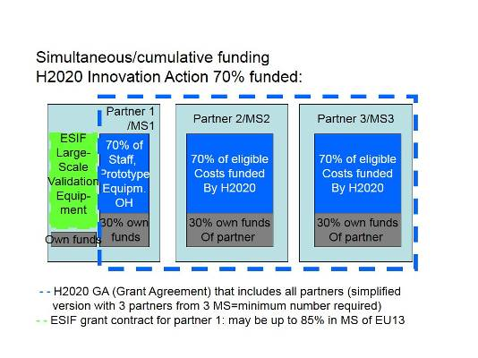
Figure 1 Cumulative funding
Possible form of ESIF investments for this purpose: Funding of specific parts or expenditure items within a Horizon 2020 project (equipment, staff costs for a specific activity etc.). ESIF could fund costs non-eligible under Horizon 2020 (but possible under ESIF) or eligible costs NOT submitted under the Horizon 2020 project, e.g. equipment (see example below). The equipment for large scale validation must not be critical to the project, in case the ESIF funding does not materialise. Alternatively, a guarantee by the MA of Partner 1 as suggested, in case the Horizon 2020 project is accepted, would solve the problem.
NOTA BENE: Costs submitted under another EU funding source than Horizon 2020 (e.g. ESIF) are considered non-eligible costs for Horizon 2020 (see Art. 6.5 b) Model Grant Agreement)
Example: An SME (Partner 1 in Figure 1) is a member of a consortium in receipt of a grant under Horizon 2020 with a 70% co-financing rate for a close-to-market action. The action consists in two activities, prototyping and large-scale validation. The budget of the action is presented per activity and per nature, with three categories, direct personnel costs, direct equipment costs and indirect costs. The company’s personnel are assigned at 80% of their working time to the action.
In this case, the cost items could be the eligible personnel costs for prototyping and the eligible personnel costs for large-scale validation, the direct equipment costs for prototyping and the direct equipment costs for large-scale validation, and the eligible indirect costs.
The application of the Horizon 2020 Rules for Participation implies notably the following:
Personnel costs:
- The remaining 20% working time of the personnel can be assigned to another action (e.g. ESIF action) and may be declared as eligible for another Union grant (e.g. an ESIF grant) since the ‘no double financing principle’ is ensured.
The beneficiary will declare as eligible 80% of its personnel costs and will receive as reimbursement only 70% of those 80% personnel costs. The remaining 30% of eligible costs not covered by the Horizon 2020 grant may not be reimbursed by a grant under the ESIF in accordance to the co-financing principle and the non-cumulative principle (substitution is not possible);
Equipment costs:
- If the beneficiary receives a grant under the ESIF to purchase the equipment necessary to the large-scale validation activities, costs under the item “direct equipment costs for large-scale validation” (including depreciation costs) may not be reimbursed under Horizon 2020. Obviously, other costs related to the action are eligible under the Horizon 2020 grant.
IN ADDITION:
- If instead the beneficiary declares depreciation costs related to a 40% use of one piece of equipment as eligible for the grant under Horizon 2020, the costs of the remaining 60% of equipment use may be declared as eligible for another Union grant under the Financial Regulation;
Indirect costs:
- If the beneficiary receives an operating grant from the Union, it may not declare as eligible any indirect costs, including in the form of a flat-rate (see Model Grant Agreement D.4.E).

While the activities are within one project (the Horizon 2020 Innovation Action), the ESIF support is subject to a separate grant agreement according to the national rules of the MS of the SME partner.
1.1.2 ESIF and Horizon 2020 funding are running in parallel (Parallel use of funds in separate projects) and are mutually supportive
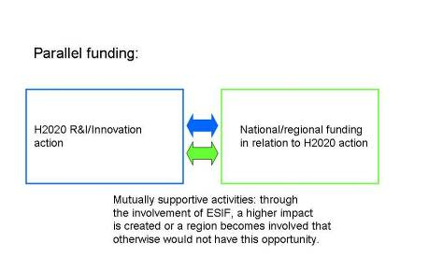
Figure 2 Parallel use of funds

Example: A project proposal on geo-monitoring based soil analysis receives a Horizon 2020 grant. A partner in the project in a rural region obtains EAFRD support to develop more drought/bacteria resistant crops analysing their reactions to specific soil compositions.
While the two projects are legally separate, synergies are developed through the targeted, parallel use of funds.
1.1.3 ESIF investment that enables Horizon 2020 participation (Upstream sequential combination)
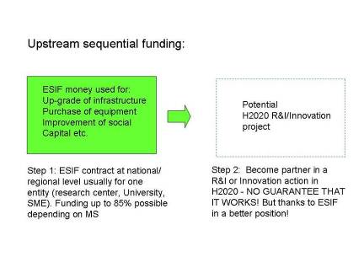
Figure 3 Up-stream sequential funding
Typical form of ESIF investments for this purpose: capacity building in physical capital (construction or improvement of research infrastructures, purchasing equipment (high potential for innovation procurement PCP –PPI), including IT equipment and connections, data storage capacities, etc.), innovation infrastructures (LivingLabs, FabLabs, Design factories, etc.) and social capital (assistance for building networks, clusters and consortia; ERDF investment priority 1a).
Example: MS X provides ESIF money to a university hospital for state of the art IT content management systems and data storage space for patient data, and trains staff in handling this IT equipment. This equipment is needed to being able to exchange patient data and enable patients to handle data themselves in a secure way. The hospital may use this "up-grade" to become a partner in a Horizon 2020 project in Societal Challenges, e.g. "secure societies". While the equipment means a clear advantage, it does not guarantee that the hospital will become a partner in a Horizon 2020 project, or that a Horizon 2020 project will be successful.
Upstream sequential funding is a potential "stepping stone" for stronger involvement in R&I activities.
Regarding depreciation costs, see scenario 1.1.1.
1.1.4 Downstream sequential combination: Horizon 2020 or FP project results are used or further developed with subsequent ESIF investments

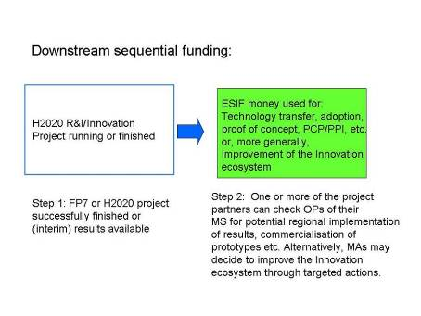
Figure 4 Down-stream sequential funding
Possible form of ESIF investments for this purpose:
A) Support to individual firms or research bodies or consortia of them or public procurers, for carrying out:
- applied research, development and demonstration activities, experimental development, prototyping;
- technology transfer and adoption;
- technology and innovation audits to identify potential demand for RDI results;
- proof-of-concept funding;
- pilot lines for first production;
- pre-commercial procurement projects (RDI procurement followed by public procurement for innovative solutions).
B) Support to improve the innovation eco-system in a territory that facilitates follow-up to successful RDII activities in order to bring them either higher up on the technology readiness level scale or closer to commercialisation, in particular:
- Incubation, financial engineering instruments (loans, guarantees, VC);
- Technology parks, clusters, partnerships between research, education and business, Living Labs, demonstrators, etc.;
- Entrepreneurial and creative skills development for researchers;
- Business advisory services, incl. design, user-involvement methods;
- Support of patenting, licensing and defence of IPR;
- Brokerage events;
- Development of buyer's groups of innovation PCP –PPI starting from needs assessments;
- "Meet the buyers" innovation events.

Example 1:
- A FP7 project developed a prototype for mobile health monitoring. While a pilot has been carried out successfully during the project phase (notably via pre-commercial procurement), the commercial app is not yet ready. The app development can be carried out by two SMEs of the consortium. These SMEs could check via the INFOREGIO website which are the relevant MA for their territory and check with them if their region has a priority on ICT for health (see also in the Eye@RIS3 mapping of the specialisation fields of the RIS3s, as most MS and regions have innovation support programmes that are not ERDF co-funded). If the RIS3 refers to the mentioned domain and the ESIF programme has an appropriate priority and disposes of funds and appropriate implementation mechanisms, the SME or public procurers will be able to apply for ESIF support to develop/procure a commercial app based on the FP7 results. Additionally, the SME of the MS/region will be able to cooperate with stakeholders from other MS/regions if the MA has chosen to use up to the 15% of its ERDF programme for this purpose (respecting the procedure set out in Art. 70(2) CPR).
This downstream sequential funding shows effective exploitation of FP7 results at national/local level.
Example 2:
In the SET (Strategic Energy Technologies)-Plan, the European Commission, Member States and Industry collaborate to define RDII technology "road-maps” that identify RDII projects needed to achieve energy policy objectives.
As an example, the Wind Energy roadmap will identify projects for deep-sea wind platforms, but also work needed for grid interconnection of offshore wind farms, part of a strategic schedule of projects needed to increase renewable electricity production from wind energy sources. Deep-sea wind platforms require new technology to be developed, and would suit the objectives and scope for collaborative R&I Horizon 2020 projects. Offshore grid interconnections may require less RDII, and work will be more specific to the location, so these projects might be better suited to ESIF (ERDF).
Similar examples could be envisaged in relation to existing technology road-maps in the SET-Plan for wind energy, solar energy, carbon capture and storage, nuclear energy, bio-energy and new grid technologies.
This downstream sequential funding option could also be envisaged as parallel funding, if the timeline of Horizon 2020 correlates with ESIF funding timing.
1.1.5 Reorientation of Horizon 2020 projects that were positively evaluated towards ESIF (Alternative funding through ESIF)
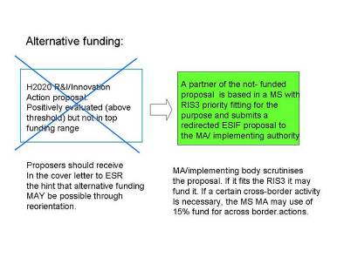
Figure 5 Alternative funding
Possible form of ESIF investments for this purpose: funding of applied research, development and demonstration activities, etc.
Example: A proposal to create a platform for the re-use of Big (open) Data for the benefit of SMEs was submitted, received a positive (above threshold) evaluation but ranked too low to be funded due to oversubscription.
The partner in charge of setting up the Big Data platform for SMEs finds out that this may be a topic under the ESIF programme of his MS. The partner therefore reorients the project towards a local/regional platform for (national open) Data for SMEs.
Extended example: If this partner needs the know-how of an organisation in another country to package the data for re-use on the platform, the MA of the original MS may decide to modify the proposal slightly and sub-contract the provision of this service, if this is in line with the rules for the relevant ESIF programme. The MA may also ask the monitoring committee of the ESIF programmes to give its agreement to the operation including the elements that take place outside the programme area, if the project is to the benefit of the programme area and is within the 15% limit for such operations under the relevant ERDF priority axis. NOTA BENE: As the Horizon 2020 project proposal must include a consortium of minimum 3 partners, the reorientation may be feasible only to those project partners which are eligible to the ESIF programme.

1.2 Spreading excellence/widening participation:
ERA Chairs, Teaming and Twinning
Why is this interesting for Managing Authorities and national & regional policy designers?
- It can facilitate the development of centres of competence and the improvement of R&I capacities under ERDF investment priority 1a. Such ESIF support can either be cumulative to the Horizon 2020 grant or subsequent to it once the equipment and infrastructure needs have been identified via the Horizon 2020 project.
- It can help remedying brain drain and attract internationally renowned researchers and professors.
- Even if a positively evaluated proposal cannot be funded from Horizon 2020, ERDF / ESF could be used to implement it, provided an ESIF programme allows for similar support measures.

Programme overview:
Horizon 2020 Spreading excellence and widening participation facts:
Definition: This Horizon 2020 sub-programme helps to bridge the Research & Innovation divide in Europe: It consists of mainly 3 actions: Teaming, Twinning and ERA Chairs.
The separate actions of Teaming and Twinning will create new (or significant upgrades of existing) Centres of Excellence and expertise and encourage pan-European networking among researchers with a strong focus on excellence and innovation.
ERA Chairs will bring outstanding researchers to universities and other research institutions that have high potential for research excellence. On their side, institutions should mobilise support from different funding sources, including from the European Structural and Investment Funds, to invest in facilities and infrastructures in the context of Smart Specialisation Strategies and commit to institutional change and a broader support to innovation.
Implementation:
(Bi) annual Work programme as basis for Calls for proposals
SEWP Work Programme 2014/15 where also details about funding and maximum amounts of funding can be found.
Applicants (and compulsory coordinators) for all three actions must be from an RDI underperforming MS, i.e. the Czech Republic, Estonia, Slovenia, Hungary, Lithuania, Poland, Croatia, Malta, Latvia, Slovakia, Bulgaria, Cyprus, Romania, Portugal and Luxembourg.
ERA Chairs: single partner application; for any area of S&T, in line with RIS3.
The ERA Chair person selection must be open to researchers from EU and non-EU countries. Max. 5 years, 2.5 MEUR; Coordination and Support Action (CSA) covering 90% of total budget. The Horizon 2020 Work Programme mentions ESIF expressly as potential additional funding source (but under the provisions of avoidance of double-funding).
Funding:
Funding for the salary of the ERA Chair and an associated research team;
Work plan and implementation costs (ERA priorities, training, meetings, publication and patenting costs, etc.). Non-eligible costs for ERA Chairs: research costs, large infrastructures.
Teaming: minimum 2 partners: Applicant organisation from a low performing Member State (for example a national or regional authority, or a research agency at national or regional level; the presence of a local partner research institution is encouraged as it could provide additional relevance to the teaming process) and an excellent research centre.
Two stages: First stage: 12 months; Clear strategy for the new (or up-graded) centre of Excellence including alignment with RIS3, long-term S&I strategy, business plan with SWOT analysis. Commitments from the interested national or regional authorities to commit financial resources need to be provided (e.g. resources coming from the European Structural and Investment Funds).
Second stage: For successful Stage 1 projects: 3-5 years strategy, EUR 15-20 million Grant coverage/Cost item: Administrative costs, staff costs
Non-eligible costs: infrastructure support, large equipment costs
Twinning: minimum 3 partners, applicant plus 2 internationally recognised research centres/universities from 2 different MS and different from applicant MS; in line with RIS3! Coordination and Support Action (Horizon 2020 funds 100 % of the eligible costs), EUR 1 million
Grant Coverage/Cost item:
Funding for short term staff exchange, training, workshops, summer school-type activities, conference attendance;
Non-eligible costs: infrastructure, equipment, new permanent research staff;
Given the different, shorter termed scope of Twinning, combined funding might not be appropriate.
Combined Funding Options:
Upstream sequential/cumulative funding through ESIF for non-eligible costs under Horizon 2020 Teaming and ERA Chair.
Scenario ERA Chair: ESIF used for costs non-eligible under Horizon 2020 (up-stream sequential or cumulative funding)
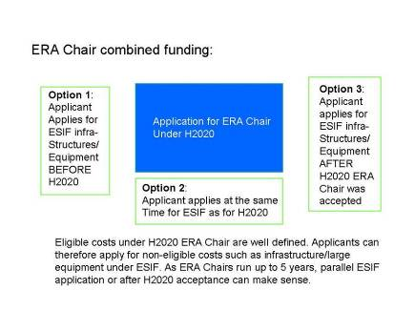
Figure 6 ERA Chair
Possible forms of ESIF investments in support of ERA Chairs:
- Construction or improvement of research infrastructures, etc.
- Research activities and R&I projects and other cost items not co-financed by Horizon 2020.
Example – ERA Chair:
A research institution in Romania applies for an ERA Chair grant. The topic is one of the priorities of Horizon 2020 and the RIS3 of its region. Once the research institution received the information from Horizon 2020 that its application is selected, it contacts the ESIF authorities for ERDF funding for improvement of its research infrastructure, in order to provide better research conditions for the ERA Chair research team.
Alternatively, the applicant organisation can apply for ESIF before or in parallel to the ERA Chair application to avoid time constraints.
Recommendations: The hosting institutions and the MA should explore together the way the institution could contribute to the RIS3 and ESIF programme.
The MA could consider the “label” ERA Chair positively when deciding on spending ESIF money. The MA can make its funding conditional to the acceptance of the ERA Chair project.
Scenario Teaming: ESIF used for costs non-eligible under Horizon 2020 (cumulative or parallel funding)
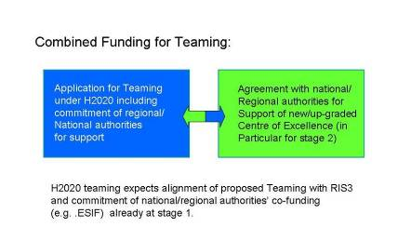
Figure 7 Combined funding for teaming
Possible form of ESIF investments in support of Teaming:
- Construction or improvement of research infrastructures, large equipment etc.
Example – Teaming:
A research agency (with or without a research organisation) in Bulgaria applies for a Teaming project. The focus of the envisaged Centre of Excellence resulting from the Teaming action is one of the priorities RIS3 of its country/region. In order to comply with Horizon 2020 selection criteria, the applicant institution needs to provide a proof from the interested national or regional authorities to commit financial resources (e.g. resources coming from the European Structural and Investment Funds) as appropriate, for implementing the future Centre, in particular regarding investment in infrastructure and equipment.
This investment is particularly crucial for phase 2 of Teaming, i.e. the implementation of the Centre of Excellence.
Remark: The applicant institution and the MA must explore together the way the institution will contribute to the RIS3 and to which purpose and magnitude ESIF can be used.

1.3 Marie Skłodowska-Curie COFUND

Why is this interesting for Managing Authorities and national & regional policy designers?

- It can help remedying brain drain and attract internationally renowned researchers.
- ESF could be used to give more excellent foreign researchers the opportunity to come to the region /MS than possible under Horizon 2020.
- ERDF / ESF could be used to make the region /MS more attractive for research talents, e.g. through development of post-graduate courses, entrepreneurial skills and other training opportunities for researchers.

Programme overview:
Horizon 2020 Marie Skłodowska-Curie COFUND facts:
Definition:
The Marie Skłodowska-Curie (MSC) COFUND scheme co-finances doctoral or fellowship programmes for training, mobility and career development of researchers. Its goals are:
- Stimulate regional, national and international programmes to foster excellence in research training and career development and to improve working/employment conditions for researchers
-Numerical impact and leverage effect
-Encourage regional and national programmes to open for transnational mobility
-Structuring the European Research Area in terms of objectives, evaluation methods and working conditions of regional, national or international programmes in this area.
Implementation:
Annual calls, published in the Marie Skłodowska-Curie Actions (MSCA) Work Programme. (COFUND p.14 ff.)
A sole participant that will be responsible for the availability of the necessary matching funds to execute the proposal. Maximum Horizon 2020 contribution EUR 10 million per applicant per call.
Project duration 3 to 5 years.
Proposed fellowship programmes are encouraged to cover all scientific disciplines ("bottom-up"), but can also focus on specific disciplines provided they allow reasonable flexibility for the researchers. Programmes that prioritise specific scientific disciplines based on national or regional RIS3 strategies will also be supported.
Researchers to be recruited within the programmes are required to undertake trans-national mobility (i.e. move from one country to another)
Funding:
Unit cost contribution to researcher cost and to institutional cost:
Horizon 2020 contribution to living allowance of early-stage researchers with employment contract: EUR 1855 per person-month; for experienced researchers with employment contract: EUR 2625 per person-month
Horizon 2020 contribution to management costs: EUR 325 per person-month
Cost items other than living allowance and management (such as research costs, travel and mobility allowances) may be funded through other resources including EU programmes other than Horizon 2020 e.g. ESIF.
For details see MSCA COFUND Funding Rates.
Combined Funding Options:
Cumulative funding; upstream sequential funding.
Scenario MSCA: ESIF used for costs non-eligible under Horizon 2020
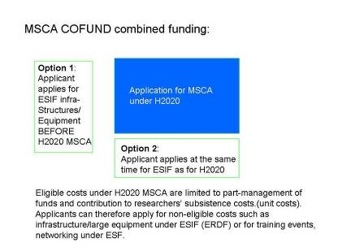
Figure 8 Combined Funding MSCA
Possible form of ESIF investments in support of MSC COFUND: Construction or improvement of research infrastructures, large equipment (ERDF) or training, networking (mainly ESF). COFUND beneficiaries may, in parallel and through other resources than MSC COFUND (for example, ESIF), support researchers that are not transnationally mobile to participate in the Programme.
Example 1 (cumulative funding):
In their Smart Specialisation Strategy, a regional authority in an EU-13 country has identified as weakness a lack of international human resources at universities in its region. As one of the measures to tackle this issue, it decides to set up a funding programme for doctoral candidates from abroad. The main research funding agency in this region applies for MSC COFUND for in total 50 research positions to be divided over the 5-6 universities that are located in this region. Job vacancy notices are drawn up by the universities and are widely advertised, including a description of the work that has an international, interdisciplinary and inter-sectoral dimension. The programme itself is managed by the research funding agency, which is also the beneficiary of the COFUND project. It recruits doctoral candidates for whom MSCA pay the Horizon 2020 contribution per person-month (for living allowance and management cost). The regional authority can fund research, travel and training costs (which are not eligible under MSC COFUND) by ESIF if all ESIF rules are respected.
Example 2 (sequential funding upstream, real life example):
The Czech Republic: ESIF are used to build large research infrastructure and MSC COFUND fellowships to attract researchers.

1.4 ERA-NET Cofund

Why is this interesting for Managing Authorities and national & regional policy designers?

- It can help improving the quality of research and innovation in the region / MS through cooperation and comparison with policy-makers and research funders from other regions.
- It can help implementing the RIS3 as regards smart specialisation priorities for which there is need for complementarities with innovation actors in other regions and MS (e.g. as identified in the framework of macro-regional strategies or thematic RIS3 platforms)

Horizon 2020 ERA-NET Cofund facts:
Definition: The ERA-NET scheme is supporting collaboration between Member States and their research programmes.
It is designed to support Public-Public Partnerships, including Joint Programming Initiatives between Member States (see below under 1.5.) and macro-regional strategies, in their preparation, establishment of networking structures, design, implementation and coordination of joint activities as well as Union topping-up of a trans-national call for proposals.
ERA-NET under Horizon 2020 combines the former ERA-NET and ERA-NET plus.
Activities eligible: one joint call with top-up funding (compulsory); additional option: Implementation of other activities and joint actions including additional calls without top-up funding.
It allows for transnational programme coordination in any part of the entire research-innovation cycle, involving both, MS priorities and Horizon 2020 topics.
Annex on ERA-NET of Work Programme 2014/15
More information on P2P initiatives
Implementation:
Horizon 2020 Work Programmes include ERA-NET Cofund actions; annual calls.
For 2014 (e.g. photonics, health, food security, climate, to mention but a few).
For 2015 (similar topics as in 2014)
Participants in ERA-NET Cofund actions must be research funders: legal entities owning or managing public research and innovation programmes.
5 years duration maximum.
Funding:
Projects resulting from ERA-NET cofunded joint calls are financed by MS with a topping up from H2020.
1. Top-up funding
The cost item for the Horizon 2020 top-up funding is the total public funding of the topped-up joint call. Horizon 2020 funding is a proportional contribution (33%) to the total public funding (as it was the case for FP7 ERA-Net Plus), between EUR 5 and 50 million.
2. Unit costs
The coordination cost for other activities than the topped up joint call takes the form of unit costs per partner per year with a maximum of EUR 29000 (of which 33% or EUR 11,962.5 EU money).
EXCEPTION: Coordination and Support Action (CSA) for preparatory purpose in cases foreseen in the Work Programme and for JPIs.
3. Trans-national Projects from Joint Calls:
At least 2 entities from 2 MS/AS must participate in a project
2 phases of project selection: Phase 1 at national/transnational level (following national criteria); Phase 2 international peer review following Horizon 2020 criteria. Funding according to national rules. A two-step procedure is necessary to ensure that only entities that are eligible for funding under the national programmes involved in the joint call are invited to step 2 and that consortia can balance the requested funding and available funding per participating state between step 1 and step 2.
Combined Funding Options:
Cumulative funding at Level 1 for non-eligible costs within Horizon 2020; Parallel funding at Level 1; parallel funding for third-country participants at level 2.
ESIF can be used for ERA-NET Cofund but no ESIF contribution can be taken into account to calculate the Horizon 2020 contribution (33%).

Scenario ERA-NET:
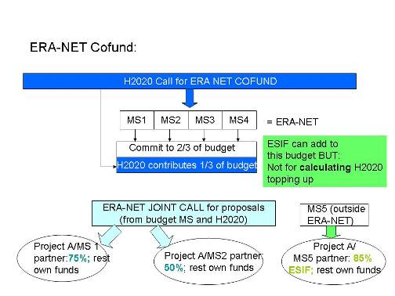
Figure 9 ERA-NET and ESIF
The total budget of the joint call or additional joint calls may include ESIF, provided that they are not declared as eligible costs and are not used for calculating the topping-up by Horizon 2020 grants. ESIF will be used in parallel to the ERA-NET.
Beneficiaries in an ERA-NET joint call research project
Financial support to the participants in the projects selected following joint calls topped-up by Horizon 2020 funds is considered one cost item and subject to State Aid rules which exclude additional funding through ESIF.
If a project stemming from a joint call involves a partner from a MS not participating in an ERA-NET, this partner is usually not funded by the ERA-NET. Hence, it is possible to use the funding for this partner through ESIF. In the above example, MS5 is a less advanced MS which allows for a funding rate of ESIF of up to 85%. Such a partner can only participate in addition to the obligatory 2 minimum partners from ERA-NET MSs/ASs.
Examples for use of ESIF in ERA-NETs at Level 1:
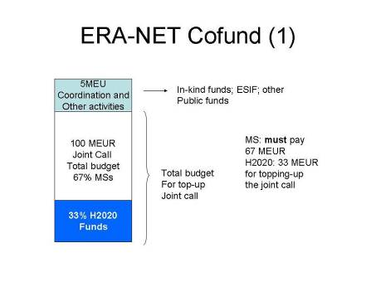
Figure 10 ESIF for Coordination activities
For activities that do not form part of the Horizon 2020 grant agreement, like coordination and management costs of the call that are not eligible under Horizon 2020, ESIF could be used if the national ESIF rules foresee the use of these funds for such purpose.
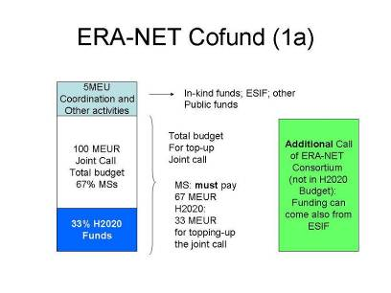
Figure 11 ESIF for additional calls
It is more likely that MSs foresee funding for areas that may be part of an additional call within the ERA-NET (outside the compulsory joint call). Hence, ESIF can be used to finance such calls and subsequent funding of projects. These projects follow national funding rules regarding selection and funding (while selection of joint calls follows the 2-step evaluation process and only then national funding rules).
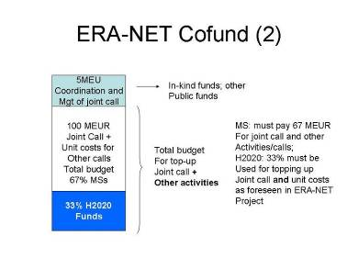
Figure 12 Horizon 2020 for topping-up and unit costs
When considering ERA-NETs in Horizon 2020, Member States will usually contribute with their own budgets to the Joint Call (that is the central element of the ERA-NET) and the costs of additional coordination activities. These budgets will be complemented by additional amounts from Horizon 2020 (in the case of a successful evaluation of this proposal) that will depend on the overall amount of budgets involved: Horizon 2020 reimburses up to 33% of the total of the national budgets involved in the call, and costs for additional activities on the basis of a unit cost.
In order to avoid the risk of any potential double funding, no ESIF money should be used to cover these national budgets (and costs for additional coordination activities) as these form the basis for calculating the Horizon 2020 contribution.
However, projects that will be generated from this Call can later on use additional national funds to which corresponding additional matching ESIF funds could be added. This would require however a very rigorous follow-up and accounting system from the MS involved.

1.5 Joint Programming Initiative

Why is this interesting for Managing Authorities and national & regional policy designers?
- It can help improving the quality of research in the region / MS through cooperation and comparison with researchers from other MS.
- It can help implementing the RIS3 as regards smart specialisation priorities for which there is need for complementarities with research actors in other regions and MS.
- Horizon 2020 can fund the coordination costs involved in the Joint Programming Initiatives that have been identified by a High Level Group on Joint Programming and recommended by the Council.

JOINT PROGRAMMING INITIATIVES facts:
Definition: The overall aim of the Joint Programming process is to pool national research efforts in order to make better use of Europe's public RDI resources and to tackle common European challenges more effectively in a few key areas. Joint Programming is a structured and strategic process among Member States on a voluntary basis with variable geometry. By early 2014 the following JPIs have been launched:
- Alzheimer and other Neurodegenerative Diseases (JPND)
- Agriculture, Food Security and Climate Change (FACCE)
- A Healthy Diet for a Healthy Life
- Cultural Heritage and Global Change: A New Challenge for Europe
- Urban Europe - Global Urban Challenges, Joint European Solutions
- Connecting Climate Knowledge for Europe (CliK'EU)
- More Years, Better Lives - The Potential and Challenges of Demographic Change
- Antimicrobial Resistance- The Microbial Challenge - An Emerging Threat to Human Health
- Water Challenges for a Changing World
- Healthy and Productive Seas and Oceans
MSs agree on a strategic research agenda (SRA) which is a common plan to identify the common research priorities. On a variable geometry basis, MS then jointly implement it by launching Joint Calls and other actions for the priorities identified. They launch these calls with their own public research funding.
Example: JPI on Food, Agriculture and Climate Change (http://www.faccejpi.com). 21 countries cooperate and issue a SRA – Strategic Research Agenda. To implement it, they can issue (national) calls, participate in EU RDI projects (e.g. ERA-NETs) or any other funding (ESIF). JPIs are politically driven by the MSs and a priori do not receive any Horizon 2020 or other Union funding.
Horizon 2020 funding for coordination of JPI:
The Horizon 2020 Work Programme foresees some Coordination and Support Actions (CSA) to coordinate JPIs (6 million EUR are directly dedicated for coordinating JPIs). For details see:
Calls 2014
Calls 2015
Synergies between Horizon 2020 and JPIs
Where the areas being addressed by JPI fit with Horizon 2020 priorities, their instruments may be used to support JPIs where appropriate:
- In general, JPI joint actions will be evaluated on a case-by-case basis to assess whether the EU value-added justifies funding via the ERA-NET scheme.
- Only in cases where a JPI realises significant collaboration as well as scale and scope of achievements could the possibility of an Art. 185 initiative (see below under 1.6.) be considered.
- Coordination activities in a JPI may be supported through CSA (co-ordination and support measures).

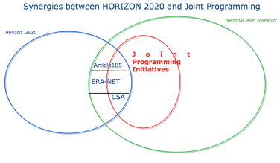
Figure 8 Synergies between Horizon 2020 and JPI
Use of ESIF in JPI
There is no limitation to use ESIF in for joint calls in the framework of a JPI, provided that respondents to Joint Calls observe the rules for ESIF funding and that an ESIF programme foresees such competitive award of research grants. The only exception is when the Strategic Research Agenda (SRA) of a JPI (or part of it) is implemented via ERA-NET or Article 185 initiative. In those cases, the conditions to combine Horizon 2020 and ESIF applicable for ERA-NET and Article 185 initiatives must be met (see 1.4 and 1.6).
Example:
A MS participates in the joint call of JPI JPND (JPI on neuroscience research) on optimisation of biomarkers. Co-funding from ESIF is used to fund the costs of the research centres in the projects under this call (in case of a less developed region co-funding from ERDF can be up to 85%).

1.6 Art. 185 initiatives and ESIF

Why is this interesting for Managing Authorities and national & regional policy designers?
- It can help improving the quality of research and innovation in the region / MS through cooperation and comparison with policy-makers and research funders from other regions.
- Participation in Article 185 initiatives can help implementing the RIS3 as regards smart specialisation priorities for which you need complementarities with innovation actors in other regions and MS. It allows voicing the RDI needs via the governance structure of the initiative and content of annual work plans.

Art. 185 facts:
Definition: Article 185 of the Treaty on the Functioning of the European Union (TFEU) enables the participation of the EU in the joint implementation by several Member States of (parts of) their national (not regional) research and development programmes, including participation in the structures created for the execution of national programmes. They are also used to enhance the complementarity and synergy between Horizon 2020 and activities carried out under intergovernmental structures such as EUREKA and COST.
Art. 185 is applicable in cases where there is a need for a Dedicated Implementation Structure and where there is a high level of commitment of the participating countries to integration at scientific, management and financial levels. Examples under FP7:
- Ambient Assisted Living (AAL)
- Eurostars (Joint research programme for RDI performing SMEs and their partners, undertaken by 33 countries, in the context of EUREKA)
- BONUS ('Joint Baltic Sea Research Programme' is fully aligned with the objectives of the European Strategy for Marine and Maritime Research)
- European Metrology Research Programme (EMRP)
- European and Developing Countries Clinical trials Partnership (EDCTP)
In July 2013, the Commission adopted the Innovation Investment Package that included proposals for European Parliament and Council Decisions on renewed Article 185 initiatives:
- AAL2 (Active and Assisted Living 2),
- EDCTP2 (European and developing countries clinical trial partnership),
- EMPIR (European Metrology Programme for Innovation and Research) and
- Eurostars-2 (Support for RDI performing SMEs within the EUREKA framework).
For more details, visit http://ec.europa.eu/research/era/art-185_en.htm
These proposals are under inter-institutional discussion, with a view to their adoption by the Parliament and the Council foreseen for May 2014.
The Decisions will set up Dedicated Implementation Structures (DIS), legal entities that are in charge of contract and budget management, the development of the (annual) work plans, organisation of the calls for proposals, handling of the evaluation and ranking of proposals for funding. Every Article 185 initiative will have a board or other governing body to steer the implementation of the initiative.
Funding:
There are 2 levels of funding:
Level 1: No grant but contribution to the legal entity through a delegation agreement signed between the Commission and the Dedicated Implementation Structure (DIS).
Union funding usually matches MS funding (50%-50%) with the exception of Eurostars 2 (under EUREKA) where the EU contributes 25% or 33% of the total amount allocated for Eurostars 2 (see final EP and Council Decision for precise rate).
Level 2: For calls issued by Art.185 initiatives’ DIS:
The Horizon 2020 rules for participation apply to Art. 185 initiatives with some derogations foreseen in the basic acts setting up the initiatives. Some Art. 185 initiatives foresee application of rules of the national programmes, provided they are compatible with EU legislation, plus any additional requirements which may be imposed by the Horizon 2020 Rules for Participation, the Decision for the respective initiative and the Delegation Agreement (see also Art. 185 implementation).
Cost Item:
A cost item is to be understood as the amount eligible for Union funding under a budget category.
Combined Funding Options:
Parallel funding at level 1 and cumulative at level 2.

Scenario Art.185 initiative:
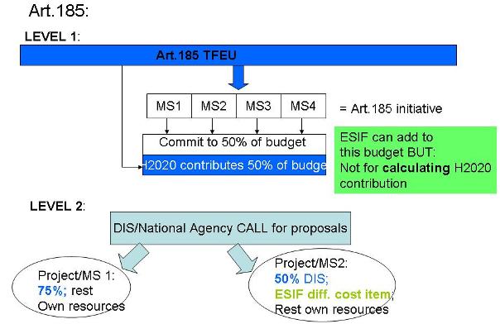
Figure 9 Combined Funding Art. 185
Level 1: National contribution to joint programme
The Union’s contribution to the Dedicated Implementation Structure (DIS) is not provided through a grant. Therefore, the non-cumulative principle does not apply. However, as one main objective of Art. 185 initiatives is to integrate national public research funding, matching contributions from the Participating States to the programme may not come from other EU funding sources such as ESIF. This means in practice that for the calculation of the Horizon 2020 contribution (50% in general, possibly only 25% or 33% for Eurostars-2) only the national contribution per country is counted.
However, this does not prevent the partner countries to additionally allocate ESIF money for this purpose to allow for more projects in the MS to be funded (leverage effect).
ESIF contribution at that level can look like that:
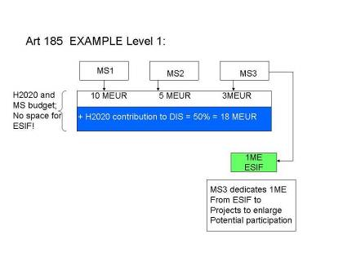
Figure 10 Level 1 ESIF example

Level 2: Beneficiaries in an Art.185 research project
Beneficiaries in research projects stemming from an Art. 185 initiative call are funded according to the national funding rules applicable in the respective MS, including rules regarding State Aid. If these rules allow for additional funding (e.g. through ESIF), this is possible but for different cost/expenditure items (see fig.14 Level 2 example).
EXAMPLE:
A research institute in MS X is specialised in Ambient Assisted Living robotics. To carry out the research work, it receives 50% support for cost items covered by a grant from its National Agency (that is financed with a mix of Union contribution received via the so-called Dedicated Implementation Structure and national funds). For necessary equipment (that is not part of this grant), it applies for co-funding through ESIF (through the relevant Managing Authorities). The remaining % of the budgets is for both grant agreements covered by own resources.
NOTA BENE: MSs involved in an Art. 185 initiative may make additional contributions in kind by putting national or regional research institutions that benefit from ESIF support at the disposal of the Art. 185 projects. In these cases, it must be ensured that cost items covered by the national contribution to the ESIF RDI capacity building action are not double financed by any Horizon 2020 indirect cost support (for instance: clearly separate the purchase and installation of equipment (ESIF) from the running costs (Art.185)).
Scenario Art. 185 Eurostars 2:
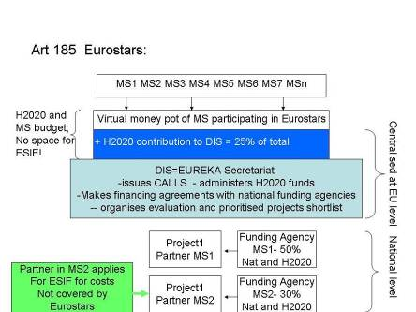
Figure 11 Eurostars 2 combined funding scenario
At programme level MS participating in Eurostars 2 calls commit themselves to contribute with national funds to the call which then is topped up by Horizon 2020 funds (see for exact percentage (25% or 33%) the final version of the Eurostars 2 Decision). At that level, there is no space for ESIF.
At project level (selection according to a prioritised shortlist centrally managed by the DIS (the EUREKA secretariat in this case), MSs foresee funding according to national funding rules. These differ considerably. Hence, depending on the respective MS, there might be space for additional ESIF funding, always provided that no double funding occurs (different expenditure items!).
HOWEVER: Eurostars2 participating MSs can use ESIF (that might provide higher co-financing rates than Horizon 2020) to fund projects that were evaluated positively in a Eurostars2 call (but cannot be funded for lack of Eurostars’ budget) or use ESIF for cumulative funding with self-standing grants for parts of an overall project proposal in line with Article 37 Horizon 2020 Rules for Participation / Article 65(11) CPR (like in scenario 1.1.1. above). This option is only possible if the respective PA (Partnership Agreement) and subsequent ESIF programme foresee the use of ESIF for the Eurostars2-type of projects.

1.7 Art. 187 Joint Technology Initiatives

Why is this interesting for Managing Authorities and national & regional policy designers?
- Contacts with companies in the territory that participate in the JTIs can facilitate the implementation of the RIS3 in particular as regards the stimulation of private RDI investments and the generation of critical mass and complementarity with the ESIF and national / regional investments in other MS and regions.

Art. 187 facts:
Definition:
Joint Technology Initiatives (JTIs) are public-private partnerships (PPPs) on a long-term basis providing a combination of private and public funding for selected fields of technology. The research funding programme is implemented through a funding body, the JTI Joint Undertaking (JU), which funds indirect actions in accordance with the Horizon 2020 Rules for participation, mainly through competitive calls for proposals.
The aim is to increase the competitiveness of the European industry in these technology fields. These initiatives mainly result from the European Technology Platforms (ETPs) that were set up at the time of FP6.
The JTIs JU are set up by the Council through the adoption of individual Council Regulations (The JTI JU basic acts). Under FP 7 the Council adopted 6 JTIs:
• Innovative Medicines Initiative (IMI)
• Nano-electronics (European Nano-electronics Initiative Advisory Council - ENIAC)
• Embedded systems (Advanced Research and Technology for Embedded Intelligence Systems - ARTEMIS)
• Air Transport (Clean Sky)
• Fuel Cell and Hydrogen Initiative (FCH)
- Shift2Rail to contribute to the implementation of the strategic research plan for the European rail system
Future JTIs proposed and discussed at inter-institutional level (Status: March 2014):
- Innovative Medicines Initiative 2
- Fuel cells and hydrogen 2
- Clean Sky 2
- Bio-based Industry
- Electronic components and systems (ECSEL, combining ARTEMIS and ENIAC)
The JUs will be in charge of contract and budget management, the development of the (annual) work plans, organisation of the calls for proposals, handling of the evaluation and ranking of proposals for funding. Every Article 187 initiative will have a board or other governing body to steer the implementation of the Joint Technology Initiative.
FUNDING: Public/private funding, typically between 25% and 50% from Horizon 2020, and rest from industry; in case of ECSEL, there are also direct financial contributions from the MSs and possibly also from countries associated to Horizon 2020.
At the level of the JU (Level 1) no combined funding is envisaged.
According to the draft basic acts of some JTI JUs under Horizon 2020, it is also expected that the private partners provide “in-kind” contributions consisting of the costs incurred by them in implementing additional activities outside the work plan of the JU, contributing to the objectives of the Joint Technology Initiative. In this case, other Union funding programmes may support these costs in compliance with the applicable rules and procedures. However, in such cases, Union financing shall not substitute the regulatory “in-kind” contributions from the private (or in the case of ECSEL public) partners. The costs relating to additional activities shall not be eligible for financial support by the Joint Undertaking.
At the level of the indirect actions (“projects”, Level 2), there will also be in-kind contributions by the private partners, consisting of the costs incurred by them in implementing these indirect actions less the contribution of the Joint Undertaking and any other Union contribution to those costs.
COST ITEM:
Projects financed through grants under a JTI/JU, can enjoy combined funding, provided that double funding is avoided (different cost items funded by different grants).
COMBINED FUNDING OPTIONS: Simultaneous funding (JTI2 ECSEL example) and parallel funding (JTI 1 example).

Scenario JTI 1: Parallel funding at level 2
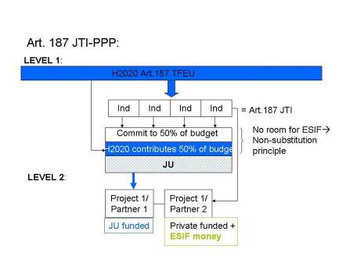
Figure 17 JTI and ESIF at level 2
JTIs are Public-Private Partnerships that combine funding contributions from industry and Horizon2020. Hence, when setting up the fund for the Joint Undertaking, the private (and in the case of ECSEL: public) funds cannot be substituted by ESIF.
However, to enlarge the potential of research projects under the JU, ESIF funds may be used as described under 1.1. (depending on national funding rules, ESIF priorities and State Aid rules).
Example:
EUR 1.8 billion are committed by industry. Of this, EUR 0.9 billion are combined with EUR 0.9 billion from Horizon 2020 to fund the projects emanating from the calls launch via the JU.
The other EUR 0.9 billion coming from the industry are invested in other projects, e.g. demonstration and flagship plants co-funded by EUR 0.9 billion from ERDF (or at other co-financing rates, depending on State Aid limitations and the relevant ESIF programme).
Scenario JTI 2: ECSEL cumulative funding – level 2, different WPs:
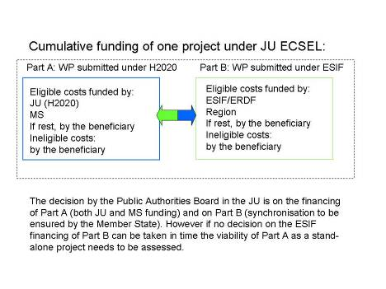
Figure 18 Simultaneous funding - ECSEL
The ECSEL JTI combines funding from industry, Horizon 2020 and Member States.
Projects under the ECSEL JU are usually divided in Work Packages and tasks, to which the partners allocate a budget. Hence, a work package and an allocated funding can be submitted under either Horizon 2020 or ESIF as the budget for each WP can be considered one cost item.
Some points need attention:
- The proposal that is submitted consists of Part A and Part B and includes the total financing plan
- Part A of the proposal is evaluated by the JU – under the assumption that there will be financing for Part B. Part B of the proposal is evaluated by the Member State or Region concerned using the rules applicable in the Member State (and the relevant ESIF programme, if ESIF co-financing is envisaged).
- The decision by the Public Authorities Board in the JU is on the financing of Part A (both JU and MS funding) and on Part B (synchronisation to be ensured by the Member State). However, if no decision on the ESIF financing of Part B can be taken in time, the viability of Part A as a stand-alone project needs to be assessed. Please note that for part B MS and regions may consider pooling the ESIF funding from different countries / regions in line with Article 70(2) CPR that allows ESIF investments outside the EISF programme areas under certain conditions (see scenario 1.1.5.).
- To determine whether or not a project needs to be notified for State Aid purposes the sum of 'A MS funding', 'B ESIF' and 'B Region' needs to be taken. The 'A JU (Horizon 2020) Funding' does NOT need to be added to this sum.
- The two essential conditions no profit from public funding and no double funding are in this model easy to verify. The latter is ensured by the project set-up. The former is ensured by reimbursement rates that are applied – the reimbursement rate by the JU (Horizon 2020) and the MS cannot exceed the maximum reimbursement rate from Horizon 2020 and is calculated on 'A eligible'.
Monitoring by the JU will only cover Part A (not part B), but the governing board of the JU should be kept informed about the implementation of part B and the MAs should vice-versa be informed about the progress with part A.
Please note that ESIF/ERDF Managing Authorities cannot be obliged to co-fund plants planned by a JTI. Their funding decisions depend on the ESIF programme priorities and those of the relevant RIS3. It is strongly recommended to discuss with the relevant MA even before conceiving the project proposal and its A and B parts.
Scenario Combined Funding in large investments in KETs observing State Aid rules - example ECSEL
- Total investment: EUR 6 billion
- Project separated in EUR 2 billion pilot line plus EUR 4 billion investments for manufacturing.
  - Pilot line: the pilot line project has clearly separated cost items that allow to attribute them to either the JU (Horizon 2020 plus industry or own national / regional funding) or ESIF plus industry or national / regional funding. State Aid intensities for experimental development + collaboration could be as high as 25% + 15% = 40%; 40% = EUR 800 million; assuming that for clearly identified cost items of the pilot line construction an ECSEL Participating State or a Region will provide 25% own funding (combined with ERDF funding), while the ECSEL JU will provide for the remaining cost items further 25% (Horizon 2020) that do not constitute State Aid combined with private industry funds.
This means that half of the pilot line is funded by industry funds. The other half in this example would be funded by Horizon 2020 and ESIF.
  - Manufacturing: 10.5% of EUR 4 billion = EUR 420 million
In total: EUR 1420 million or 23.66% of the total investment.

1.8 EIT / KICs and ESIF
European Institute for Innovation and Technology (EIT) and Knowledge and Innovation Communities (KIC)
Why is this interesting for Managing Authorities and national & regional policy designers?
- KIC participation can help implementing the RIS3 as regards smart specialisation priorities for which there is need for complementarities with innovation actors in other regions and MS.
- The KIC-model can help improving the cooperation among research, education and business in the region in line with ERDF investment priority 1.b.

EIT /KICs facts:
Definition: The EIT’s mission is to contribute to sustainable European economic growth and competitiveness by reinforcing the innovation capacity of the Member States and the Union in order to address major challenges faced by European society. It shall do this by promoting synergies and cooperation among, and integrating, higher education, research and innovation of the highest standards, including by fostering entrepreneurship.
A KIC is a highly autonomous partnership of top-class higher education institutions, research organisations, companies and other stakeholders in the innovation process that tackles societal challenges through the development of products, services and processes and also by nurturing innovative entrepreneurial people.
Co-location Centres (CC) are parts of a KIC, embedded in a regional or local context.
Goals: Integrating the knowledge triangle HE/Research/Business:
-from idea to product
-from lab to market
-from student to entrepreneur
Activities include:
KICs carry out a whole range of activities, covering the entire innovation chain – including training and education programmes, reinforcing the journey from research to the market, innovation projects and business incubators.
EIT Strategic Innovation Agenda
Principles for financing, monitoring and evaluation of KICs: define the principles and details on the functioning of the EIT funding model and the principles and design of the EIT's monitoring system.
Framework of Guidance: is intended to help those interested in forming a KIC. This document presents what the EIT is and how it works, what the KICs are and how they work, and what makes a KIC successful. Based on the lessons learnt since the establishment of the EIT and its first three KICs, it also contains tips on starting a KIC and key information what happens after the designation of new KICs including the EIT and KIC contractual relations, the EIT funding model and the EIT monitoring system. It mentions ESIF for funding of KIC activities, including the "RIS – Regional Innovation Scheme" (not to be confounded with RIS3!) that promotes the engagement of KICs with the wider Innovation community.
Themes:
The existing KICs concern Energy, ICT and Climate Change. The new KICs will be established in three waves, starting in 2014 with “Healthy living and active ageing” and “Raw materials”, followed in 2016 by “Food4Future” and “Added value manufacturing” and in 2018 by “Urban mobility”.
Call for KICs 2014
FUNDING:
As set in the EIT Regulation, the EIT funding on average may not exceed 25% of a KIC's overall funding, which means that the remaining minimum 75% must come from non-EIT sources.
For KIC Added Value Activities (KAVAs, i.e. activities contributing to the integration of the knowledge triangle of higher education, research and innovation, including the establishment, administrative and coordination activities of the KICs, and contributing to the overall objectives of the EIT) the EIT grant may cover up to 100% of the total eligible costs).
Other KIC activities, the so called KIC Complementary Activities (KCAs), are not financed by the EIT grant, but must come from other sources, such as, in particular, the ESIF and Horizon 2020). KCAs must contribute to the implementation of the long term strategy of the KIC and relate to at least one KAVA.
EIT can use around 5% of its budget (2014-2020) for dissemination and outreach activities (including the financing of the mobility actions under the Regional Innovation Scheme).
KIC partner organisation centres can also participate in RDI programmes.
Horizon 2020: EUR 2.7 billion for 2014-2020 for EIT
Combined funding scenarios: Using ESIF for complementing KIC “added value activities”.

Scenario EIT/KIC: Using ESIF for complementing KIC added value activities
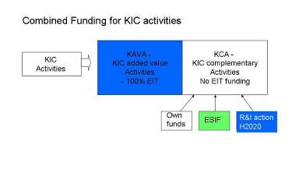
Figure 19 ESIF for activities not funded by EIT
While KICs are funded up to 100% by EIT for the so-called “added value activities”, the "complementary activities" are not funded by EIT. It is up to the KIC to find funding sources for these activities. Amongst them can be ESIF (if the activities correspond to ESIF priorities in the region of the KIC), but also RDI actions within Horizon 2020.

1.9 Research Infrastructures and ESIF

Why is this interesting for Managing Authorities and national & regional policy designers?

- It can help prepare better for the construction or up-grade of research infrastructures under ERDF investment priority 1.a.

Research Infrastructures: ERIC/ESFRI/”major projects” facts:
Definition:
Research infrastructures are facilities, resources and services that are used by the research communities to conduct research and foster innovation in their fields.
RIs are a key instrument in bringing together a wide diversity of stakeholders. They offer unique research services to users from different countries, attract young people to science and help to shape scientific communities. RIs are part of the knowledge triangle of research, education and innovation, producing knowledge through research, diffusing it through education and applying it through innovation.
Activities funded under Horizon 2020 RI grants foster the innovation potential of research infrastructures, for example by reinforcing partnerships with industry, transfer of knowledge and other dissemination activities, use of research infrastructures by industrial researchers, and involvement of industrial associations in consortia or in advisory bodies.
Research Infrastructures (RIs) are natural candidates for synergies as they involve national/regional research centres in priority disciplines, often trans-territorial, and involve a high budget for planning and implementation. Existing research infrastructures already use the different financing schemes.
WP 2014/15 of Horizon 2020 regarding research infrastructures including e-infrastructures: The Work programme specifically mentions the potential synergies with ESIF (p.53); many thematic areas include research of/into national or regional research activities. Most of these topics will be implemented via R&I, Innovation actions or Coordination and Support Actions (CSA).
More info on research infrastructures on the Horizon 2020 website dedicated to Research Infrastructures.
ESFRI – “European Strategy Forum on Research Infrastructures” was established to support a coherent approach to policy-making on Research Infrastructures in Europe.
ESFRI is a coordination body to agree on a set of research infrastructure initiatives of European added value (the so-called ESFRI roadmap). ESFRI has an incubator role, the implementation can be carried out via ESIF or Horizon 2020 (and subsequently, often national/regional resources). Support will be provided for central coordination, operation, access provision, enlargement of the membership, training and innovation activities. Activities can include setting up and initial running of the central coordination office, enhancement of the technical architecture, detailed RDI and engineering work, development of innovative components, users' access, data management (including possible open access to data), inter-operability, standardisation, outreach, training and international cooperation.
EGTC - European Grouping of Territorial Cooperation (=legal instrument designed to facilitate and promote transnational and interregional cooperation and to give these consortia a legal personality). Currently no EGTC is involved in managing research activities but potentially will in the future.
For “Major projects” under ERDF (= operations of EUR 50 million or more total eligible costs comprising a series of works, activities or services intended in itself to accomplish an indivisible task of a precise economic or technical nature with clear goals which may be research infrastructures) please note:
- major research infrastructure projects need to be referenced in the ESIF programme’s indicative list of major projects
- they have to be in support to the RIS3 priorities
- they have to be in line with the indicative multi-annual plan for budgeting and prioritization of RI investments (ex ante conditionality 1.2.).
A Managing Authority (MA) can request assistance from JASPERS, technical assistance facility set up with REGIO support. JASPERS assists in producing mature project proposals compliant with EU requirement. See: http://www.jaspers-europa-info.org/index.php/what-we-offer.html
Network of National Contact Points for RI under FPs: http://www.euroris-net.eu/
By the nature of RI, combined funding will be either sequential or parallel. For RDI or Innovation actions, combined funding scenarios as described under Horizon 2020 multi-country projects are possible.

Scenario RI 1: Sequential funding from different sources
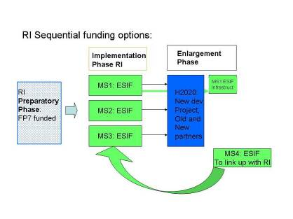
Figure 12 RI Sequential funding options

The RI scenario is best explained by a real-life example that is currently running:
Extreme Light Infrastructure (ELI)
Sequential funding:
- FP7 supported preparatory phase of ELI
- Currently, implementation is co-funded by ERDF in the respective MSs -Hungary, Romania and the Czech Republic. Please note that as of 2014 only ESFRI projects that fit into the relevant smart specialisation strategy may be supported from ERDF.
- In case ELI proves useful for the RIS3 of the relevant country, for enlarging to other players or involving SMEs, Horizon 2020 or ERDF funds can be used: Horizon 2020 for the joint development of parts of ELI not yet funded; (running costs of existing RI and fees for using existing RI such as CERN are NOT eligible under ERDF). ESF could be used to up skill the researchers in ELI, e.g. giving them training in entrepreneurial skills.
- Horizon 2020 could provide risk capital to possible spin-offs from ELI.
Future management structure of ELI: ERIC is planned.

Scenario RI 2: Parallel ESIF Funding
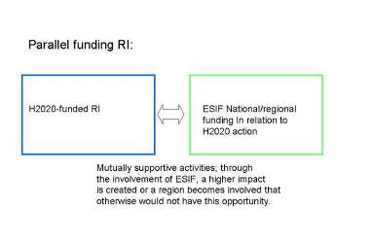
Figure 131 RI parallel funding
ESIF could be used to up-grade a research infrastructure (if this supports the socio-economic development of the host region and is in line with the RIS3 and relevant ESIF programme), while Horizon 2020 funds the research activities.

1.10 Pre-Commercial Procurement and Public Procurement of Innovative Solutions and ESIF

Why is this interesting for Managing Authorities and national & regional policy designers?
- PCP and PPI offer a win-win situation as they help to develop faster concrete solutions to societal challenges and improve public services and infrastructures, while helping innovators to bring their solutions faster to the market.
- PPI can be used under ERDF investment priority 1.b, but also under investment priorities related to energy, transport, health, environment, etc.

PCP and PPI facts:
Definition:
PCP = Pre-Commercial Procurement, i.e. procurement of RDI services involving risk-benefit sharing under market conditions (IPR ownership is owned by the RDI provider as in Horizon 2020 grants). PCP under Horizon 2020 is run in several phases with competitive development work by different RDI providers. There is a clear separation of the RDI services procured from the deployment of commercial volumes of end-products (the actual large scale procurement of the innovative solutions). Horizon 2020 calls for PCP cofund actions aim to co-finance PCP procurements carried out by trans-national buyers groups (= public procurers from different countries). This enables procurers to share the cost and experience of undertaking a PCP to address a challenge of common interest. PCP falls under the RDI exemption of the EU public procurement procedures /directives: http://cordis.europa.eu/fp7/ict/pcp/home_en.html and http://ec.europa.eu/digital-agenda/en/pre-commercial-procurement
Goal: to foster demand-driven innovation; speed up the development of innovations to address public / societal needs.
For details see Annex to Horizon 2020 WP on PCP
PPI = Public Procurement of innovative solutions that do not require RDI but maybe a new combination of technologies and service models. Normal procurement procedures / EU public procurement directives apply. PPI is procurement where procurers act as a launch customer, also called early adopter, for innovative goods or services which are not yet available on a large-scale commercial basis, and may include conformance testing. Horizon 2020 calls for PPI cofund actions aim to co-finance PPI procurements carried out by trans-national buyers groups (= public procurers from different countries). This enables procurers to pool resources (both as regards administrative, technical and legal capacities and as regards generating a sufficiently big demand to attract good value for money offers from innovative firms) and obtain economies of scale.
Goals: speed up the market introduction of innovations and thus improve the efficiency and effectiveness of public services and infrastructures and create return on investments for innovative firms.
CSAs = Coordination and Support Actions. In several priorities of Horizon 2020 there are calls for CSAs to support the creation of buyers groups and the preparation of future PCPs and PPIs.
For details see Annex to Horizon 2020 WP on PPI
Support for networking and capacity building for PCP and PPI: Procurement Forum
Implementation:
In Horizon 2020, calls for proposals to reinforce support to 'pre-commercial procurement' and 'public procurement of innovative solutions' are available across all priorities of the programme where mentioned in the Work Programme. All PCP and PPIs co-financed by Horizon 2020 launch an open market consultation in preparation of the procurement to inform potentially interested tenderers across Europe about the upcoming call for tender. PCPs and PPIs are open to companies of all sizes in line with the Treaty on the Functioning of the EU principles. Phase 3 of the SME instrument may also connect to such measures to promote PCP and PPI opportunities to SMEs (see graph below).
Info can be found: PCP/PPI website
Apart from calls for PCP/PPI in specific domains addressed by Horizon 2020, there are also calls open to PCP/PPI proposals to address a challenge in any area of public interest:
ICT-35(f): EUR 1 million call for CSAs - for procurers interested to prepare potential future PCPs or PPIs (call deadline: 23 April 2014)
ICT-36: EUR 4 million call for PCP COFUND actions - for procurers interested to do together a PCP (call deadline: 25 April 2015)
Funding:
Consortium of participants from minimum 3 different Member States (MS) or countries associated to Horizon 2020 (AC), of which minimum 2 public procurers from 2 different MS or AC investing in the joint procurement that form the buyers group (+ possibly other procurers – e.g. private, NGO procurers - that are providing services of public interest and other entities that are assisting the procurers)
Horizon 2020 co-financing rate: 100% for Coordination and Support Actions (CSA, e.g. the set-up of a trans-national buyers group and the identification of a common procurement need and other relevant preparatory activities), 70% for PCP cofund actions and 20% for PPI cofund actions. PCP and PPI cofund actions can reimburse the price of the call for tender as well as related coordination and networking costs to prepare, manage and follow-up the call for tender. CSA actions cannot reimburse the price of procurement, only coordination and networking costs.
Combined Funding Options:
Simultaneous/cumulative funding, sequential funding, alternative funding, parallel funding

The following figure shows that PCP and PPI may be linked, i.e. based on identified needs/demand, PCP funds research work in different phases with different “vendors” pursuing different solution approaches. PCP ends with the original development, testing and possibly the deployment of a limited set of end-solutions. The PCP may lead to a PPI that calls for the deployment of commercial volumes of products/services and a first "early adoption" at broad level.
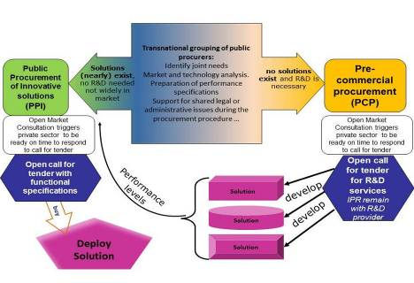
Figure 14 Relation between PCP and PPI in the innovation value chain
A PCP can thus be the first step, followed by the PPI.
However, a PPI can also be launched independently without previous PCP. If the buyers group realised during its formation and demand aggregation that the sought after innovative solutions do not require RDI, they directly launch a PPI procedure.
Scenarios for preparing a PCP or PPI:
A first step for MA/procurers is to identify other public procurers who have similar needs for innovative solutions. The different European Innovation Partnerships, or the transport, environment, energy etc. related groups of Member States and regions, or thematic RIS3 platforms ,or the Innovation Procurement platform could be used for this task (see: http://www.innovation-procurement.org).
A buyers group should then consolidate itself, identify common needs for innovative solutions and work out ToR (Terms of Reference) for their procurements.
A buyers group is a group of procurers that is interested to invest together in a PCP or PPI procurement to address a common challenge. The buyers group can consist of procurers from different MS/regions that already have an ongoing cooperation agreement (e.g. EGTC) or procurers that form an ad-hoc consortium for tackling one specific common public need. Common needs for innovative solutions may be identified among regions with similar priorities in their smart specialisation strategies.
The preparatory work conducted by the buyers group to prepare together the PCP or PPI procurement may include conducting an open market consultation with industry, preparing the tendering documents, appointing a lead procurer to coordinate and lead the procurement, etc.
ESIF can support the above type coordination and networking activities to prepare a PCP or PPI, e.g. via European Territorial Cooperation actions and technical assistance under ESIF programmes. Alternatively a Horizon 2020 funded Coordination and Support Action (CSA) can support these activities at 100% funding rate where foreseen in the Work Programme. Alternatively, max. 30% (PCP) or 50% (PPI) of Horizon 2020 funds can be used for coordination, preparation and networking activities to prepare, manage and follow-up a PCP or PPI.

Regardless of whether procurers from different MS/regions get together in the framework of an ESIF or Horizon 2020 funded project to prepare a PCP or PPI, sequentially the execution of the actual PCP or PPI procurement can be co-financed either by Horizon 2020 or by ESIF or by a combination of both.

NOTA BENE: Not all areas of Horizon 2020 foresee CSA funding for preparing PCP or PPIs. Having obtained ESIF funding gives no up-front guarantee to receive Horizon 2020 funding. Proposals for CSAs, PCP and PPI Cofund actions are accepted for funding after a separate process of submission and evaluation of proposals to the appropriate Horizon 2020 call for proposals.

Scenarios for executing a PCP:

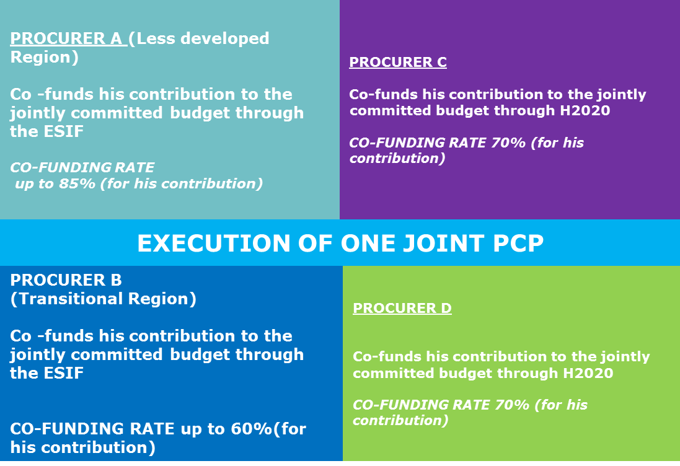
Figure 23 Cumulative use of ESIF and Horizon 2020 in the same PCP

A buyers group consisting of procurers A, B, C and D decides to co-finance the execution of the PCP through a combination of ESIF and Horizon 2020 funding. In this case the buyers group should apply for a PCP co-fund action under Horizon 2020 to purchase together RDI services via a joint PCP call for tender.

A buyers group consisting of procurers A and B may prefer to co-finance the execution of the PCP by ESIF without combined funding from Horizon 2020 while procurers C and D use Horizon 2020 funds.

Cumulating of funding from ESIF and Horizon 2020 means that some participants of the consortium of the buyers group may receive co-funding from the ESIF and others from Horizon 2020 for their contribution to the total jointly committed procurement budget. The cumulation of ESIF and Horizon 2020 funding requires that there is a clear identification of which ESIF programme is used for which expenditure and where the procured service or object will materialise its benefits (will generate the targeted quality/efficiency improvements in public services) and who is the owner of the expenditures co-funded by Horizon 2020.

NOTA BENE: Condition for success: synchronization between the ESIF calls and the Horizon 2020 PCP co-fund action calls.

MA could then use ESIF separately for a potential follow-up PPI to procure solutions according to the performance levels that have been identified as achievable in the PCP action.
PCP can deliver territorial benefits for regions by:
- getting solutions developed that realise concrete quality and efficiency improvements to public service provisioning in the region;
- strengthen the local innovation ecosystem as stronger local public sector demand for innovative solutions attracts additional investments into the region and helps to prevent relocation of innovative companies to other parts of the world;
- enhancing the technical know-how about the pros and cons of competing solutions on the market and the access to RDI results for procurers in the region.
- Procurers can define in the PCP tender specifications the tangible results they want to obtain as a result from the PCP. This typically includes company reports on achieved RDI results, a copy of the solution design, as well as the prototype and test specifications. If needed, procurers can also acquire as part of the PCP a limited set of prototypes and test products developed during the PCP (for max 50% of the contract value).
- Regarding the intangible results generated by participating RDI providers during the PCP, Horizon 2020 foresees that, while RDI providers remain IPR owners, the procurers enjoy royalty-free access rights to the RDI results, the right to license - or to require RDI providers to license - IPRs generated by RDI providers during the PCP to third parties, the right to transfer IPR ownership generated by RDI providers during the PCP to the procurer in case IPRs are abused against the public interest or not commercialised within a time limit specified in the PCP contract and the right to publish the key RDI results. Procurers also obtain (via lower PCP grants compared to ordinary procurement of R&D services) a financial compensation for leaving the ownership rights of IPRs generated by RDI providers during the PCP with the RDI providers. For example the region of Lombardy requests this financial compensation in the form of royalties on future sales realised by RDI providers and reinvests these royalties into a fund for financing future PCP and PPIs by the region.

Scenarios for executing a PPI:
PROCURER A
(Less developed Region)
purchases the innovative solution with the support of the ESIF in line with the objectives of the relevant O.P
CO-FUNDING RATE up to 85% (for his contribution)
PROCURER C
purchases the innovative solution with the support of H2020

FLAT CO-FUNDING RATE 20% (for his contribution)
PROCURER B
(Transitional Region)
purchases the innovative solution with the support of the ESIF in line with the objectives of the relevant OP
CO-FUNDING RATE up to 60%(for its contribution)
PROCURER D
purchases the innovative solution with the support of H2020

FLAT CO-FUNDING RATE 20% (for its contribution)
EXECUTION OF ONE JOINT PPI

Figure 24 Execution of a PPI using combined funding of ESFI and Horizon 2020
A buyers group consisting of procurers A, B, C and D can prefer to co-finance the execution of the PPI through a combination of ESIF and Horizon 2020 funding. In this case the buyers group should apply for a PPI co-fund action under Horizon 2020 to purchase together innovative solutions via a joint PPI call for tender.
A buyers group consisting of procurers A and B may prefer to co-finance the execution of the PPI by ESIF without combined funding from Horizon 2020 while procurers C and D use Horizon 2020 funds.
Framework contracts/agreements with lots can be used, with specific contracts for procuring the specific quantities of innovative solutions for each procurer individually.
Cumulation of funding from ESIF and Horizon 2020 means that some participants of the consortium of the buyers group may receive co-funding from the ESIF and others from Horizon 2020. The cumulation of ESIF and Horizon 2020 funding requires that there is a clear identification of which ESIF programme is used for which expenditure and where the procured service or object will materialise its benefits (will generate the targeted quality/efficiency improvements in public services) and who is the owner of expenditures co-funded by Horizon 2020. This is for instance possible by asking suppliers to issue separate invoices per procurer for the innovative solutions procured by each procurer.
To achieve innovation goals in their territory, by using ESI Funds procurers – in particular from less developed regions - could receive higher co-funding rates to participate in a PPI that is implemented in the framework of Horizon 2020 together with procurers from more advanced Regions.
NOTA BENE: Condition for success: synchronization between the ESIF calls and the Horizon 2020 PPI cofund action calls.

1.11 Horizon 2020 Innovation in SMEs and ESIF

Why is this interesting for Managing Authorities and national & regional policy designers?
- The model of the Horizon 2020 SME instrument with its different phases, starting from a small lump-sum based feasibility action, could be adopted in ESIF programmes. This could improve the SME innovation support.
- If the cost model in an ESIF programme is fully aligned to the SME instrument grant conditions, it would even become possible to take up excellent project proposals that come out of the Horizon 2020 evaluation process, but for which not enough Horizon 2020 budget is available.
- The results of the first or 2nd phase of the SME instrument could be carried further towards the market via ESIF support

Innovation in SMEs facts:
Definition: Horizon 2020 supports innovation in SMEs via the SME instrument and diverse SME support actions that are complementary. Collaboration with COSME and ESIF is (partially) foreseen and encouraged.
The SME instrument shall provide staged and seamless support covering the whole innovation cycle. It shall be provided for all types of innovation, including service, non-technological and social innovations, provided that each activity has a clear European added-value. The aim is to develop and capitalise on the innovation potential of SMEs by filling the gap in funding for early stage high risk research and innovation, stimulating innovations and increasing private-sector commercialisation of research results.
It will be implemented via a continuously open call within all societal challenges and Leading and Enabling Industrial Technologies areas under specified bottom-up topics.
Innovation in SME WP 2014/15 that refers explicitly to ESIF: "ESIF can help deploying innovative solutions for a better SME support emanating from Horizon2020 in the regions […]".
FUNDING: Within Horizon 2020, embedded in the enabling and industrial technologies parts of Horizon 2020.
- Phase 1: Lump sum EUR 50.000 for feasibility study= 6 months
- Phase 2: Innovation (pilot) projects with 70% funding, 1-2 years
- Phase 3: Commercialisation: no direct Horizon 2020 funding, but possible support from Financial Instruments, the COSME programme or ESIF
COST ITEMS: Eligible costs in one project – ESIF can come in for costs non-eligible under the SME instrument or alternative funding.
NOTA BENE: The SME instrument type of grants is only possible where foreseen in the WP (see pp.4-6).
Other SME Support Actions with relevance to ESIF:
“Cluster animated projects for new industrial value chains” plan to develop new cross-sectoral industrial value chains across Europe, by building upon the innovation potential of SMEs. The draft work programme mentions "Synergies with Cohesion Policy funds that may further support such large-scale demonstration projects will also be actively encouraged, notably through the engaged SME intermediaries.” This is meant to support the roll-out of a staged process of experimentation and implementation with accompanying support that reaches out to groups of mutually reinforcing SMEs.
Combined funding options: Cumulative funding (for non-eligible costs under Horizon 2020); alternative funding, sequential funding
Scenario SME 1: alternative funding
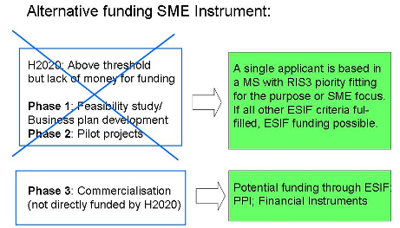
Figure 25 Alternative funding SME Instrument/sequential funding

Support in Phase 1 and 2 of the SME instrument:

If the MS ESIF programme allows funding small grants for the type of business plan development and if the substance of the proposed idea fits with the RIS3 specialisation fields, MAs can fund SME proposals that were evaluated positively in Horizon 2020, but for which there is not enough Horizon 2020 budget. Such proposals might be awarded a ‘Seal of Excellence’ to easier communicate the positive evaluation to programme managers of the national / regional action. Passing on such information will always require the previous approval of the project participant(s).
The proposal can be reoriented towards ESIF and funding could be granted either under TO1 (R&I within the RIS3 priorities) or TO3 (competitiveness of SME which does not demand RIS3 priorities).
SMEs can also take own initiatives and contact the relevant regional or national Managing Authority of European Structural and Investment Funds to explore whether they could provide similar support in line with the relevant ESIF programmes’ rules and priorities. See: http://ec.europa.eu/regional_policy/indexes/in_your_country_en.cfm
Given that the SME instrument allows for single SME application, the reorientation towards an ESIF support appears easier than with standard, multi-partner Innovation projects (The ESIF funding of such multi-beneficiary SME projects might be possible, if the rules of Article 70(2) CPR are respected).
Support in Phase 3 of the SME instrument: ESIF sequential funding in the SME instrument

ESIF can support regional SMEs for phase 3 commercialisation, including possibly through financial instruments or public procurement, when all ESIF criteria are fulfilled.
NOTA BENE: ESIF cannot substitute the co-funding principle, e.g. in a “phase 2” 70% funded project, ESIF cannot be used for the remaining 30%.

2. COSME – the programme for the competitiveness of enterprises and SMEs - and ESIF

Why is this interesting for Managing Authorities and national & regional
- The COSME Enterprise Europe Network is located in many regions all over the EU and even beyond. It offers direct access to international business or innovation partners for SMEs.
- The Enterprise Europe Network offers advanced high-quality advisory services that could give a model to be replicated within an ESIF programme’s territory with ESIF funded business and innovation service provision (e.g. brokerage events).
- The Enterprise Europe Network trans-national support may also be amplified via coordinated ESIF funded SME support services, in particular under ERDF investment priorities 3(b) new business models for SMEs, in particular with regard to internationalisation, 3(d) supporting the capacity of SMEs to grow in regional, national and international markets, and to engage in innovation processes.
- The impact of Enterprise Europe Network support might also be enhanced if the hosting MS or region ensures coordination with other ESIF supported SME support, e.g. voucher schemes, financial instruments, incubation services, etc.

COSME facts:
Definition: SME-specific support programme, follow-up of CIP-Entrepreneurship and Innovation Programme.
Please note that the COSME basic act does not include derogation from the non-cumulative principle. Hence, all combined funding must be either sequential or parallel or alternative. However, Article 10(2) of the COSME Regulation ("the [Enterprise Europe] Network may also be used to deliver services on behalf of other Union programmes") opens the path towards additional services that must be considered different actions (which all implies like tracking and allocation of costs to these services) observing the rules of the respective Union programme (e.g. Horizon 2020 or ESIF). An additional service “Enhancing the innovation management capacity of SMEs” is already foreseen to be funded from H2020. The COSME WP 2014 mentions explicitly ESIF for the benefits of SMEs and entrepreneurs (p.2).
EUR 2.3 billion are available for:
- facilitating access to finance for SMEs;
- supporting entrepreneurs;
- more favourable conditions for business creation and growth;
- access to markets.

COSME website for more information on the programme.
European Enterprise Network: covers the entire EU territory (and beyond); run by consortia bringing together national / regional business support providers (no trans-nationality); goal: provide business support services that strengthen competitiveness to European SMEs that seek to explore opportunities in the Single Market and in third countries. The service shall integrate and complement the services already available in the region. Some flexibility to emphasise (or reduce) services within the total service package exists.
Goals: Support to SMEs in general, not designed as a specific support for RDI: there is no specific "innovation" criterion.
Expected Results:
- easier access to finance for entrepreneurs and small businesses
- more prominent role for self-employment and business development as important sources of growth and job creation
- a more competitive industry, more entrepreneurs and higher employment rates
- increase of SME growth
- increase of share of Union citizens who wish to be self-employed
- increase of share of SMEs exporting within or outside the Union
- reduction of unnecessary and administrative regulatory burden on SME
- improved performance of SMEs as regards sustainability
FUNDING: Grants (to consortia implementing the EEN project for COSME and Horizon 2020 services)
COST ITEM: For EEN, the support of the EEN and services delivered by the EEN network for COSME/Horizon 2020 are considered cost items.
Combined funding options: parallel funding

Scenario COSME – Parallel funding - EEN

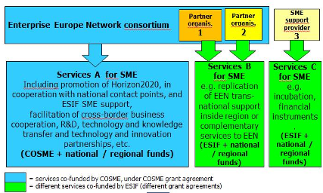

Figure 26 COSME and ESIF
EEN network in Region 1 is supported by COSME/Horizon 2020 for a defined set of services to SMEs that provide some flexibility with respect to advisory services. The ESIF programme of the same region foresees services to SMEs (that can be services also eligible for COSME/Horizon 2020 or different ones). The services to be carried out under the ESIF programme and therefore, co-financed by ESIF must not be the same as those supported by the grants from COSME/Horizon2020 programmes in the regional EEN project. The same is valid for Horizon 2020 SME services: if submitted for co-financing under Horizon 2020, they must be different to the two other types of services.
Example:
EEN partner X in MS/region 1 receives COSME funding for coaching and mentoring schemes with regard to SMEs' access to finance, to facilitate cross-border business cooperation, and ‘provides access to services to enhance material efficiency of SME’. The material efficiency services in region are however weakly developed. Partner X uses 50% of its staff for the European Enterprise Network services.
Partner X knows that the ESIF programme of its region wants to support SMEs in the area of energy efficiency with new and deeper services. Their staff is competent in this area and the EEN ‘technology partnering service is a suitable mechanisms to source technologies enhancing material efficiency’. It applies for ESIF and gets a grant contract that covers another 25% of its staff for these specific services under the ESIF programme.
In its book-keeping system and the time records of staff Partner X must clearly distinguish the EEN-project and the ESIF project. To avoid the risk of possible double funding, Partner X must define – for example – that the analytical phase for material efficiency is covered by the ESIF project (and resources in the EEN project redeployed), while the search for technological solutions is done in the EEN project and excluded from the ESIF supported actions.
NOTA BENE: EEN centres can act as valuable regional intermediaries to raise awareness of combined funding options. They should be key targets for the guide.

3. ERASMUS+ and ESIF

Why is this interesting for Managing Authorities and national & regional policy designers?
- It allows improving the skills levels in a region and preventing or reversing brain-drain by attracting students to a region.
- It allows experimenting with new forms of cooperation between education centres and businesses – also with a view to better targeting the education offer to the skills needs of enterprises, which can be crucial for the success of a RIS3.
- Erasmus+ support for policy learning reforms could be scaled up through ESF investments under the thematic objective 10 on “investing in education, training and for vocational training for skills and lifelong learning”, in particular priority 1(d)(ii) capacity building for stakeholders delivering education, lifelong learning and training policies.
- There may also be potential for synergies between Horizon 2020 and Erasmus+ thanks to the prestige of an ERA Chair holder (see above 1.2.) who makes institutes more attractive for foreign students.

Erasmus+ facts:
Definition: Erasmus+ is the EU education, training and youth and sport programme for the period 2014-2020. It brings together elements from the previous Lifelong learning (LLP) and Youth in Action (YiA) programmes and the international programmes in Higher education (Erasmus Mundus, Tempus, Alfa, Edulink) as well as the bilateral cooperation programmes in higher education into a single structure. It is structured around three "Key Actions" (KA): KA1: learning mobility of individuals, KA2: cooperation projects for innovation and exchange of good practices and KA3: support for policy reform. All three key actions have potential synergies with ESIF investments in general and in the field of innovation in particular. Erasmus+ also includes a specific chapter on sport with potential for such synergies.
Please note that Erasmus+ has no legal basis for cumulative funding (= combined funding in the same project or for the same individual beneficiary) so that all combined funding options are sequential, parallel or alternative.
Support for Mobility (KA1): Each National Agency (NA) receives a national allocation from the programme which is then allocated by the NA to individual higher education institutions (HEIs) or VET organisations based on a combination of past and expected demand (in most cases demand exceeds the resources available). HEIs/VET organisations allocate the grants to individual students and staff.
Support for Strategic Partnerships (KA2): A competitive approach exists with calls for proposals at national level. Each NA receives a national allocation from the programme and then selects projects on the basis of annual national calls for proposals. Project coordinators from the participating country submit proposals, which must include partners from at least two other countries. Projects last two or three years.
Support to Knowledge Alliances and Sector Skills Alliances (KA2). Annual calls for proposals are organised at EU level by the Education and Culture Executive Agency (EACEA), which selects projects level with the support of external evaluators.
For Sector Skills Alliances, lead organisations (coordinators) from a programme country submit proposals, which must include partners from at least two other countries. Projects last two or three years. The proposal must concern only one of the following sectors:
• sectors that have constituted a European Sector Skills Council, such as Textile/Clothing/Leather and Commerce;
• sectors with skills imbalances, to which current European Commission policies respond, such as Advanced Manufacturing, Information and Communication Technologies, Eco-Innovation (environmental technologies), or Cultural and Creative Sectors.
For Knowledge Alliances, lead organisations (coordinators) from a programme country submit proposals, which must include at least six partners from at least three countries. Two partners have to be higher education institutions and two partners have to be enterprises. Knowledge Alliances are open to any discipline or sector. Projects last two or three years.
The Erasmus+ Programme Guide mentions explicitly ESIF at several instances, e.g. within the framework of Collaborative Partnerships (KA2) or Support to Policy Reform (KA3).
FUNDING: Funding for student and staff mobility (KA1) is in the form of a monthly grant, the level of which varies between countries.
Funding for KA2 and KA3 covers unit costs for personnel, travel, events etc.
Cost item: A cost item for mobility is the grant itself (provided as a lump sum).
As all Erasmus+ projects will be included in the Erasmus+ Dissemination Platform (http://ec.europa.eu/dgs/education_culture/eve/), it can be consulted by anybody interested in project results (e.g. for results up-take at national/regional level.
KA3 supports policy reform through specific calls for proposals for
- Policy experimentations: field trials led by public authorities (ministry or equivalent) for assessing the effectiveness of innovative policy measures through robust evaluation methodologies. Policy experimentations results can therefore help to assess the potential scalability of such measures through ESIF
- Forward –looking cooperation projects, led by representative and highly respected stakeholders, for exploring new policy avenues that have the potential to generate systemic impacts. They can help to identify solutions to emerging issues, that can be further developed through Erasmus+ KA2 (Strategic partnerships, Knowledge Alliances, Sector Skills Alliances), or KA3 projects (Policy experimentations, Forward-looking cooperation projects) and ultimately up-scaled through ESIF.
The Erasmus+ Programme Guide mentions explicitly ESIF in relation to Support to Policy Reform under KA3 with a view to exploiting synergies.
Both policy experimentations and forward-looking cooperation projects are managed centrally by the Education, Audiovisual and Culture Executive Agency.
Scenario Erasmus+ 1: Parallel/complementary funding for mobility
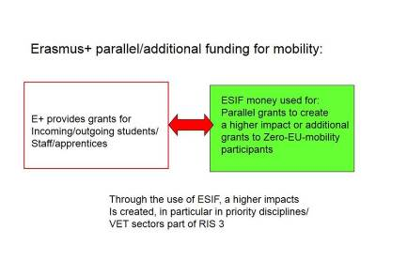
Figure 27 Funding for additional mobility grants from ESIF
ESIF (ESF) can be used to complement Erasmus+ funding for outgoing students/trainees/apprentices at national or regional level by providing additional grants to individuals not in receipt of Erasmus+ grants. This would be a means to promote credit mobility to other countries and thus international experience and skills development relevant to innovation and regional skills base (and could in principle be focused on “priority disciplines or VET sectors that are part of RIS3).
As double funding of the same cost items from the EU budget is not permitted and Erasmus+ grants are designed to cover a range of cost items (travel, living expenses, books and equipment), it would not be possible to use ESIF to fund "top-up" grants to individual beneficiaries already in receipt of Erasmus+ grants.
In the higher education sector, the E+ Programme Guide provides for "Zero-EU Mobility" participants, i.e. students and staff that do not claim travel and subsistence costs but benefit from all other Erasmus+ mobility scheme advantages. The Guide mentions that “Students and staff may receive, on top of the EU grant, or in replacement of the EU grant (zero-EU grant mobile participants) regional, national or any other type of grant, managed by another organisation than the National Agency (e.g. Ministry or regional authorities). These types of grant provided by other sources of funding than the EU budget are not subject to the amounts and min/max ranges set in this document” (emphasis added).
Given the contribution to travel and subsistence costs (between EUR 150 and 500/month, depending on the country of origin and host country), additional funding for individual Erasmus+ grant recipients may be an option to increase the effectiveness of the mobility scheme. However, to avoid double-funding, these will need to come from national sources. However, ESF can be used to fund grants for the so-called "Zero-EU-mobility" participants in Erasmus+, who do not receive Erasmus+ grants but go to Erasmus+ participating institutions and for whom institutions receive management funds.
Example 1.1 HE: Higher education institutions (HE) a region X has comparatively low levels of out-going mobility, which limits the international exposure and skills development of students. To address this, ESIF is used to provide additional grants to students who are not in receipt of an Erasmus+ grant to undertake a mobility period within the overall cooperation and quality framework of Erasmus+. If a region has a smart specialisation in a particular sector (e.g. aeronautics or viticulture) this type of support could be targeted at students in related study programmes undertaking mobility to follow related programmes/ undertake related work placements in another country. Higher ESIF-funded grants could be provided to encourage mobility in specific priority fields and thus maximise the added value of ESIF.
In the same way, ESIF (ESF) can be used for additional mobility of outgoing academic staff to promote skills and innovation capacity. Such additional support could be directed to specific "priority" disciplines/VET sectors.

Example 1.2 VET: This example for VET is comparable to example 1.1 for Higher Education: ESIF is used to provide additional funds to increase the number of apprentices benefiting from transnational mobility of apprentices and the on-the-job mobility of initial VET students in sectors identified by a given region/MS within Smart Specialisation Strategy. Moreover, since a successful implementation of apprenticeship systems is only possible with qualified staff, ESIF may also provide additional funds to scale-up transnational mobility for in-company trainers and other VET professionals to develop specific skills in sectors identified in Smart Specialisation Strategy.
Scenario Erasmus+ 2: Parallel/complementary funding for Multilateral Cooperation Projects
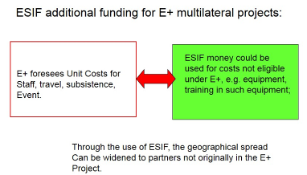
Figure 2815 E+ additional funding for KA2

ESIF could potentially be used to fund preparatory, complementary or directly related activities within partner institutions participating in Erasmus+ Strategic Partnerships/ Knowledge Alliances /Sector Skills Alliances in order to enhance the contribution of the partner or improve dissemination or use of results.
Example 2.1: A regional university is a partner in a successful Erasmus+ Knowledge Alliance. The project aims to enhance teaching and learning in the field of advanced manufacturing in the participating HEIs, drawing on expertise from participating businesses and involving improved methods for teaching and learning in an advanced factory environment. ESIF provides investment for laboratory equipment (or any other not eligible costs in E+) in the regional university to strengthen training capacity and contribute to the overall results of the project.
Recommendation: Given the highly competitive nature of E+ projects, the most likely scenario would be for partners to submit proposals for ESIF funding after securing the E+ project (so that parallel funding was in place for year 2 or 3 of the E+ project). Another option would be enlarging the geographical spread through ESIF in other MS/AS not partner in the E+ project.

Scenario Erasmus+ 3: Downstream sequential funding for Multilateral Cooperation Projects
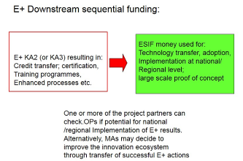
Figure 29 E+ Downstream sequential funding
Strategic Partnerships and Knowledge Alliances are multilateral activities of Erasmus+ Key Action 2: Transnational cooperation for innovation and the exchange of good practices to improve quality and relevance of teaching and curricula in higher education. Knowledge Alliances and Strategic Partnerships could have a similar set-up, i.e. involving Higher Education Institutions and companies as core partners in the project (however, whereas this is a main requirement for the Knowledge Alliances, it is encouraged for Strategic Partnerships). Such cooperation has proven particularly effective for capacity building and raising innovation and entrepreneurial potential. As such, regional or national cooperation projects on the same model could be supported by ESIF, thus building on the experience gained from transnational partnerships or vice versa.

Erasmus+ Sector Skills Alliances work on occupational profiles, competence standards and related training programmes at European sector level. ESIF financed projects could integrate these results into national qualification frameworks and national training standards. Knowledge Alliances work on trans-regional or transnational university-business cooperation and are open to participation of public authorities.

Downstream combined funding can be applied mutatis mutandis to the outcomes of KA 3: Forward-looking cooperation projects in innovative areas may include specific elements that are immediately usable and can be integrated in programmes/projects funded through ESIF (ESF). Furthermore, the implementation of innovative policies successfully tested on a small scale through policy experimentations can be scaled up at regional or national level through combined funding with the support of ESIF (ESF).

Example 3.1: In an Erasmus+ Sector Skills Alliance European stakeholders from the automotive sector have agreed and defined required skills, competences and qualifications standards for the profession of mechatronics. These European- and sector-wide results will be translated at national level through the ESIF (ESF) by financing projects that establish nationally recognised/certified innovative, learning outcome-oriented training programmes which are based on quality assurance mechanisms (e.g. EQAVET) and foresee credit transfers through ECVET.

Example 3.2: A new and innovative model for training students in the field of sustainable energy technologies developed as part of an Erasmus+ Knowledge Alliance has proved particularly interesting and effective. ESIF (ESF) funds are used to help establish similar training programmes (staff training, materials, cooperation links etc.) in other regional or national HEIs in order to strengthen educational capacity in the field.
Example 3.3: A regional university of applied science has cooperated effectively with a local television production company to develop a new curriculum for a broadcast media course as part of a much wider, international cooperation project under Erasmus+. Following the project, student placements within the production company and on-going cooperation on innovative production techniques between the business and university are supported through an ESIF innovation project at regional level.
Example 3.4: Results of Erasmus+ Strategic Partnerships used to test implementation of quality assurance systems in VET based on the EQAVET. Recommendations are mainstreamed and scaled up through ESIF into an implementation of a national quality assurance system in vocational education and training system.
Example 3.5: Erasmus+ Strategic Partnership projects develop innovative curricula aimed to match VET provision with the needs to labour market. A region, in line with its focus defined in Smart Specialisation Strategy, is using the results and the partner/s involved in Erasmus+ projects to help to solve the problem of skills shortages of vocational skilled workers. With the use of ESIF, it establishes VET excellence centres and promotes investments in equipment of VET schools to provide VET students with up-to date skills. These centres then play a major role in technology diffusion, for instance in making the case regarding benefits of green technologies for business. VET excellence centres are supported with ESIF to enter in new forms of partnerships:
- Opening up facilities and infrastructures of VET schools in a form of basic business services
- Co-location partnerships with creation of joint facilities shared by VET schools and companies
- Functioning of VET schools as technology diffusion and (virtual) demonstration technology centres for technology suppliers
VET schools assisting companies in incubation – support to product-service development.

Scenario Erasmus+ 4: Upstream sequential funding for Multilateral Cooperation Projects

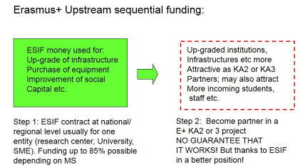
Figure 30 E+ Upstream sequential funding

Similar to scenario Horizon 2020 up-stream sequential funding, ESIF can be used to improve research and education infrastructures in national/regional universities or research institutes. This would improve the RDI capacity and make the institutions more attractive for Erasmus+ projects. However, there is no guarantee that "follow-up projects" will happen.
NOTA BENE: The scenarios above present the most likely combination possibilities for achieving synergies between Erasmus+ and ESIF (ESF) funds in the field of innovation. However, other scenarios could be possible. In particular, it could also be possible for specific elements of an ESIF innovation project to be developed further at grass-root level through an Erasmus+ Strategic Partnership or Knowledge Alliance.

4. Creative Europe and ESIF

Why is this interesting for Managing Authorities and national & regional policy designers?
- Technology is often not enough to be a successful innovator. Besides entrepreneurial skills, also creative thinking, design related activities and the use of new media can be crucial for innovations to succeed.
- The results of CreativeEurope projects can thus be amplified and carried forward via ESIF investments to achieve a durable impact on competitiveness, innovation and growth.
- Initial ESIF support for creative and cultural industry SMEs or other small organisations (including as part of social integration projects under ESF or rural development projects under the EAFRD) could be carried further via the CreativeEurope Loan Guarantee Facility (available as of 2016).
- Cultural heritage initiatives might also consider the sequential use of Horizon 2020 support for research in the field of cultural heritage preservation and digitisation and CreativeEurope support.

Creative Europe facts:
Definition: Creative Europe brings together 3 existing programmes - Culture, MEDIA, MEDIA Mundus – and is divided into 2 sub-programmes: Culture and Media and one cross sectoral strand consisting mainly of a Loan Guarantee Facility. The Guarantee Facility, to be launched in 2016, is designed to facilitate access to finance for micro, small, and medium sized organisations in the sector, as well as to improve the risk-assessment capacities of participating financial intermediaries.
EUR 1.46 billion are available in total. This programme is geared at the cultural and creative sectors.
It is important to note that the non-cumulative principle is explicitly mentioned in the Guidelines of all CE sub-strains (Art. 9/3): ”[…] To ensure this, applicants must give details in their application form of any other grant requests related to the same project which they have submitted or intend to submit to the EU stating in each case the budgetary year, the budget heading, the Union Programme and the amount requested”.
Creative Europe website
Creative Europe national desks
FUNDING: For grants, between 50 and 80% depending on the action. Eligible costs are costs incurred for implementing the project.
Cultural and Creative Sectors Loan Guarantee Facility: capped guarantee instrument offering up to 70% on the first losses (with a cap of 25% on a loan portfolio, bundled with the Capacity Building Scheme targeted towards financial intermediaries).
Combined funding options: Given the emphasis of non-cumulative funding in the Creative Europe guidelines, only sequential funding appears to be feasible.
Scenario Creative Europe: sequential funding

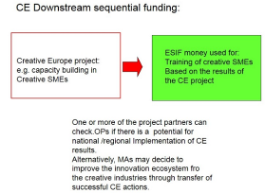
Figure 31 Sequential funding Creative Europe
Innovation in the cultural and creative sectors, for example like funding of incubation facilities for Cultural and Creative Industries (CCI), provided this is covered by the ESIF programme priorities for SME competitiveness, or the cooperation between technology / manufacturing oriented firms with CCI firms can boost innovation performance.
(See Handbook on CCIs in the RIS 3 context: http://s3platform.jrc.ec.europa.eu/documents
/10157/0/120420%20CCI%20Policy%20Handbook%20(FINAL).pdf
ESIF could fund additional capacity building in the region of some of the project partners (as clearly separated ESIF projects) or in regions not being part of the project but that might benefit from Creative Europe project results. Examples of potential investments in CCI could include investments in research, innovation, SME competitiveness and entrepreneurship.
Example Creative Europe: CE supports a collaboration project among SMEs in the cultural and creative sectors with the view to providing them with new skills or competences for new ways to access content and new business models based on ICT. Two of the partners are in regions that support ICT capacity building among SMEs. After the successful end of the CE project they inform their MA about the project results and receive ESIF (ESF) for training creative SMEs in their respective regions, based on the results from the CE project.

5. Connecting Europe Facility (CEF) - Digital Services

Why is this interesting for Managing Authorities and national & regional policy designers?
- Investments into e-government solutions under ERDF investment priority 2.c or ESF investments in thematic objective 11 (institutional capacity and efficiency of public administrations) can gain in quality and efficiency if they are designed to be interoperable with the solutions in other EU countries or at EU level via aligning with the CEF digital services platforms.

Connecting Europe Facility:
Definition: The Connecting Europe Facility (CEF) is the funding instrument for the trans-European networks and will roll-out high-performing, sustainable and joined-up trans-European networks in the fields of transport, energy, and telecom (broadband & digital services).
A large part of the Digital Services builds on the CIP ICT-PSP projects and Large Scale Pilots for cross border online public services, to promote the trans-European interconnection and interoperability of public online services as well as access to such networks in order to facilitate the mobility of businesses and citizens and facilitate cooperation among public services.
The CEF digital service infrastructures (DSI) are composed of core service platforms and generic services. The core service platforms shall be implemented primarily by the Union while generic services shall be implemented by the parties connecting to the relevant core service platform. This opens scope for synergies with ESI Funds investments but needs a coordination of local/national/regional programmes and initiatives with CEF to reach a critical mass.
Building blocks for Digital Services Infrastructures (DSI) are components reusable at EU and national level. The following priorities for such DSI have been identified in the work programme 2014:
- Electronic identification and authentication — eIdentificantion and eSignature
- Electronic delivery of documents — eDelivery
- Electronic Invoicing – eInvoicing
- Europeana - single access point to Europe's digital culture
- Safer Internet - Creating a Better Internet for Kids
- Open Data- facilitate access to public sector information, e.g. geographical information, statistics, weather data, data from publicly funded research projects, and digitised books from libraries
- Automated Translation - make online content available in every European language.
- Cyber security
Two funding mechanisms
• Procurement (mostly for core service platforms)
• Grants (mostly for generic services)
Regarding synergies with CEF broadband support see up-dated broadband guide

Scenario CEF Digital Services
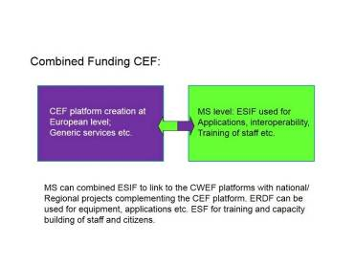
Figure 32 CEF combined funding
ESIF can complement CEF investment through national/regional projects linked to CEF platforms. ERDF can provide the equipment necessary (in particular, its interoperability with the CEF platform) and ESF can train staff and other involved persons.
Example: CEF funds the development of an interoperable cross border e-Health services platform, which enables the interaction between citizens/patients and health care providers, institution-to-institution and organization-to-organization transmission of data, or peer-to-peer communication between citizens/patients and/or health professionals and institutions. The services comprise cross border access to electronic health records and electronic prescription services as well as remote health/assisted living tele-services, etc.
ESIF invests through ERDF in the development of local e-Health applications and ensures inter-operability with the CEF funded platform. The ESF funds the up-skilling of medical personnel and patients to be able to handle the e-|Health tools.

A ‘demonstration or pilot’ aims to validate the technical and economic viability of a new or improved technology, product, process, service or solution in an operational (or near to operational) environment, whether industrial or otherwise, involving where appropriate a larger scale prototype or demonstrator.
Demonstration or pilot projects in the field of Environment or Climate Action may also be funded by the LIFE Programme. See: http://ec.europa.eu/environment/life/index.htm
A ‘market replication’ aims to support the first application/deployment in the market of an innovation that has already been demonstrated but not yet applied/deployed in the market due to market failures/barriers to uptake. 'Market replication' does not cover multiple applications in the market of an innovation that has already been applied successfully once in the market. ‘First’ means new at least to Europe or new at least to the application sector in question. Often such projects involve a validation of technical and economic performance at system level in real life operating conditions provided by the market.
Currently defined for Horizon 2020 purposes as the Czech Republic, Estonia, Slovenia, Hungary, Lithuania, Poland, Croatia, Malta, Latvia, Slovakia, Bulgaria, Cyprus, Romania, Portugal and Luxembourg
List of investment priorities: article 5, ERDF regulation 1301/2013.
Public-Public Partnerships (P2P)
Public-Private Partnerships (PPPs)
For ERA-Nets this is conceived to last normally only for one joint call, whereas the Dedicated Implementation Structures or Joint Undertakings are set up following often years of preparatory work and European Parliament and Council Decisions or Council Regulations and the Article 185 and 187 initiatives are like separate trans-national R&D programmes with annual work plans, governance structures, etc..
Information on how the process works: http://ec.europa.eu/research/era/how-does-it-work_en.htm
http://ec.europa.eu/research/participants/portal/desktop/en/funding/reference_docs.html#h2020-mga-sme
See for Proof of concept: http://erc.europa.eu/proof-concept and for the SME instrument: http://ec.europa.eu/programmes/horizon2020/en/h2020-section/sme-instrument (and scenario 1.11)
See: model grant agreements for the SME instrument Phase 1 and phase 2 both for mono-beneficiary grants and multi-beneficiary grants: http://ec.europa.eu/research/participants/portal/desktop/en/funding/reference_docs.html
Definition of “Research and innovation action”: Action primarily consisting of activities aiming to establish new knowledge and/or to explore the feasibility of a new or improved technology, product, process, service or solution. For this purpose they may include basic and applied research, technology development and integration, testing and validation on a small-scale prototype in a laboratory or simulated environment. Projects may contain closely connected but limited demonstration or pilot activities aiming to show technical feasibility in a near to operational environment.
http://ec.europa.eu/research/participants/data/ref/h2020/wp/2014_2015/annexes/h2020-wp1415-annex-ga_en.pdf
See for calculation examples for this bonus: Multi-beneficiary Annotated General Grant Agreement: http://ec.europa.eu/research/participants/data/ref/h2020/grants_manual/amga/h2020-amga_en.pdf
See re. TRL: http://ec.europa.eu/research/participants/data/ref/h2020/wp/2014_2015/annexes/h2020-wp1415-annex-g-trl_en.pdf
The ERDF may not be used to support the decommissioning or the construction of nuclear power stations
The 15% limit applies to ERDF, Cohesion Fund and EMFF per priority axis; for EAFRD the limit is 5 % at the level of the programme (see Article 70(2) CPR) ; for ESF it is 3% of the budget of the operational programme (Article. 13(3) ESF)
Definition of CSA: Actions consisting primarily of accompanying measures such as standardisation, dissemination, awareness-raising and communication, networking, coordination or support services, policy dialogues and mutual learning exercises and studies, including design studies for new infrastructure and may also include complementary activities of strategic planning, networking and coordination between programmes in different countries. Horizon 2020 funds 100 % of the eligible costs.
including via the EURAXESS - Researchers in Motion portal http://ec.europa.eu/euraxess/index.cfm/jobs/index
See: http://ec.europa.eu/regional_policy/cooperate/macro_region_strategy/index_en.cfm
Information on how the process works: http://ec.europa.eu/research/era/how-does-it-work_en.htm
See: http://ec.europa.eu/research/era/art-185-individual-initiatives_en.htm
See: http://cordis.europa.eu/technology-platforms/individual_en.html
See: model grant agreements for the SME instrument Phase 1 and phase 2 both for mono-beneficiary grants and multi-beneficiary grants: http://ec.europa.eu/research/participants/portal/desktop/en/funding/reference_docs.html
Upon approval of the participants, information on positively evaluated European Research Council, Marie Sklodowska-Curie, teaming actions, phase-2 SME instrument or collaborative project proposals that have been evaluated above threshold according to the Horizon 2020 criteria but could not be funded for lack of Horizon 2020 budget, can be shared with the responsible authorities in the MS and regions. See Commission declaration following GRI meeting of 12 July 2013 [SI(2013)366/2]
See call documents: http://ec.europa.eu/enterprise/newsroom/cf/itemdetail.cfm?item_id=7229&lang=en&title=COSME-Enterprise-Europe-Network-2015%2F2020
pp. 42/43 of the Programme Guide
See COM(2013) 329
See: http://s3platform.jrc.ec.europa.eu

